# ASSESSMENT BRIEF - COVER SHEET

| **Course: BSc Computing (All pathways)** | | | | **Year: 1** | **CSY1019 - Software Engineering 1** | | |
| --- | --- | --- | --- | --- | --- | --- | --- |
| **PJ1** | | **Title: System Specification, Analysis and Design** | | | | | |
| Date due out:  22/11/2021 | Date due in: | | Extension date: | | | | Extension agreed by: |
| **Group Name:**   | Group Member Names | Student ID's | | --- | --- | | Kenneth Mathew Da Cruz | 21406242 | | Qudsia Noor | 21414562 | | Jason Wiredu | 22403382 | | Alane Assi | 2145781 | | Ahmad Dawood Alam | 20413263 | | Elizabeth Aning-Amponsah | 18412818 | | Abayomi Peters | 21420798 | | Lisa | 21413808 | | Casey Tcheukam |  | | Madalina | 20410468 | | Beverly | 19425338 | | Madhab | 22400129 | | Joel Da Costa | 20418155 | | Yassin | 21416118 | | | | | | | **Tutor: Mark Johnson** | |

**ASSESSMENT FEEDBACK:**

| **RATING SCALE** | **A+ - A-** | | **B+ - B-** | | **C+ - C-** | **D+ - D-** | | **F+ - F-** |
| --- | --- | --- | --- | --- | --- | --- | --- | --- |
| Formulated Aims and Objectives  (10%) |  | |  | |  |  | |  |
| Problem Domain Elicitation Activities and Presented Findings (10%) |  | |  | |  |  | |  |
| Requirement Specification Document  (20%) |  | |  | |  |  | |  |
| System Interface Design  Documentation  (20%) |  | |  | |  |  | |  |
| Systems Architecture Analysis and Design  (20%) |  | |  | |  |  | |  |
| Client Presentation  (10%) |  | |  | |  |  | |  |
| Report Quality – Presentation, format and use of English  (10%) |  | |  | |  |  | |  |
| Specific aspects of your assignment that the marker likes: | | | | Specific aspects of your assignment that need more work: | | | | |
| Tutor’s Signature: | | Date: | | | | | Grade: | |

**System Specification, Analysis and Design**



**Table of Contents**

**ASSESSMENT BRIEF - COVER SHEET 1**

**PJ1** 1

**1.Introduction 6**

1.1 Project Background (1 page) 6

1.2 Project Aims and Objectives (1 page) 7

1.3 Project Development Methodology (2 page) 9

**2 Requirements Engineering 12**

2.1 Elicitation Activities 12

2.1.2 Interview findings 20

2.1.3 Other problem domain research 56

2.1.3.1.1 Records Management Systems 57

2.1.3.1.2 Zoo Websites 60

2.1.3.1.3 Visitor Kiosk/Information Systems 67

2.1.3.2 Development Relevant Legislation 67

2.1.3.3 Visitor Questionnaire (Optional) 69

2.1.3.4 Visitor Questionnaire Results Analysis 72

2.2 Requirements Specification 80

2.2.1 Problem Domain Description 81

2.2.1.1 Existing Business Operation 81

2.2.1.1.1 Animal Life-Cycle 82

2.2.1.1.2 Sponsorship Life-Cycle 82

2.2.1.2 Summary of existing business limitations 84

2.2.2 Functional Requirements 85

2.2.2.1 Records Management System 85

2.2.2.2 Zoo Website 100

2.2.3.3 Visitor Kiosk Information System 104

2.2.3 Performance Requirements (Records Management System) 106

2.2.3.1 Speed 107

2.2.3.2 Capacity 107

2.2.3.3 Reliability 107

2.2.3.4 Usability 108

2.2.4 Performance Requirements (Zoo Website) 108

2.2.4.1 Speed 108

2.2.4.2 Capacity 108

2.2.4.3 Reliability 109

2.2.4.4 Usability 109

2.2.5 Performance Requirements (Visitor Information System) (Mobile App) 110

2.2.5.1 Speed 110

2.2.5.2 Capacity 110

2.2.5.3 Reliability 110

2.2.5.4 Usability 110

2.2.6 Design Constraints (All software components) 112

2.2.7 Commercial Constraints (Total Project) 113

**3 System Interface Designs 114**

3.1 Draft Interface Designs for RMS 115

3.1.1 Wireframes 115

3.1.2 System Navigation Diagram 122

3.1.3 System Screen mock-ups 122

3.1.4 System Activity Event Diagrams 125

3.3 Draft Interface Designs for Zoo Website 125

3.1.1 Wireframes 125

3.1.2 System Navigation Diagram 137

3.1.3 System Screen mock-ups 137

3.1.4 System Activity Event Diagrams 148

3.1 Draft Interface Designs for Kiosk/Visitor Information 150

3.1.1 Wireframes 150

3.1.2 System Navigation Diagram 163

3.1.3 System Screen mock-ups 164

3.1.4 System Activity Event Diagrams 166

**4 Analysis and Design Records Management System – 168**

4.1 Preliminary Analysis Stages 168

4.1.1. Textual Analysis 168

4.1.2. Significant Event Analysis 168

4.1.3. Class- Responsibility-Collaborator (CRC) 168

4.2. Detailed Static System Designs 168

4.2.1. First Draft BON System Architecture Diagram 168

4.2.2. BON System Chart 168

4.2.3. BON Cluster Charts 168

4.2.4. BON Class Charts 168

**5 Report Conclusion 168**

**6 References 171**

**7 Appendix 172**

# Introduction

This section will provide a brief introduction for the project overall. It will provide the background information for the project. The aims and objectives will outline in detail, the end expectations of the projects and the software suite of products that are expected to be developed. Furthermore, it will also cover the project development methodology, which will provide an in-depth summary of the different elicitation techniques such as questionnaires, interviews etc… that will be used to extract key information, essential in the success of the project.

## Project Background (1 page)

The name of the project is Claybrook Zoo. The Synergy Solutions software development company was approached by Matthew Jones, the current zoo manager at Claybrook zoo, who wants us to develop a suite of software products that includes a website, visitor information technologies and records management system.

Four key stakeholders:

1. **Matthew Jones:** The current zoo manager. As he is the manager, he is a key stakeholder who is an expert on the existing organisational procedures and practice at Claybrook zoo.
2. **Thomas Smith:** An existing, regular visitor to the zoo. He will be able to provide us with good insight into the current visiting experience that is available for general members of the public.
3. **Jonathan Rodgers:** A senior administrator within the Claybrook zoo, who is responsible for running the animal sponsorship scheme effectively. This key stakeholder will be able to provide us with key information about how the data is stored at Claybrook zoo.
4. **Phillip Brown:** A local small business owner who is very interested in the animal sponsorship scheme if he can understand the potential benefits through advertising/positive publicity available through the scheme.

The current situation is that the zoo does not currently have any technology implemented in the business. All administrative tasks are paper based.

The problem with the current situation is that there are concerns about loss of staff, animals and visitors’ data stored in the zoo, due to it being paper based.

There is also a lack of technology implemented in the business, which is affecting the development and growth of the zoo, as there is less outreach to the members of the public.

The signage is only updated once a year, as it is not technical.

We will implement technology available to resolve all the concerns of the client.

For example, at the moment the animal’s record is stored on a paper-based record form. To resolve this issue, we will develop an RMS (Record Management System), a database, which will allow the members of staff to find the required animal record easily. We will achieve this by allowing complex search criteria combinations which the staff member can use to interrogate the database. This database, therefore, will allow the members of staff to search for animals using multiple search criteria easily. Furthermore, we will also include a graphical representation of the animals held within the database, so that the animals can be easily identified.

To help promote the zoo and the features/benefits that it offers, to the wider members of the public and therefore provide more outreach, again through the implementation of technology we will develop and produce a zoo website. The website will allow potential visitors to look at the critical zoo animals held within the zoo, prior to actually visiting the zoo. The website will also include key information about the zoo, which will also encourage more visitors.

To resolve other issues, such as queuing at the zoo tickets office, we will also investigate the relevant technologies that the zoo can implement to incorporate possible touch-screen features which will be a part of the visitor information technology, such as a kiosk system or a QR driven and Mobile Application that will run on a smartphone that will allow visitors to interact with the existing attractions at the zoo.

## 1.2 Project Aims and Objectives (1 page)

The key aim of this project is to develop very effective and efficient suite of products which includes:

1. A customer facing zoo website
2. An internally facing visitor information technologies
3. A zoo records administration/content management system that will allow key business records for the zoo to be effectively managed.

The end goal of the project is that the three software products developed will very effectively resolve all the concerns of the client. In order to successfully meet this aim, the following provides an overview of the objectives that have been developed for each of the three software products.

The objectives for the zoo records administration/ content management system are as follows:

* Investigation into existing record management systems
* Organisation of current record management
* Technologically advance the current record management system in order to create an easy method of storing important information
* Create better security for the new system to decrease the chance of the zoo being liable for any damages or losses in important data and information
* A more effective way of providing sponsors and customers their personal information

To develop a customer facing zoo website, that is of high quality and very user friendly the following objectives have been developed:

* Investigation into existing zoo websites, as comparable system, to identify common features or characteristics of the website, that must be implemented in zoo websites.
* Evaluation of the positive and negative aspects of the existing zoo website. This will help to identify the strengths and also the weaknesses of each website.
* Investigation into existing design principles, that can be implemented to improve the usability of the website for the target audience.

The objectives for the internally facing visitor information technologies are as follows:

* Investigation into existing visitor information technologies.
* Create better flow within the zoo by creating a kiosk system that allows people to purchase tickets quickly.
* Create another source of income through the shopping kiosk and creating a new shop design.
* Create a more effective way for members to find, correct and know their personal information through the mobile app.
* Create a way for visitors to know about seasonal activities through the new kiosk system and the mobile app.

## 1.3 Project Development Methodology (2 page)

In this section we will be discussing the different elicitation techniques such as questionnaires, interviews and reading the brief. We will briefly discuss the advantages and disadvantages for each of the elicitation technique and justification for why we have chosen the particular technique.

The table below provides a brief explanation of the advantages and disadvantages of the different elicitation techniques and a justification, for why we have chosen to implement the technique.

| **Technique** | **Advantages and Disadvantages** | **Justification** |
| --- | --- | --- |
| Background reading – Reading the client briefs | Advantages  - Provides background information to the project.  - Helps to gain an understanding of the key stakeholders involved in the project.    Disadvantages  - Doesn’t provide in depth information for the project. | The decision was made to implement this technique, so that we can gain some background information on the project and understand who the key stakeholders are, before, we begin working on the project.  Reading the briefs helped us to identify the problem domain characteristics for this project before we start planning our interviews to obtain key information from the clients. |
| Interviews | Advantages  - Opportunity to explain questions in detail and to also discuss the answers in detail with the clients, to gain any necessary clarifications.  -Potentially saves the client’s time, as the interviewer, doesn’t have to ask a particular question if the client has already answered it while answering another question, compared to a questionnaire/form for example, where the client has to answer all the questions, separately, with less detail or explanation. The interview format gives them the opportunity to expand on their answers if needed.  Disadvantages  - It can be very costly and also very time consuming.  - The client might not feel as comfortable answering the questions, especially in group interviews, as they are face to face, and it can be intimidating to them, compared to a questions form conducted online, where they can take their time to answer the questions.  - Furthermore, if the questions were asked in an online form/questionnaire format, they would feel more comfortable answering the questions, as they are not under time constraints and they do not feel the pressure from the interviewer. Also, since they are not under pressure, they will be able to think more clearly, resulting in better and more detailed responses to the questions. This will mean, that we the interviewers, will have more detailed and clear answers to the questions asked, which we can then analyse in detail to extract the key information. | The decision was made to implement this technique, so that we can obtain key project information from the clients. Interview plans were developed to obtain key information about the project from the clients. The interviews will help us to understand more clearly, about the requirements of the project and obtain key additional project information from the clients regarding the software products that they would like us to develop.  The information obtained from the interviews will be essential, in terms of the development of the software products. |
| Questionnaire | Advantages  - It is not expensive, as it is conducted online.  - The visitors will not be under pressure to answer the questions as there are no time constraints.  - It is easily scalable. This is because you can send the questionnaire to hundred visitors, for example, within seconds, which makes it a very practical option.  - You can get the results extremely fast. As, the questionnaire is carried out online, when the visitor/user completes the questionnaire, you can get a notification email, depending on the questionnaire software tool used.  - Carrying out the questionnaire online, allows you to analyse the results for each of the questions separately, easily and also very effectively. This is because there are several software tools available, which allow you to automatically analyse the results for each of questions, and also provide bar charts, pie charts, to illustrate the complex aggregated statistics collected from the questionnaire.  - Finally, the questionnaire can be anonymous, and the visitors, completing it should be informed this at the start of this questionnaire. This is a major advantage of questionnaire because it potentially means that the visitors, will be more honest with their responses as their identity is anonymous.  Disadvantages  - It lacks detailed information. It doesn’t allow them to expand or explain the answers that they have provided.  - The visitors might ignore or leave some questions unanswered.  - The information gathered may not always be reliable and accurate, as we do not know whether the respondent of the questionnaire, has understood the question fully before answering or responding to it. If the questions were answered, without fully understanding, this will lead to inaccurate data. | The decision was made to implement this technique, so that we can gain valuable information about the views of the existing Claybrook zoo visitors and what they feel about the current zoo visiting experience and also what they would like to see improved in the future.  The questions will be short and simple, which will make it very easy for the visitors of the zoo, to complete the questionnaire and therefore lead to more accurate results.  The information gained from this questionnaire, will be key in terms of the development of the software systems for the project. This is because, we will be able to take into account the views and the perspective of the visitors of the zoo and what they would like to see improved in the future as well as the requirements of the clients of the project to develop effective software products. Furthermore, this will make the current visitors of the zoo feel valued, as their views are taken into account, when developing the software systems which will be used by the visitors itself and also attract new visitors, therefore improving the overall visiting experience of the zoo. |

# 2 Requirements Engineering

This section will cover the elicitation activities that we will carry out, to ensure that we gather the requirements that are required to achieve success in this project. The main elicitation technique that we will use to gather the information will be interviews. It will outline the interview plans and then an in-depth documentation of the interview findings. Furthermore, we will also carry out other problem domain research as a review of the comparable systems for each of the software products, where we will carry out in-depth research into existing systems for each of the products. We will also provide a summary of the relevant legislation for the project. Finally, to gather further information we will also develop a questionnaire for the current visitors, to gain a better understanding of their perspective of the zoo.

## 2.1 Elicitation Activities

There are a few elicitation activities that we carried out, such as interviews with the key stakeholders, to extract the key information for the project. We recorded the findings from the interviews in a table. The information gathered from these interviews will be essential in the development of the software products. We will also develop a visitor questionnaire and distribute it to the current visitors of the zoo to ensure that we take into account the views of the current visitors of the zoo. Furthermore, we will also carry out comparable software system review for each of the three software products, where we will evaluate the current existing systems for the three software products.

2.1.1 Interview plans

In order to ensure that we gain all the required information from the key stakeholders, we decided to develop interview plans for each of the three interviews. This will structure the interview, so that we can gain all the essential information effectively.

2.1.1.1 Interview plan for Matthew Jones

**Interview plan**

**Link to the presentation:**

<https://docs.google.com/presentation/d/1OkR5rEXR3rKBumYhSp-cPzXVOuiz3YJG/edit?usp=sharing&ouid=109614238906931772822&rtpof=true&sd=true>

**Note: 20 minutes per sub-group**

**Sub-group 1 - Website - Up to 2:20pm**

>>>>> Kenneth - Introduction

They will introduce themselves

Good afternoon Mr Jones. My name is Kenneth. May I address you by your first name(Matthew). This is my team and we are from Synergy Solutions. I will let the rest of my team introduce themselves to you.

**Brief introduction of all the team members** (Introduce according to your specific team:       e.g. Hi, my name is Kenneth and I will be asking you questions about the website)

>>>>> Kenneth Today we would like to ask you a few questions regarding the project.

For research purposes, we will be voice recording this interview. Please be rest assured that any confidential information discussed during this interview will be restricted to members of our team only.

May we continue with your permission ?

Great. Firstly, we will be asking you a few questions regarding the website.

>>>>>Qudsia - Start asking questions

* What do you aim to achieve?
* Can we please get a map of the zoo?
* What is the current implemented system – do you have an existing website?
* What are your existing social media platforms that we can advertise on the website ?
* Do you have an existing logo for the zoo?
* Tell me a bit about the history of the zoo ?
* Can you tell me any interesting facts about the zoo ?

>>>>> Kenneth

* What are the main competitors of the zoo?

“I have done a bit of research on the different competitors and these are the top three” - show the top 3 competitors **(Links in slide 3)**

When you show the design say "These are some examples of competitor websites that we have researched, but it is your view that matters, so please be absolutely honest with me about your view on it"

* How would you like the potential customer/visitor of the website to interact with the website? - show the different navigation examples **(Links in slide 4)**
* From the examples of navigation shown, is there one that you particularly like?

When picked ask “What is it that you specifically like about the style ?

* Do you have an idea in mind about the general layout of the website ? - show the top 3 competitors **(Links in slide 3)**
* From the examples of the competitor websites shown, is there one that you particularly like?

When picked ask “What is it that you specifically like about the website that you picked, eg.. how its displayed, fonts, colours etc.. ?

>>>>>Jason- End questions and move on to the next sub-group.

* In your opinion, when you open a zoo website, what is the first thing that you expect to see (any specific information, pictures etc..) ?
* Do you have existing content that you would like us to use (e.g. Articles/news, pictures of animals etc..) ?
* What are the key sections that the website must have?

Would you like a special section on the website where the customer can rent the zoo for parties or family time?

>>>>>Madhab

* What type of information (e.g... any interesting facts about a particular animal etc..)how would you like to display the information regarding the critical zoo animals on the website? - show example
* What are the main colours you would like to see on the website?

**Sub-group 2 - RMS - Up to 2:40pm**

**Introduction**

>>>>>Alane - we are now going to ask questions about the record management system.

* How do you currently store data about the animals, the clients and the sponsors?
* (If the client says any digital form then ask) What operating system are you currently using? Do you prefer the latest version?
* How do you manage client data and sponsors?
* How do you adjust and change information about the animal?
* What do you like and dislike about your current record management system?
* What is the current way of sharing files between all business members?

>>>>>Dawood

* What do you like and dislike about your current record management system?
* How do you currently distribute information about the animals to the public?
* Can you tell me a bit more about how you would like to interact with the record management system, any key functionality that it must have?
* Are there any existing photographs of the animals in the zoo that we can access, to be added to the database?
* Can we access existing data of the current animals in the zoo?
* How many people work for you?

>>>>>Elizabeth

* What are the different job roles people have in the zoo?
* Who currently has access to your documents on the animals/ the clients / sponsors?
* Is there anything you do not want in the database?
* What is the proposed budget for this project?
* What is the deadline for the project?
* What if any worries do you have about the system?
* What issues do you think there may be with the software?

>>>>>Beverley- End questions and move on to the next sub-group.

* Is there anyone else we will need to speak to who is not on our list?
* What would be the best way to reach you?

**Sub-group 3 - Kiosk - Up to 3:00pm**

>>>>>Lisa - We are now going to ask questions about the kiosk

* What systems do you have currently i.e. do you have kiosks currently
* Do you have Wi-Fi available for guests?
* Who are your current target audience?
* Do you want a self service kiosk for the tickets to buy to get into the zoo?

>>>>>Madalina

* What key information do you want to see on the kiosk ( gift shop, food machines, tables and sponsor banners)
* Are there any specific attractions that you would like to see
* Do you have any design ideas for the kiosk

>>>>>Abayomi

* Do you want a QR code system?
* what functions would you like the kiosk to perform
* Would you like a QR code reader on the mobile app as well as the website?
* Do you want the kiosk to sell products such as QR cards and other products like stuffed animals(cuddly animal toys)
* What are your expectations from the QR codes in terms of its performance and reliability.
* Do you have a specific pattern or where you want the QR codes to be displayed?

>>>>>Casey

* Where do you want the kiosks to be located?
* How many kiosks would you like to have?

>>>>> Ending - Kenneth

Thank you for your time today Mr Jones. It has been really productive speaking to you, we have gained lots of information, are there any other topics you would like to discuss, or is there any information you think I should know.

We will be in touch soon, to make sure that the solution we come up with is what you expect.

2.1.1.2 Interview plan for Thomas Smith and Phil Brown

**Interview plan**

**Link to the presentation:**

<https://docs.google.com/presentation/d/1ieRnwPjwx0HPnaikgeeq8e8X_UWwp-zz/edit?usp=sharing&ouid=109614238906931772822&rtpof=true&sd=true>

**Introduction**

>>>>> Kenneth

They will introduce themselves

Good afternoon Mr Smith and Mr Brown. My name is Kenneth. This is my team and we are from Synergy Solutions. May I address you by your first name(Thomas & Phil).

For research purposes, we will be recording both voice and video throughout the interview. Please be rest assured that any confidential information discussed during this interview will be restricted to members of our team only.

May we continue with your permission ? Great.

Today we would like to ask you a few questions regarding the project.

We will begin the interview with Thomas, Phil you’re welcome to provide any given inputs/suggestions throughout the interview.

Are there any questions you would like to ask before we start ?

**Interview Subject:  Thomas Smith – Regular visitor (Key Stakeholder)**

>>>>>Jason

**1)  Motivation**

Tell me a bit about yourself - background, family etc..

In your opinion, what about the zoo keeps you coming back & being a regular visitor?

Did you visit any other zoos prior to Claybrook Zoo? (Leading Question)

* Is there any particular reason that made you make the switch? (Follow Up Question)
* If so, what elements of Claybrook do you prefer over the prior Zoo? (Follow Up Question)

>>>>>Madhab

**2) Current visiting experience**

How did you hear about Claybrook zoo?

Do you visit the Claybrook zoo often?

Describe your current experiences at Claybrook Zoo?

>>>>>Qudsia

Describe your current booking processes at Claybrook zoo

What would be your ideal experience at a zoo?

What features would you like to see on the website you feel that would improve your visiting experience in the future ?

>>>>>Dawood

**Usability**

How often do you use computer systems/devices? For example, a computer, laptop, tablet or mobile device?

What functions/features would you say makes it easier for you to use and navigate around the device?

**Comparable systems**

In the past, what have you seen at other zoos that you don’t see at Claybrook zoo?

>>>>>Lisa

What do you like at other zoos that you would like for Claybrook zoo to improve on?

What content would you like to see on a zoo website and the kiosks?

Would you be interested in purchasing merchandise and souvenirs online as well as in store?

The closing - Thank you for answering our questions. Now, we will move onto Phil Brown, but please feel free to give any inputs/suggestions throughout the interview.

**Interview Subject: Phil brown - Sponsor  (Key Stakeholder)**

>>>>>Abayomi

**Background**

Can you tell me a bit about yourself and your background?

How long have you been associated with the zoo?

What are your goals for this sponsorship?

Have you been contacted by people who have visited the zoo regarding your business?

>>>>>Alane

**Current experiences**

How can you describe your current experiences with Claybrook zoo?

What would you say are pros and cons of working with Claybrook zoo?

What features or improvements would you like to see within the business?

What features would you like to keep the same within the business?

>>>>>Elizabeth

**Comparable systems**

Are you a current or former sponsor at a different organisation?

In being a sponsor for this/these organisations what made the outcome successful?

What do you see at other zoos that you do not see at Claybrook zoo?

>>>>> Kenneth

What catches your eye when you visit a zoo website/any other form of advertisements for zoos? e.g. color schemes, navigation, easy to access etc..

What makes you most engaged when you visit a website?  e.g. pictures, videos etc..

>>>>> Beverly

**Usability**

How often do you use a computer system/device? For example a Computer, Laptop, mobile device…

Do you have any form of social media outlets? such as Facebook, twitter, instagram etc.

What key features do you see on Zoo websites that you consider ‘easy to use’?

Joel

**Future prospects**

Would you be interested in being featured on the Claybrook zoo website as a Sponsor? This would include a little bit about yourself, your business, what animal you are sponsoring and why, which in turn may boost customers for your own business.

What is your short-term goal with Claybrook zoo?

What is your long-term goal with Claybrook zoo?

>>>>>Madalina **- Show PowerPoint after your questions**

**knowledge on Kiosks & website content**

Are you familiar with what a Kiosk is?

Would you say a kiosk has been convenient for you in the past when visiting anywhere that provides one or not? and why?

Say Claybrook zoo were to introduce kiosks to facilitate things such as self-service ticket booths and providing information about the zoo, what kind of content would you also like to see on these kiosks?

***Final Questions***

Do you both have any questions in mind or information you think we should know?

>>>>> Kenneth

Thank you for your time today Mr Smith and Mr Brown. It has been really productive speaking to you, we have gained lots of information.

We will provide a brief copy of our conversation today and we'll be sure to keep in contact with you via email so that you may get the best possible solution.

Thank you once again.

2.1.1.3 Interview plan for Jonathan Rodgers and outstanding questions for Matthew Jones

**Outstanding questions and questions for Jonathan Rodgers**

**Only Kenneth asked the questions**

**Questions for Jonathan Rodgers – Administrator (Key Stakeholder)**

* How long have you worked as an administrator for the Claybrook zoo business ?
* What do you like and dislike about the current system ? - asked
* Are all your current animal records managed in office and how ? - asked
* Can you tell me what type of records you keep for the current animals in the zoo ? - asked
* Can you tell me a bit about the animal sponsorship scheme? - asked
* How is the animal sponsorship scheme currently run/promoted? - asked
* Can you tell me what type of information/data do you record/keep of the visitors and sponsors to the zoo? - asked
* How is the visitor data stored? - asked
* How experienced are you with technology ?
* What current legislation protocols do you currently have in place ?/What legal policies do you already have ? - asked
* What measures do you have in place to protect the children that visit the zoo ? - asked
* Are there any programming languages that you wish for us to use such as java, html etc. - asked
* Do you have a preferred database system that you would like us to use ? - asked
* What is the duration of the sponsorship scheme ? - asked

**Outstanding questions**

Client name:  **Matthew Jones**

1. Performance

* How fast would you like the website to run at? - asked
* What is your maximum capacity of site visitors do you intend to have? - asked
* Say it would take 2-4 hours for website maintenance to occur, between what hours would you like for this to happen at? E.g. software updates - asked
* How many hours in a day would you like your site to be available for (e.g. 23 hours a day, 20 hours a day…) - asked, but confused with “actual site” opening sites.
* So I asked about the website availability hours - answerd
* Would you like a feature to change the language of your website for visitors? - asked
* How many records do you intend to store a day? or - asked
* How many records do you intend to store - asked
* How much storage would you need for your website and records management?

* Most websites **don't need more than 1GB of space**, with blog sites typically coming in at around 700-800MB of disk space. But since you will be storing records and content it would range between 10gb and 20gb lets say, we will get back to you in terms of storage when we’ve accumulated all data needed for the site &kiosks

What are the current legislations in place for the business? - asked

Client name:  **Phil Brown**

No questions

Client name:  **Tom Smith**

No questions

## 2.1.2 Interview findings

We recorded the findings from the interviews in a table. Below is the information gathered from the three interviews.

2.1.2.1 Interview findings for Matthew Jones

**Initial Interview with key stakeholder – Matthew Jones**

Interview Date: **09/11/2021**

Duration: 1 hour

Persons in attendance:

* Kenneth
* Qudsia
* Jason
* Madhad
* Alane
* Dawood
* Elizabeth
* Lisa
* Madalina
* Abayomi

| Topic 1 | | Website |
| --- | --- | --- |
| **Interviewer** | **Question number** | **Question – Client response** |
| Qudsia | 001 | **What do you aim to achieve?**  Answer – Ok errm… I think that is a really good question and I’ve got to give you a tiny bit of background information first, if that’s ok just to make the context meaningful. We as a business have been running since 1965 when I started it in my 20s, it is my baby, and I am very passionate about its success. In recent years we have noticed that there has been a drop off in numbers, that less and less people have been coming and that has really put a errm has caused us problems when it comes to the budget because our biggest revenue is our ticket sales. At the moment we have called you in to really get you to think about what we can do to increase our contemporary feel, satisfaction of the people that come to the zoo, and also our marketing so if we can enhance those, I can show you the figures for our financially later but I just want to give you the background. So, to answer your question about the website, I would say that the idea is to give us a better outreach. We do use local papers and we put articles in there and we pay for publicity, but I’ve been told that a website is relatively cheap once its established, you can use other social media and the idea of the website is to advertise how great we are to get people through the door. So its super super important that the website is a  good way to attract new visitors to the zoo. |
| Qudsia | 002 | **Would it be ok if later on you give us a map of the zoo?**  Answer – Yeah, I can do that now. I was expecting you so I’ve actually got a few documents and as you as them I will provide them as much as possible. Very quickly, if it opens up for me, I’ll make sure you get copies of these on Wednesday afternoon. I know I’m aware that there is another consultancy group coming in tomorrow so I wanna make such they get them all at the same time, but anything I show you today you will get later on. Apologies for the delay, here we go, so this our zoo at the moment and it includes the colour schemes that we have for the overall structure of the zoo. So you can see that we rebranded recently and the individuals that suggest it said that we have a colour scheme to indicate the different locations and types of animals. So we have yellow is our mammal areas, we have the aquariums in the colour 4 and 5 sort of purplely colour and then the colour at the top is for the aviary area for all our bird houses and then red is the hot house area for all our amphibians and reptiles. So those colours we would like to use consistently for indicating areas in the zoo but that’s what the zoo looks like. |
| Qudsia | 003 | **What is your current implemented system?**  Answer – quite a general question, what do you mean by that do you mean. **Do you have an existing website?** Ok yeah, I can tell you about our structure at the moment. All our records at the moment are on site that we keep for both visitors who are members of the zoo and have paid for membership, all our administration records for staff and all our animal records are kept clerically in filing cabinets. So, you can imagine each animal, each person has a file which we keep the records in, so it very very limited. Again, I can show you if it’s useful what a record looks like and send these to you. This document here is one from one of our star attractions which is Redwell and you can see that it has all the core information and some specific to him and even areas for recording his death and or subsequent removal from the zoo.  So all animals have that document and also have the location their stored in as a compound within the zoo. So I will make sure you get that information going forward. You did ask about the other processes. I would say we don’t have a website, that’s non existent, and we have all our signages physical signages at the moment so we thinking about potentially using technology to make it a little bit more interactive. |
| Qudsia | 004 | **What are your existing social media platforms that we could advertise on your website?**    Answer – None at all. We are open to your suggestions. I know we are missing a trick but there isn’t any technology infrastructure at all in the zoo or the business. |
| Qudsia | 005 | **Do you have an existing logo for the zoo?**  Answer – We do yeah. We rebranded approximately 2 years ago now and we have these as our colour schemes and logo, so you can see the base logo. We would want to keep that as we spent a lot of money and when you go round the zoo you will see all our signage has the corporate colour scheme as well. As you can see that is an example and I showed you the animal record form for mango Redwell and that shows how we use the forms to populate a lot of data for each animal. You see the sort of leaves junglely effect, we have that consistently throughout the zoo. The only other thing that I would say is present is the concept of now the colours as well in the areas which are based on the different areas, yellow for mammals for example, but those are the colour schemes that we do deploy. |
| Qudsia | 006 | **Could you tell me a bit more about the zoo, like your background?**  Answer – Background, we arrived in 1965 when I was in my early 20’s. I’m very proud that I started the zoo at the time, I’ve been working here consistently. Our figures for the number of people that we have used to be exceptionally high, we did have a surplus in revenue back in the day but as time when by we’ve noticed the zoo seems to be a bit outdated so our demographic which is young families would bring the children has really suffered. Covid was horrendous for us which you can imagine we had to physically close the zoo down completely as some point so its super important as I say that you guys come in and help us with the technology concept to make the zoo viable again. |
| Qudsia | 007 | **Can you tell me any interesting facts about the zoo?**  Answer – Again that’s quite a wide scope, we had a pair of breeding pandas and that was quite rare, you might have seen it with the zoo in Edinburgh where they brought in from China and we had a similar scenario but they were our pandas we weren’t borrowing them from China so that was one of our impressive things and that was in the late 80s. |
| Kenneth | 008 | **What are the main competitors for the zoo?**  Answer – In the North – West we do have a few zoos which are known and are branded. I would say Blackpool Zoo is one, Chester Zoo is another those are quite close to us in the North-West but people are willing to travel nowadays so Whipsnade, London zoo, Colchester zoo. There are quite a few that would attract people and I do know because I did do a bit of research that they all have a really good web presence, they’ve got good websites and they also use social media so I think that would be something that we would want to go down those roots.  **Shows London Zoo and Chester Zoo websites**  I like the idea that they are advertising events. Some really nice websites, for me I mean there’s a lot of nice features that we could go through but I really like the idea of like the core navigation up at the top of the menu and then going down once you click it takes you to the individual components, so I think if we were talking about the products going forward I definitely would like to see some of those feature incorporated in the new zoo for Claybrook. Chester Zoo was nice with the navigation up at the top and then some sort of marquee effect, but I think there’s a lot of nice features on the three that you’ve shown me |
| Kenneth | 009 | **In terms of the content which of the 3 would you prefer**  Answer – I think it would probably be worth taking some time to list what was included in each and then comparing them. Again, I don’t know how you would do it, whether it would be a table or a grid but some way of seeing what each of them have. If it helps you I did compile a list of some features that I would really like on our website. Long story short what we did is we got together as a group of colleagues, and we said if we had a new website what would we have on there. So, we did a brain- storming activity and this is the list we came up with so again I want you to know that we are definitely not experts so if there’s things on here that we are suggesting that you don’t think are viable we will listen to you but this is what we came up with so we thought a really good homepage, we’d want some contact details for the zoo, we would want the ability to see some sort of map as to how to find the zoo, we would want some background information about the zoo as your colleague was asking previously about when we were founded. I also think we want the ability to show our ticket pricing scheme and structure, the ability to buy tickets online, that’s one of the criticisms from our client base that you have to be at the zoo to buy. News letter sign-ups, so we could advertise events, the ability to see news articles and events that are coming up at the zoo, maybe with a calendar, examples of some of the animals that we have got there and we felt it would be crazy to have the same animals every week so what we thought is maybe rotating the animals so we had an idea of animals of the week and we show a few examples rather than putting everything there. Finally, a member’s area so you could renew your membership and look at your membership details, the same again with the sponsors renew your sponsors to see what the benefits are, look at your personal details and renew and feedback and testimonials. So, the idea that if we had a client that really liked their experience just like you get on trip advisor you could go in and  you could leave some comments and then those comments could show for other people about the zoo. I’m not sure whether we want to go straight to trip advisor I’d like to see the feedback that comes through first of all is like but certainly something on the website saying about our benefits. |
| Kenneth | 10 | **In terms of navigation, I have looked at three different styles - shows the three different navigation styles - how the customer could interact with the website**  Answer – That to me, is my favourite personally, (the simple dropdown) absolutely, and the, with the submenus that appear once you go over it. It might be worthwhile talking to the visitor as well, so Tom, because he is one of the people we targeted, so his perception of the view is very important. |
| Kenneth | 11 | **In terms of the layout of the website, what do you expect to see when you first open a website ?**  Answer – I think the example you had of the second one with the animals, with the(chester zoo) yes, that, really liked that with key events, with a menu at the top and maybe with a dropdown approach that you have got and then some of those core things, so you know, like, buy tickets and news this week or highlighted animals, things that are gonna make the clients really want to explore. And we are, as I say, we are not experts, that was just a list that we came up with and I am more than happy to listen to your advice. So, if you think that there’s other things that we missed, let us know and we will consider. |
| Kenneth | 12 | **Do you have existing content that you would like for us to incorporate on the website ?**  Answer – We don't have content, which has been written for the website, but we will have documents and leaflets that we can find and provide for you, with background. |
| Kenneth | 13 | **Would you like a special section on the website, where the customers can like rent the zoo, for parties etc..**  Answer – No, we don't have any facilities for that at the moment. It could be something eventually for additional revenue, but it wouldn't be renting the whole zoo, I would like to think that it would be areas, you know like the cafe area or something like that as a way of getting everyone together. |
| Madhab | 14 | **What type of information (e.g... any interesting facts about a particular animal etc..)how would you like to display the information regarding the critical zoo animals on the website?**  Answer – Okay, that's a good question. I mean, we are open, I keep repeating this, we are open to your suggestions, but the structure that we have used before for the signage could be a starting point. So if you look, the type of things that we have, would be sort of facts about the animal. But the downside, is that this is very static, we can't change this easily, whereas on the website, we were thinking about more dynamic content, maybe videos, maybe sounds of the animals, maybe even quizzes about the animals, or you know some sort of interactive game or elements that would make the whole experience of interacting with the website more enjoyable, especially for the younger market. So I think this was great 30 years ago, when people were coming in the late 1990s, but now it's a bit dated. So the key thing will be to say, maybe take some of the core information about the animals and the pictures and make it more engaging for younger customers. |
| Madhab | 15 | **What are the main colours you would like to see on the website?**  Answer – Yeah, for me, it would be the corporate colours as a starting point and maybe using our different colours to classify the different animals. So if this on the (shows redwell who is the mammal), so maybe yellow as some of the branding for mammals and then the other colours that we have got as a way of differentiating the different types of animals that we have got at the zoo. |
| Jason | 16r | **Ideally, when you open or when your first website gets launched, what is the first thing you would expect to see on the website ?**  Answer – To me, it would be something that hits our demographic in terms of appropriate style. So, child friendly would be there, you know to hit the market, the younger market, maybe colours and fonts which are quite bright, easy to use. I would like to think, maybe so that, even some of the children locally, would go on the website and get excited about it and then say to their moms you know please tell mum, dad, you know take me to this. So, it would need to sort of appeal to our demographic. It would need to have enough information, to make the parents understand how to get there, so you know the contact details, directions, pricing guide as well, but really sort of clear, consistent, child friendly, exciting that’s it. I want it you know, you go to some, you know the BBC news site for example, and you look at it, it's not exciting. It's designed for an older audience, so we wouldn't want that. Lots of graphics, maybe lots of engaging games when you go to the animal specific things to really get the children excited. (**To clarify your target demographic, the main sub target would be the family ?..**) absolutely, 100 percent. We, if you look at our numbers, I’d say maybe 10 percent of the business revenue comes from school trips and the educational side and the other 90 percent of the revenue comes from either families with small children, probably up to the ages of about 11,12. They seem to get disinterested once they get over that age and occasionally there's a few couples, you know,romantic afternoons, but it's predominantly families, maybe eighty percent families, young, up to children, pre-teens. There is always exceptions but that would be the sort of the major demographic that we have got.(**That’s the major demographic, but would you be looking to expand ?**) I am happy to get anybody through the door, yeah, you know, if you feel, that you know, there were offers, I mean somebody said about doing a seniors afternoon and offering discount tickets for OOPs and things like that or even students.We've got quite a few universities, but again, I suppose its finding a niche that would get those people through the doors, but we are open to suggestions. (**Back to the content of the website, in regards to existing content, is there any models or do you have any models in particular that/any model content websites which you have seen before, which you would like to incorporate ?**) There are some really good ones out there. I mean the ones that Ken showed me I think are quite nice, Chester is one of my personal favourites. I think the London, slash, Whipsnade is not quite as good as some of the others, it's a bit all over the place I think, because it links to multiple sites now, but I do like the overall feel with the navigation as Ken has discussed and some of the nice bright pictures and then clear sections, so you can find what you want very easily. So, when you look at it, you are not thinking, oh how do I find, but it's there, very clear for you to see and you can find the information very quickly.(**So, content like articles and news..?**) hundred percent, events. I mean, I will illustrate, one of our, I think it's just like the Chester right ?(Ken: Chester) they have their Christmas theme already on there. We recently had an event which was like scary animals for Hallowen, so we had a special week and opportunities for people to come in and we've got a vampire bat and we have got some animals which are seen as quite scary and we advertised that and promoted it. So, those things should be really clear, you know, through the newsletter and on the website, “come and join the event” and that will hopefully pull more people. (**And the- website content should be consistently and frequently be updated on a seasonal basis of course** ?) hundred percent, yeah. The downside of everything that we've got at the moment is, it's very static. The signage is usually only updated once a year when, and if the sponsor changes, because the sponsorship can't change, but a lot of content has been the same. So again, talk to Tom about this, but he was telling me that his children were saying, oh I have read all this, you know, why do I want to see it again, why do I wanna go, because it is exactly the same content. So, dynamic nature of technology, for me is huge and if you can get something in there, including the internal side as well as the website that changes.  (**Just one more thing, don’t want to keep you long.. I have just like, Ken, our team leader, he has, you know, presented to you some examples of what type of content you would like ideally incorporated into your website and I made, I produced myself a small clip(showing the clip) model clip of, you know, could entail of Claybrook zoo) (Showing the clip: this ideally is what I would like to see on the About page. Like you said, it's colorful, bright pages, it's more immersive rather than (shows example of fully text based) more for the kids, it's more kid friendly, so this is targeting your kid audience and the oriented zoo just something small.**  Some of the key slogans as well, a lot more interested in. I mean, this is exactly my vision. That we have got this sort of dynamic, interactive content that you as a child and even as a young adult would look at and find enjoyable. Again, maybe some additional text like this thing, so you can see where this is. |
| Alane | 17 | **How do you currently store data about the animals, the clients and the sponsors?**  Answer – Yeah, it's very very outdated, because you will see as previously on the form, everything is stored in a paper file format and you will also see there's a sponsorship form as well, but it's exactly the same structure. Its, we've got the forms, we, write in the details and having all our paperwork like this is rubbish to be absolutely honest. I mean, it leads to lots of problems, we could lose case papers, when we get them out, to update them, they get filed incorrectly, we’re using massive storage area at the moment for all the animals and sponsorship records and visitor records. So, the actual physical space that we are using is crazy. We've got some buildings in the zoo, specifically for storage, our filing system, so if we were able to convert these to an electronic format that would have a massive impact on the efficiency of the business. You know, we’ll be able, if a customer rang in and said, can you tell me, when my sponsorship scheme is ending, I need to, you know, arrange payment, at the moment we are going down to the files and we are getting the information. If it was a electronic screen and our administrators could say, yeah, no problem, give me your details and get the information immediately, that would increase the efficiency of the business. So there's lots and lots of potential limitations with paper at the moment, that we want you to solve. |
| Alane | 18 | **I would also like to know what operating system you are currently using?**  Answer - I’m going to be completely honest with you, I’m going to tell you the infrastructure regardless  of which area you working at we have a few Pcs with office on to send letter to customers  but there isn't really any infrastructure at all. We've got a connection to the internet for research, sending emails etc...  but it's rubbish we haven't invested on technology for many many years so I would almost say scrap any use of old material  and if we can afford it, we buy the system you are developing. We know it’s not fit (current system) for purpose its very old we want emails to fly to the customer, newspapers, letters it should be hopefully automated. |
| Alane | 19 | **What do you like about the current management system?**  Answer - I suppose the positive is that the system works even though it works slow. Our system from the attributes we store the data we store the way we manage our areas/locations they each have a code example given. We have a map which is a zoomed in area of the bigger map and we have a system which enables us to recall which animals are located in these. And we can also see with our current system which areas of the zoo are free, should we look to bring more animals we can look at what areas are available within the zoo.   It does what it is supposed to do but it is very clunky. All the data we keep is sound, all of the records work but processing paper compared to electronic systems is so outdated. it would not necessarily be adding to a massive new amount of data field for our records, it will be a conversion from paperwork to electronic. So that's what I like about it the system works. |
| Alane | 20 | **I’d like to know who’s in charge of making changes/ adjustments to the animal information?**  Answer - Yhh that's a really good question. I would say we have one or two senior administrators who have access to everything and we have the zookeeper's who can go in and make changes to certain things like medical history of animals, they would record changes. There's a section on the animal form where we keep track of any changes like diets health problems. And I suppose the visitors get access to this information via our signage, they also see it through kiosks.i |
| Alane | 21 | **Lastly, I'd like to know the current way of sharing files between all business members?**  Answer - Literally using folders of paper documents you can understand how that could cause problems. We had one of our zookeepers writing notes and then accidentally dropped the file into one the wet area in the zoo meaning file was destroyed. If that was a computer version that would have never happened, you know. |
| Dawood | 22 | **Can you tell me a bit more about how you would like to interact with the record?**  Answer- I would like to think I am one of the senior managers so I would be able to have full access rights to all the records, add new records, edit, we don't actually delete, we archive paper records once they reach a certain age. Top level administrators will be able to do all of that whereas the zookeeper's staff who upkeep animals would only be able to view records and maybe make adjustments to certain fields. But it would mainly be people like me who would do a bulk of the changes. |
| Dawood | 23 | **Are there any functions you specifically want on the record management system?**  Answer- I think for me the idea of creating, these are  the listed requirements in the specification, being able to make adjustments, archive and delete forms if there was an error record. Searches so if we want find animals we are looking for from a particular area. The ability to make searches for specific record types would be really useful. |
| Dawood | 24 | **Are there any existing photographs of the animals in the zoo that we can access, to be added to the database?**  Answer- At the moment there are a couple of digital cameras in the zoo and what we do is take those and on one of the PCs we have a reasonably sized hard drive, and all those pictures go on there. But we do for the signage for example we send the signage as a template to the master printers and that’s when we use the photos and put them to one side or if we are embedding them into files, we have that particular animal photo at that particular time. |
| Dawood | 25 | **Can we access existing data of the current animals in the zoo?**  Answer-For you coming in I’m happy for you to see the records or at the very least examples of the documents. So, you can use that to understand what we need in our record. |
| Dawood | 26 | **How many people work for you?**  Answer- We were shown a document please refer to the document given by Mathew. Around 80 - 150 |
| Elizabeth | 27 | **Is there anything you wouldn’t want in your database?**  Answer: Almost a direct translation of what we’ve got now into the new system & you would need to advise me whether we needed any additional fields in the database. I wouldn’t want the new system to consider personnel, we do have our own HR system with all the staff records & employees but other than giving them access rights I wouldn’t want those records to be converted – I don’t want my HR system to be converted electronically only purely animal, visitors and sponsors which is the part of the system we want to focus on |
| Elizabeth | 28 | **Do you have a proposed budget for this project?**  **Answer:**  We’ve got a pot amount of money and there’s multiple companies coming in to do the initial investigate for us So I’m keeping the amount of money I’ve got close to my chest with the view that in January when you’ve done the initial investigation you can give me a quote for the different products and for the whole package and then based on the price I will pick with my available budget which is the project team that I want to go for, based on the functionality you’re offering me, how well I think it fits my business theme and how much you’re actually going to charge. The only thing that is an absolute fix is the deadline, so the deadline for the initial proposal and to give me a presentation about what you want to plan is in January and then I would like the final product to have that ready for beginning or end of May maximum. The reason why I want it by end of may is that because it is coming into our peak period so if we have the new software in place, it means that we can benefit from more customers throughout the summer. So that is one essential deadline, price negotiable but deadlines for the original proposal – January and then may for the ultimate product |
| Elizabeth | 29 | **Do you have any issues that you may think you would have with the new software?**  Answer:  I guess it would be scary for some of my staff like myself, I’ve been here for many years, and I think some of our staff would need some training. So, the idea of creating some news guides or embedded training inside the products so if you needed some help, you could click, and it would tell you how to use the tool. And for our most inexperienced computer staff maybe even a couple days of training with you as you know how to use the product on how to use the software well because the last thing I would want to do as a manager is make my staff unhappy, I really want them to enjoy their jobs so making sure they know to use the software is important. |
| Elizabeth | 30 | **How well is you and your staff’s knowledge in technology?**  Answer:  ***Question not asked: Previously answered – Question …*** |
| Lisa | 28 | **Do you know what a kiosk is?**   Yeah, I’ve seen a few of them, not in zoos I have to be honest but in the local we have a huge specialist mall which is quite local it’s called the Trafford centre and in the Trafford centre they have really good kiosk terminals where you can find out where you are, and you can look at where you want to find what shops you’ve got. I’ve had a very positive experience of kiosk technology in those sorts of things, those malls (shopping centre). |
| Lisa | 29 | **Do you have Wi-Fi available for your guests?**  We do have but its not any at a business rate, its pretty basic, it is through Virgin Media, its very basic so I’m guessing that if we are going to be using a lot of bandwidth throughout the zoo maybe including people downloading things, we will need to think about a business package rather than what we have a the moment |
| Lisa | 30 | **Would you like a self-service kiosk so that people could buy tickets at the zoo?**  My gut feeling would be yes, one of the biggest criticisms and again you going to talk to Tom who is one of our visitors and is a personal friend of mine to be fair, he’s always complaining that one of the biggest limitations of the zoo is that you have to que up for the tickets and on a day where there is a lot of people there he’s lost half and hour, 45 mins of his day which if you do something quicker, whether that’s online or actual himself through a kiosk technology that would be absolutely amazing |
| Lisa | 31 | **Do you have a record of people coming to the zoo like when your peak times are and peak times throughout the year?**  We do yeah, what we do at the moment is when the individuals come through and buy the tickets, we have like a counter thing, I don’t know if you have ever seen them and the person literally(counts them) so at the end of the day we don’t know individual details but we know how many people have come through the system it would be nice to maybe mechanise them, mechanise that system if we had kiosks it would be able to give use details of who’s purchased tickets especially through the website if they’ve gone through and entered their personal details we would even have their emails and contact details so again that information I’ve been told could be used for marketing  at a later stage if they agree to it. You know they buy tickets and agree to the newsletter and then we can send them information as well. So, its, for me it's all about making every possible use of technology that’s out there so we can get more people to come to the zoo. You know market ourselves much better than we are doing at the moment. |
| Lisa | 32 | **Where would you like the ticket kiosk to be?**  I would honestly take your advice on that so you can look at the map and you can look at the way, where we are at the moment and maybe make decisions as to the physical locals. |
| Madalina | 33 | **What key information do you want to see on the kiosk ( gift shop, food machines, tables and sponsor banners)?**  Believe it or not, we have a few cafes and restaurants i believe that last year our revenue was around 23,5 mil and most of that was ticket sale , we had some money through our sponsorships scheme 1.5 mil and I think about 1 mil pounds profit ,I mean we spent more on what we had to pay for the materials and the gift items, so about 1 mil came through from sales, we definitely would want that going forward if we have online websites as well, there is nothing to stop this potentially summing some of our gifty items and that could be a way of revenue.  **How many kiosks would you like?**  One idea that we were initially talking about in the staffing room is that there would be a central kiosk and things like tickets near the main entrance. It could potentially be kiosks that tell you where you are, having a display that shows some of the animal compounds and gives you information.  As you can see, we have hundreds of animals and the idea of having one terminal, on everyone seems a lot we would like to see if is an alternative to that, somebody was talking about letting their customers download an app is they come with a smartphone and use that app to get the information rather than a terminal in each location.  But to be honest this isn’t my expertise; I’ll be open to suggestions but some terminals around the zoo but to make it more accessible an app that you can use to navigate the zoo.  **Are there any key attractions that you would like to see?**  I would say location absolutely, if it is tied to an animal, it would be an electronic version with the signage and more videos, games that are related specifically with the animal, extra information if you want it but again, I am open to suggestions.  The only thing I don’t want is the idea of bottlenecks in the zoo where let’s say it’s a really popular and kids are playing and people are fighting because they want it, it’s got to be in a way that it will allow to reach a lot of people and that could be phones or even  hiring mobile tablets where the customer goes around and use it for the day ,then we would have to think about security, we don’t want people carrying it outside but that could be a very interesting way to make more physical screen space in the zoo  **Do you have any design ideas for the kiosk?**  The only thing I can tell you that I think is worth mentioning is that i did go to another zoo recently with my grandchildren ,we went to the science museum and they had lots of games that you could play as a young children , so the one that really stood out was an interactive  building of a steam engine so you drag and drop the different parts and if you got them all in the right place , eventually the steam engine would work and it would leave out the screen .  Now I think that was great as it was something that got the children engaged. My grandchildren are on their devices so if we can tap into that so they feel comfortable, and they are doing things as if they would engage normally, I think that's a really positive way to get people in the door.  At the end proposed to show PowerPoint “Initial ideas” but the time was limited. |
| Abayomi | 34 | **Do you have a QR code system?**  No, we don’t we I suppose the only thing that you could say that is close to that we would we can use credit cards, XY cards when you come through, so we have payment system but there is not any technology in the zoo that is related to information, no kiosks, no apps it is very very limited, so that is why we’re desperate for you to get involved.  **Would you like a QR code reader on the mobile app as well as the website?**  I think that was one of the real positive ideas. So the example somebody tells him and i thought that is brilliant if we have a bill of QR code on our signage as well as the sign of people that doesn’t have the QR code the will use their camera on the phone, the QR will trigger something on the application and you will get the extra information, you will get the fun things, you get the video, you will get extra sound beats which we couldn’t have on the signage so I am not saying it’s a definite way we go but it’s one of the thing I will like to consider as a possibility. I definitely want people to do things in advance, at home on the website 100% so one option might be if you buy the ticket it says to you to maximize you day, download the ticket in advance so they do that at home or when they turn up when they are ready to go. Some little video, I like a real example there just showing them the instruction and benefit of doing that and again I took my grandchildren to Lego land winter and they have an app that told you about the rides and if you have it on in advance it will tell you how long you have to wait and I thought that was great just another bit of interaction to make your day and visit better so things like that will work.  **Do you want the kiosk to sell products such as QR cards and other products like stuffed animals (cuddly animal toys)**  Eventually it might be able to use the tools to buy items from in the gift shop as well just as we discussed maybe food items I suppose you can do it in one way at the moment without pool paying things like that but it might be possible through the app to order things maybe stop you waiting in queue if you have order some food or a toy you will literally just go to collect it as I oppose to queuing so there is lot of things like that which I think are really good idea that we will definitely consider as part of this process.  **What are your expectations from the QR codes in terms of its performance and reliability?**  I just want to make, at the end of the day we are the biggest opposite of this new investment in money is to give my visitors a better time when they come to the zoo to make their visiting experience better so if you think it will safe them time buying ticket in advance, if it will give them more information if it will give them more fun things to do then those are all thing that I think will be advantageous and using that forward is important.  Do you have a specific pattern or where you want the QR codes to be displayed?  Absolutely 100%, I mean the actual location weather these are and weather its reader or the codes themself combination of those I mean it’s possible isn’t somebody came that they don’t have a mobile phone so to be able to use it then they might be given a device during the day. |

2.1.2.2 Interview findings for Thomas Smith and Phil Brown

**Final Interview with key stakeholder – Thomas Smith**

Interview Date: **16/11/2021**

Duration: 1 hour

Persons in attendance:

* Kenneth
* Jason
* Madhab
* Qudsia
* Dawood
* Lisa
* Abayomi
* Alane
* Elizabeth
* Kenneth
* Beverly
* Joel
* Madalina
* Kenneth

| **Interviewer** | **Question number** | **Question – Client response** |
| --- | --- | --- |
| Jason | 001 | **Tell me a bit about yourself - background, family etc..**  Answer – He lives locally,  First zoo experience at age 5  Had a positive effect on him  Watched a few channels like BBC and shows Natural World  Went regularly as a kid, - “My Mum and Dad always made an effort to take me, and what it  did is it just got me hooked to the zoo…”  When he had a family of his own, he brought the tradition down to his children,  He noticed that “they are very into tech” - “Nowadays, they are super hooked on their  phones”  He believes technology has “changed their mindset slightly, that the real life perhaps isn’t as  engaging as it used to be for me when I was that age..”  He’s told Mathew that using something “technology based” as a way to revive the engagement is a good way of going forward. |
| Jason | 002 | **What about the zoo keeps you coming back & being a regular visitor?**  Answer – “The staff and the effort they put in”, friendly staff, very knowledgeable and they get the kids  involved. His kids prefer the “hands on approach” rather than reading the signs. They appreciate  actually, doing things. A family facing staff who wants to help you out, want to make you have a good  day. “The perception of being really approachable, really friendly is a massive positive.” |
| Jason | 003 | **Did you visit any other zoos prior to Claybrook Zoo and if so what made you make the switch ?**  **If so, what elements of Claybrook do you prefer over the prior Zoo? (Follow Up Question)** (Both questions answered together)  Answer – It’s always been Claybrook through and through, the zoo is his “absolutely love”  Went to ? Zoo (zoo name isn’t important), to see the illuminations  He liked the kiosk maps, there was a new rebranding of the kiosks he likes which shows the colour  schemes for the different areas of the zoo. The maps of the zoo that shows you directions for where  to go, it showed you your current location on the map and you could tap other areas on the maps to  view what those areas were, as well as the best way to get there. That means of interactivity even  for something little as a map, “made the experience a little bit easier” –“if we had something like  that here, that would be a positive” |
| Madhab | 4 | **How did you hear about Claybrook zoo?**  Answer – I literally as I as I grew up. My parents took me when i was only five. In survey, Claybrook is in my boy does it work in a pit bulls through advertising. It was literally, I’m living locally and been taken a small child. |
| Madhab | 5 | **Do you visit the Claybrook zoo often?**  Answer –Claybrook house or data with you know this but he has a visitor members game where you can pay for a yearly pass. On the actual cost is quite. Competitive is just two times the standard ticket a price. So, two tickets entry can come as long as many you want in s twelve-month period. So, we I do not for the whole family survive me, my wife and also children can come. On I think that gives us, i really good value we possibly come. If I could be once a month for my kids a little bit reluctant.so, it’s probably nearly six weeks. But we know weekends nothing else to do get the kids in account come on. I’m grown and it’s a family diner. |
| Madhab | 6 | **Describe your current experiences at Claybrook Zoo?**  Answer –Am I would say that it is genuinely and is usually a very positive experience. The downside out there is some negatives. I will give you an example, I invited my colleague from work who was summoned to come and join us and said, ``Great, you know you brought your family, and we will meet. Two families were around together.so we didn’t laugh but when he arrived, he didn’t have the membership like we did. We could just go straight through the doors of several way with you in the cave. But they were that for an hour now I’m not really pull him off tray away such an hour if I’m going to spend a lot of money to get into the zoo and hunter waste half my that has an exaggeration but it felt like a we with after such a long time so he was really upset and then I think that at taking said his view of the same for the rest of the day. So, there’s definitely some bad things key getting into save not been able to buy tickets in advance so you can just turn up and go through. An all the things is have my children say especially that the zero is boring and I think this couple reasons. One day they are somethings when you come the animals aren’t as active as the a big known they all love of days. On a do think that if the zoo have some maybe some videos of when it’s they were upset. So, they could see the good days as well that would be really useful. And also, that interactively is almost non-existent unless you get one of those days by the zoo. Keepers like you how fun and engaging with animals have been a passing of the and feeding them and so the those two things stumbled the getting to the zoo and also the engagement for the younger audience. Once you are inside is not much to do, when it comes to interrupt they can do that but the reason that technology side so. I think both of those with prefer use. |
| Qudsia | 7 | **Describe your current booking processes at Claybrook zoo**  Answer – When we come we first time we came was this year in February there were issues with the membership schemes and COVID, so we messed up with the renewals but the first time we could come we would renew then , the ques were very low and we went to the ticket office and they gave us the forms we filled them in and they processed, they give you a little picture of you if you do the renewal cause they wanna make sure the membership is you, not have random people use your membership card.  But now we got membership passes which is cool because we can come and show the people in the booth and come straight through I do know like in the example I have given your colleague it is worse queuing on the day having to go through the process and in the summer during peak times its horrendous it really is mad. The process is for me is okay but I would like to see a renewal placed onto the website get a notification that your renewal is coming through i personally am a member of the national trust that's one of the other organisations that I support, you can see when your membership is up for renewal, you even get a temporary card when you actually join through an email and then they send your physical card to you later so if they had something like that at Claybrook it would reduce the queuing dramatically and I think it would make customers more satisfied with the process. |
| Qudsia | 8 | **What would be your ideal experience at a zoo?**  Answer – in an ideal world it would be a combination of the high quality of education that they do here, with the wonderful customer service from the staff internally, with technology from children. So instead of having the signage boards I think you probably saw when you walked in, we’d actually have something the children could interact and enjoy their day with technology which would encourage them to come. On the website, which you mentioned you were part of the development team, I think they should have some interactivities games and videos even if it’s for certain animals a sort of try before you buy to get people interested and want to see what’s on offer but I definitely think it needs something a website for marketing I am always saying to Mathew you don't advertise the events very well and  a lot of people don't know about it whereas if the website included advertisement for things that are gonna happen I think that would make a big difference. |
| Qudsia | 9 | **What features would you like to see on the website you feel that would improve your visiting experience in the future ?**  Answer – I would say those animal highlights, videos or audio clips maybe some games which is specific for the animals, let’s say you were looking at a lion and you would look at what the lion would eat, feeding the right things, just silly little quirky things that they are teaching you about their habitat. I also think events that we have already mentioned, maybe a newsletter so you could sign up and get the information through, online ticket purchases already mentioned which are absolutely essential and that area for customers to renew their details if you want to continue as a member. |
| Dawood | 10 | **How often do you use computer systems/devices? For example, a computer, laptop, tablet or mobile device?**  Answer – I do but I try to use it as little as often. I’m of the opinion it is bad for your mind, so I use it mainly for checking text messages from the wife, but I very rarely go through social media. If I do use it, I would like to think it's for something rather than recreational. That is not the case with my children. I have one but I don't use it as much as some people. |
| Dawood | 11 | **(What functions/features would you say makes it easier for you to use and navigate around the device?)**  **When you use your device what do you find easy to use about it, so when you want to make a call… ?**  Answer – I'd say I'm reasonably tech savvy. I mean I use some technology in the job I do. So, I wouldn't say I'm technophobic as such. So, if I wanna do a search or buy something on the internet I can do them sorts of things. So, I'd say I'm a good example of someone with a reasonably good set of IT skills who could hopefully use any technology at the zoo reasonably well. So, I Know if you said to my parents they'd be scared to death. So, I think looking at the different generations you would need to cater for. You couldn't just cater for the younger generation and ignore the older generation it will have to be able to be used by both groups so somebody like my parents like the old signage that's there bag rather than have to use the technology, but I think if the choice was there I think that would work. |
| Lisa | **12** | **You spoke earlier about content you would like to see on the website, but do you have ideas of what you want to see on the kiosk?**  Answer – I think the kiosk to me if it was done well, would definitely include the map like the one I mentioned about Blackpool where you could see navigation and maybe highlights- maybe some videos. The one thing I’m a little bit worried about is that if you put everything into the kiosk that you could end up with the ques of children trying to engage with it. And the closest I’ve seen to that my kids went to the science museum in Manchester and I think Matt the owner has been to the London one, I had a lot of activities that I could engage with and the kids loved it but the downside was that the kids were getting into fights of who was going to go first even the ones that weren't technology with the levers so I didn’t like that. But I’ve heard I don't know whether it's true cause I know something not everything about technology, but you could use your own device in conjunction with a camera which triggers your phone on getting information on games and everything like that. And I thought that would be the way to please everybody because my kids could bring their devices they could do those things we wouldn't have a big que everyone could get on at the same time and the old signage maybe with a modern kiosk technology for finding your way around would give the whole picture for everybody weather your old or didn't want to engagement with the technology or with my kids who would have just done everything, scanning the locations. A real mint that would hit all the different audience groups would be my perfect recommendation and the fond thing would be games, video clips, sound clips, quizzes, puzzles anything that gets the kids to think about their experience and engage with that they are doing, so a real mixture of features |
| Lisa | 13 | **Would you like to see merchandise and souvenirs sold on the website as well as in store?**  Answer – I think yeah one of the ways that I persuade my children to come is if you’re really good I’ll take you to the gift shop at the end of the day buy them a little treat so I think when it comes to increasing revenue as well any sort of sales that the zoo gets, I do know that the zoo is not financially sound as it used to be so that’s important to me so if I did see increased revenue for the zoo I would support it definitely as a loyal customer |

**Final Interview with key stakeholder – Phil Brown**

Interview Date: **16/11/2021**

Duration: 1 hour

Persons in attendance:

* Kenneth
* Jason
* Madhab
* Qudsia
* Dawood
* Lisa
* Abayomi
* Alane
* Elizabeth
* Kenneth
* Beverly
* Joel
* Madalina
* Kenneth

| **Interviewer** | **Question number** | **Question – Client response** |
| --- | --- | --- |
| Abayomi | 14 | **Can you tell me a bit about yourself and your background?**  Answer –100% Phil brown as they say, I have lived in the area again I have moved here probably about in my teenage up from Wolverhampton and at that point I knew about the zoo and I think it was a football I can't believe it or not I haven’t been involved with the local football clubs but I met Matthew and we had a drink after the match and he said was the manager of the zoo I took more of the interest I brought my family and I see him at games and before you know it we became a really good friends this is obviously as I got older, I was older as this time. He said to me at one point cos he knows I own a business and it reasoning successful it took a real hit with covid nobody could afford their window or nobody want people coming around either he spoke to me and said probably about 3 years pre-covid that the zoo was struggling and he asked my advice as a business owner and I said to him why don’t you do what we do with the football so we have sponsor where you can pay a fee to have you sponsor a match ball for example and we have sponsor on the football kit for the logo club and I said to him give it a go to see whether people will be interested. I was one of one of the very first sponsors, I sponsored Redwell Amango the 201 Gorilla. You can see my logo and paperwork since it began. It cost me up at least a total of £5000 for the year they are bandei I believe some of them are visually prominent animal in the zoo and as far as I know it has been reasonably successful we got about 700 animals or group of animals you can sponsor and I've told of the company I know you know help the zoo grow I think long term I think they need it more now because Matthew has hinted that they are struggling financially so I don’t know what the answer is myself weather it is increase try to increase sponsorship try to get more people more in there or though I can imagine some visitor wouldn’t like if it get too commercialized so getting the balance is right. I definitely got some ideas for if you do go down strategy for making some of the accept of the zoo electronic things I will like to see as a sponsor I think that sought of gives you the background Matthew is a genuine good friend of mine I see him regular at the match he likes football as well as the animals we often have a pint to pull the world to right and then I will do my best to help as an organisation |
| Abayomi | 15 | **What are your goals for this sponsorship?**  Answer – 100% I’d like to think that we if the Zoo incorporated a technology I will like a website and if it was me if they advertise some of the animal even if it’s not throughout the whole year even if it a rotational bases I’d like to the see the animal that are there not only have their sponsorship details  on the signage but it will be on the website and at that point the website could be very easily link to our company website so if you let say you went to the website you thought aww you know what sponsoring the animals I need window click you are on our business and that will be a direct referral I also believe as well it’s possible to track the clicks from where they come from to actually see where you know that ……… the business referral effective that’s what we call it and what I have noticed is at the moment when we get customer we always say to them where do you hear about staybright and we ask them as part of the signing up process for a new windows and we do find that some people at the zoo I have seen it at the zoo and have use it as a point of contact but the data we have is a bit dodgy so if it was through referral through the website we could have hard in fact number of how many people are interested in our business as a direct result I will like to still keep some physical signage at the zoo you know with our information and the other thing that would be nice is I don’t know if you know that they only print the signage once every year so if you want an offer code for example with a……, window is a crazy business but people want their windows done generally in the warm weather they don’t want to have their window to be taking out in the middle of winter so what we do to get people to take the option we actually do offer codes but those are seasonal so one thing it will be great if the system is electronic is that we can actually physically change the offer codes at different time of the year to get people to take advantage and at the moment we can’t do that because the sign is a physical signage whereas if it was electronic that could be changed really very easily so I would say those are the sort of the advertising sides and also save us a lot of time paperwork it would to have the business so you could do all the transaction online you know so it might be an online portal where you log in and you update your sponsorship details yes we want to continue the sponsorship pay your bills things like that all to do with you security will be premium we would really want it to be secure but I think form my mind those would be really key part of the project so really good advertising on the website and on the site on a website portal for us to manage our sponsorship. |
| Alane | 16 | **I would like to hear about your experience as a sponsor ?**  Answer – I actually am a visitor as well as one of the things sponsorship package you get invited to a sponsors all event which is at the start of the year when the new signage goes off for the following year where you just paid to sponsor animals, you get the ticket to the zoo to come you can bring your family which I usually do it is a really nice Family Day out so I get to see from a visit visitor perspective too and I do think there's a lot of good things staff are very friendly the actual animals they've got there are really well cared after looked after and I wouldn't support anywhere if I thought there would be any animal cruelty I think the zoo has just been re branded and nice colour schemes now so when you go through it looks nice and modern. It did prior to the refurb looked a bit old now we needed a lick of paint so the actual visitor experience as long as you're not queuing up somebody like me in particular, I don’t mind reading information opposed to engaging with technology is actually quite good I enjoyed the day. I have heard from Matthew that he feels it's a little bit outdated for the younger generation because of the lack of technology and I can understand that. It does seem like it is the same zoo 20 years ago you wouldn't think that it is out of placed uhm so the idea of bringing technology to improve it but I do think there’s a lot of volume at the moment they would be devastated if the zoo had to close down because of financial constraint,  fingers crossed we can do some adjustments and  get the right system solution . |
| Alane | 17 | **What would you say are pros and cons of working with Claybrook zoo?**  Answer – Uhm I think it's slightly bias to be honest because I know Matthew so well like a friend obviously he keeps me informed of what's going on you know we be having a few drinks afterwards and it will tell me all the latest news so I don't necessarily think that mine is a very skewed perception because he's a personal friend but I have talked to all the people on a day asking families said some questions e.g. How are you? How's your day been? I do a little bit of market research for Matthew to see if people will complain and generally it goes down well, some will complain sometimes with the queuing during the busiest period of times  but I say to them you know if you went Alton Towers it will be exactly the same. I think in some ways because the zoo has big spectator areas where you can get a lot of people round it's not even as bad as a theme park is where everybody can get by the gates go to the areas so I would say positive generally positive specially people of my age or slightly younger, young children I think that is again purely because of what they used to do in very different from when I was there youngster. |
| Alane | 18 | **What features or improvements would you like to see within the business?**  Answer – Some of the things that we've already mentioned about the sponsorship the website marketing information from my company as well as the zoo statistics are huge I think I have to my company is owned predominantly by me but there are other shareholders and they always want to know about the viability the things that we spending so I can write off after as a charity or donation that the funds that I paid to Claybrook to sponsor the animals but it would still be nice to see some evidence statistically that it is bringing in business I do ask  people when they sign up for Windows where did they hear about to it some say yeah absolutely we saw other zoo but it doesn't always get captured so if we could do a direct correlation between what we spend on supporting the zoo to how many customers it brings in that would be huge. |
| Alane | 19 | **What features would you like to keep the same within the business?**  Answer –Without a doubt the sort of caring attitude the zoo has. If they change that and become money orientated if it was just about money and visitors, we can get. I think that would have closed the zoo down. People want to feel that when they go to the zoo, we are interested in them and want them to have a good day as a visitor, so I think that sort of attitude is very important. |
| Elizabeth | 20 | **Are you a former or current sponsor at any other organisation?**  Answer:  We’ve got the football team that I’m involved with, I also help and sponsor them as well as much as I can. We’re not the kit sponsor but we do a lot of the match day hospitality sponsoring so my company often go into the program as well and put our discount codes in there because often in the middle of the winter if we can get our cheap discount codes to people and they think they’re getting a good deal then they would come to us. So, the experience with the football corporation goes back even further than 10 years, so we got some previous track record of working with companies and it’s been positive. I think more business from the football comes in as a direct result of that now, but it is very difficult to say for definite because of the statistics of where the companies get their business from, but I would like to maintain it. |
| Elizabeth | 21 | **In being a sponsor for these organisations, what made the outcome successful?**  Answer:  For me and I suppose us few businessmen would say the same, which is that it’s the investment in the sponsorship/advertising because that is what it really is, advertising our services and trying to get customers to take it on the board, does the sponsorship bring you that at least as much if not more in terms of business. So, let’s say the average house in this area had windows and the windows were for an average house were £7000, and I got made 10 referrals through the year, that’s £70,000 which is a direct result of people seeing the ad and that would cover the amount of money that I am paying in terms of sponsorship and the football club and at the zoo. So, you can see that there is a clear relationship. If we had some years and we didn’t get any takers, then again I would try to keep going as long as possible, especially with the zoo and Mark is my friend and I think the zoo is valuable in the community, But eventually I might have to cut it if I think it didn’t brought in any money at all, you know if it wasn’t at least breaking even then I would eventually have to say can we keep on affording this if the company was in difficult circumstance but at the moment its fine. |
| Elizabeth | 22 | **What do you see at other zoos that you don’t see at Claybrook zoo for them to improve on?**  Answer:  I think the website is huge and another thing that they are missing is that they don’t use any social media at all. I can’t imagine in this day in age going into anywhere else such as a museum or any zoo and not have any sort of social media presence to advertise because effectively it is free advertising. Anyway, we have our stay bright page and again it also sometimes brings business, so why is the zoo not doing that? I’m hoping when you deliver the website for marketing and advertising, you’ll deliver the e-coms solutions |
| Kenneth | 23 | **What catches your eye when you first visit a zoo website/any other form of advertisements for zoos?**  This is other zoos, because obviously Claybrook hasn't got one at the moment (Kenneth: Yeah) I would say, the, probably strange, but it's finding what I want as quickly as possible. (Kenneth: So navigation ?) 100 percent, yeah I have been to some sites and if you, you know, I wanna know how much tickets cost, and I can't find it very quickly, I get frustrated. So, for me, when you go to the website, it should be really easy to see what you want, find the information you wanted very quickly and then be able to click and get that information. |
| Kenneth | 24 | **What makes you most engaged when you visit a website?**  I think, it is just the usability and when I say that it ties in a little bit with what we said before, is it really easy for me to use it, to maybe, again, buy the tickets, get the tickets, download the tickets, have them ready to go. If it's a real challenge, then it really drives me mad. So, an example, I was trying to set up an account on an online store the other day and I got so fed up, because it wasn't working, and I didn't understand what I was doing wrong, and I walked away and I thought stick it. I am not actually gonna buy anything here because it's too difficult. So, I would say that if you are coming to the zoo, to the website, you want that experience to be super positive and make you feel like it was easy, really, really simple to do what you wanted to do, so you feel, you come back and also that you want to visit the zoo. So, that user friendly side is super important. (Kenneth: I hope to implement that in our website) I want it, I want it, Ken. |
| Beverly | 25 | **How often do you use a computer system/device? For example, a Computer, Laptop, mobile device…**  Answer- I'm pretty tech savvy, so we use them all the time. We've got a little department in the company that actually manages our website, they do the administration and content management, we've even got a team signed that do development of logos and designs and things like that for the business and promotion material and I get involved with that sometimes so out of I would say a lot of visitor I would consider myself tech savvy and that certainly from a point of view with websites I couldn't maybe code them but I can certainly manage them and make adjustments. So yeah, let's go with reasonable competence. |
| Beverly | 26 | **Do you have any form of social media outlets? such as Facebook, twitter, Instagram etc.**  Answer- Yeah for the zoo, absolutely. We use everything we can on Instagram, Facebook, snapchat and twitter… Literally everything we can do to get things out to our customers; you know, here's a new brand of windows that we sell in here, here's our discount for November, here's our satisfaction feedback from one of our customers. We want to really push that we are doing a good job, we even offer a 5% discount to customers if they do a testimonial for us, you know to say that they've had a positive experience and take some pictures that are on our Facebook page. It really does make a difference when you go somewhere and see somebody's finished windows and their positive comments are more likely to do it. So, I would definitely say erm we use as much as can for stayby. |
| Beverly | 27 | **What key features do you see on Zoo websites that you consider ‘easy to use’?**  Answer- Erm, obviously at the moment there isn't one but just as we've mentioned Ken if the system is produced, and user friendliness is very very important and erm being able to book your tickets in advance. I’ve been told there's some real problems, I always have it because I’m a sponsor so I’ve got my pass that comes through that, but I have seen erm at peak time big queue and I do think that frustrates people so a key feature I’d like to see definitely is purchasing to get people through the door. |
| Joel |  | **Q What is your short-term goal with Claybrook**  A: Erm the short-term goal for me as a company working with a zoo or? Ok to keep a really good relationship with them (Claybrook). To keep sponsoring them and to see the zoo help me as a business by advertising what we’ve got you know, so we get referrals that come directly through, I’d even say that’s my long term goal - to continue that relationship and to continue to see people using my service as a direct result of the advertising, it wouldn’t be ideal if we didn't get referrals from the zoo. |
|  |  |  |
|  |  |  |
| Madalina |  | All of my questions have been answered previously, and continued to show our PowerPoint “Merchandise for the shop” presenting our ideas for the zoo. |

2.1.2.3 Interview findings for Jonathan Rodgers and outstanding questions for Matthew Jones

**Final Interview with key stakeholder – Johnathan Rodgers**

| **Question** | **Client response** |
| --- | --- |
| 1. **What is the current process for animal sponsorship scheme (joining, renewing leaving )** | It’s a really important question so in character as Jonathan he would explain but the sponsorship process is basically a yearlong sponsorship agreement, sponsorship runs from the 1st of January to the 31st of December each year for the full calendar year on the 1st of January I'll go through in chronological first thing that happen is that the sponsors are invited to the sponsors event to celebrate the new year of sponsorship this takes place at the zoo the clients can bring their families the named person who is the business owner is invited they can pass their tickets onto somebody else but they normally say how many tickets would you like your family. People have been known to take advantage and ask for ridiculous number of tickets but we would say normally a business would be entitled up to around 10 so the we've asked them in advance of them turning up on the day they can arrive we do a little bit of a party atmosphere with few drinks and paus e sandwiches the usual sort corporate events style and they can see their signage so as you know at the moment in the current business all animals have a specified signage which is printed out in advance of the first of the year and then the new signage for new sponsors is reportedly or if the sponsor hasn't changed their signage we will keep it from year to year to avoid the cost of people what's the signage is open running sponsorship sponsor initial events the next key date in the business process is the 1st of August where the renewal process starts what Jonathan does hr literally goes to the filing cabinets were all of the sponsorship agreements ask her and go through he will pull out the sponsorship he will send the renewal form to the client which basically says do you want to renew or not and the period of the 1st of August to the 15th of September is where all of the renewal data needs to be captured same. In that period there is a number of weeks where the client is initially contacted and they are given two weeks to buy stop text around about 14th if there's no reply we send a reminder letter we said another week on top of that 24st of August no reminder also no response by that then we normally send a letter saying that we assume that master contact source within the next period by the 15th of September to renew that we are assuming that do not wish to so in the business model we definitely have by the 15th a list of those that will be renewing and those that are no longer continuing because they right told us they don't continue or they haven't provided us with the relevant documents from the 16th of September to 15th of October we start the recruitment for you sponsors so we have advertisements in the zoo and we use the local press to say the following animal need a sponsor and on the 1st of October we run an event called sponsor Ball where we actually say anybody who's interested come along and type on and hopefully we encourage people to sponsor the outstanding animals. At present we done really well we have probably the vast majority of animals are actually sponsored let me just cheque it on records is around 700 animals or animal groups that are all sponsorship and I would say that of those seven only around 5% are not sponsored so it is quite successful hopefully with the improvements of the information on the sponsorship scheme available online the sponsors all those who agreed to sign up will be given the documentation and explain how to pay and then the final deadline for those who haven’t already 30th November the worst came to the worst if somebody had said that they were going to pay and become a sponsor but hadn’t by the 30th November then we wouldn't have a sponsor that anymore but yeah cause from the 1st of December we have to design the new signage and has to be sent off by the 15th  and the reason why it has to be sent off on the 15th of December is it takes approximately 2 weeks to get it produced shipped back to the zoo so it's actually ready on the 1st of January so there are some strict deadlines with reminders that we provide but that is the deadlines and the key points within the sponsorship scheme and obviously all the paperwork gets filed with each of our sponsors response the paperwork for the animals is alphabetically and based on the sponsors name and those are stored in relevant filing cabinets and if a sponsor no longer continues with us then we keep the sponsor records in our dormant filing cabinet which basically no longer sponsors and we keep that for two years after the sponsorship agreement has ended and after two years we will destroy both paper records for the ones that sponsors but that no longer sponsors with the zoo so that is the sort of deadlines. |
| 1. **Are there any programming language that you wish us to use e.g. Java, HTML etcetera?** | Yeah if you were asked to ask my questions and Jonathan he would say he's not really an expert on programming languages and to talk to Matthew if you then went to Matthew, Matthew would say that he would be taking advice from your organisation spot the actual final decision asked to what it was coated in it would leave to your organisation so the answer is there is no requested programming languages to use for this development it would base it would be as recommended by your organisation. |
| 1. **What are the expectation of the new software and how do you want the new system to solve your current problem.** | yeah good question again Jonathan would say something like this but he is very frustrated with the current process is because it is all clerical he is very unhappy that they've not moved to a more efficient system many years ago he has been talking to Matthew Jones an explaining that they need to make a better record system is frustrated because paperwork gets lost these frustrated but the time it takes for him to process the renewals as an example that information often or occasionally gets misfiled so you've got data loss slow access speeds and he is very disgruntled he is desperate for the new product and in an ideal world he wants the software the records management system to send out all the reminders automatically and let him know when renewals come through he wants the website for advertise the sponsorship programme so it's absolutely clear what customers who are going to get involved he wants a portal on the website for those companies who are current sponsors go in register that company has an online be ability align going look at their account look at animals but their sponsoring see all the communication has been sent to them responds to them. Communication online the area so what they'd like to have on their signage this year upload signage for example so the signage can be created for the physical signage under eventually for the electronic he'd like it to have the ability to make dynamic changes if it's for the electronic version so the client can request different signage maybe with different offer codes at different times of the year and or payments to be made online via the portal the sponsors start literally converting what they've got into online communication for the clients and improving the speed of processing of things that come through and that would make a massive difference to the business. |
| 1. **What is your main role and which assign responsibilities do you have?** | yeah good question is So Ross repay anything yes so I want to ask Jonathan what is your main role in which assign responsibilities you have good question the zoo Ozzy as it's organised at the moment is dominant play I am delete when it comes to sponsorship so from the start of August when we start going through the sponsorship renewal process the majority of my tasks are dealing with sponsorship renewals reminders sponsorship payments et cetera however once the sponsorship scheme is completed for that even year then I go back to all the duties within all the administration juices within the zoo so requests for memberships come in throughout the year no doubt about that so I would process visitor membership applications I would answer the phone some days when we get any queries about membership insert sponsorship such a open jobs that I have been known to do when we're very slack in the office I've also even helped out in the ticket to tease home works you know taking the tickets and I would like to think that the all a lot of jobs that I do at the moment which are very laborious like compiling reports working out the income from the sponsorships how much we bring in each year which is all done honey only at the moment I like to think that these can be done via software so I could generate reports for financial I am friends from the sponsorship scheme and have the ability to answer queries very quickly so if a sponsor right got even if they didn't have access to our website to the sponsors I could go into my computer from the records management side typing their name company name and find out the relevant information so you are sponsoring X animal and it's due for renewal on X day and the why so those I would say the typical sort of duties that I do but definitely from August when the renewals process start last pretty much everything I do until the end of the year and the sponsors event takes place and then I go back to other duties because the sponsorship scheme is fix for the whole year. |
| 1. **What sort of exposure do you want to offer for the logos?** | At the moment we have a standard offer which is in the contract for the amount of space that we offer to the sponsors and that is 1/8 of the principle area there is it's actually less than that because the borders but we offer them 1/8 and we normally put it in the bottom right hand corner of the signage and they can have pretty much whatever they want providing it is only from so I think you may have heard scenario where the gentlemen's club actively strip joint locally wanted to sponsor  Ronnie the rhino that we have in the zoo we didn't think about gentlemen's club friendly so we refused that sponsorship scheme but we do have even individuals that sponsor we had an elderly couple that came from many many years when the wife died recently  the husband wanted to sponsor an animal just for a personal message it says something loving “sponsored by the name of the person in loving memory of his wife's name became parents who came here and enjoyed her visits over 50 years” so actually description could be a personal message whether it’s appropriate or in most cases 95%  are companies advertising their engagement with us maybe have contact details as well so definitely text must be done family friendly is the key component. |
| 1. **How is the visitor data is stored?** | You are absolutely right I deal with all the membership renewals for customer visitors who've paid for the yearly membership all of those files at the moment asked board in a filing cabinet and restore the visitor data alphabetically so if you come in and you have a query about your membership details we have to go to the filing cabinets and go through and to find your surname and then first name so it's alphabetically by your surname as the primary sourcing we do have IDs four visits a memberships as well so you have a membership number but we found that there easier to get misfiled numbers are for some reason seemed to get easily misfiled already needs to be one or two hour and then they the number is last so filing cabinets by the surnames and again we will send out a reminder when the renewal is due to see if we can encourage repeat but it's nice but that takes a significant amount of time because we have to go through the case papers looking at the front when the day of renewal is due so that's a regular job it takes time it will be nice if that was actually done automatically and it would also speed up the process of answering questions when people do ringing. |
| 1. **Do you have any specific visions for how the sponsorship of animals are displayed on the kiosk and website?** | yeah that's a really good question my long term perfect scenario would be to use the template that we've got in the zoo where we have a big wall where all of the animals that require sponsorship are listed and then people in the zoo if they see them can fill out the forms and to show that they're interested and then we keep them on file until the sponsorship is process is ready to start and we tried to get him to sign up so I would like to keep what we have at the zoo so there's a physical display of the animals awaiting sponsorship but I'd also like to see that on the website as well or if you if you click on sponsorship it explains the process and then there be another link upstairs animals who need to be sponsored and then it would give you the pictures and the details of the animals and the cost of sponsorship for that year and explain the rules of what you can have in your area or visible area on the signage so really important that we get the advertising out to these people as quickly as possible. |
| 1. **How do you keep data private?** | At the moment is stored on physical paperwork we just make sure that the areas the filing cabinet areas where all the data is stored is very secure so they're all locked filing cabinets which somebody at the end of the day goes around uses the master key usually meet for the sponsorship ones lock them up and then there's a room that they're in which is blocked up so it's all about physical security we also have security guards and cameras on site and we have from a point of view of damage fires in particular we have a sprinkler system in the rooms under filing cabinets have to submit them some protection if there was a fire obviously eventually the paper inside would be damaged but the filing cabinets are fireproof I'm would protect the paper for a reasonable amount of time hopefully the fine would be under control so at the moment it's physical when we dispose of any records so for example in in the case of sponsorship where it's been dormant 2 years they sponsorship agreements haven't been renewed with disposal players and they are disposed of in confidential waste I'm literally shredded and then just send to an organisation which disposes them carefully. |
| 1. **Would you be interested in using visitor data and which animals are mostly visited to increase your tier system for your sponsorship?** | We've tried to do the sponsorship ratings based you've seen the tiers from A band all the way down to E two and a half thousand to 500 and that was drawn based on the locations on the popularity of the animals so and also on the cost of keeping the animals so the larger the animal is usually the larger the location it would be in and the more footfall the bigger animals tends to attract the most visitors so the key thing for the organisation is that we can justify why there's a price differential so if you did have some sort of system that monitored interaction maybe with the kiosk  or  active technology visitor information technology on each of the locations then that definitely would make a difference to us as an organisation cause we could say look these is how many people actually saw and interacted with the technology near your animal so I would I would say that would be a really nice feature going forward please |
| 1. **What current legislation protocols do you have in place like legal policies that you have?** | OK we even though our records aren’t electronic at the moment we are aware that we have to make sure that the data is safe because we're dealing with living people in many cases especially when it comes to the visitor memberships so we are under the regulations on the paper based side of data protecting our customers obviously we don't want records to be released to anybody it needs to be confidential our customers need to feel secure that we keeping their data so when we move to an electronic system again will need to comply with legislation like GDPR to make sure that we are compliant in this field we are safe the way we do that may mean that we invest heavily in the security side and tried to restrict access to our date space systems so we don't get hacked and find out all our customers personal details and possibly the financial details add bank details how thanks but we will take your advice going forward if you think there are any other bits of legislation that we should comply with. |
| 1. **Who should have access to the record management system and on what level should they be able to access it?** | Yeah really good question myself Matthew and other senior administrators would have access to all the core record types so that would be animal records visitor records and sponsorship records and we would be able to create them an do pretty much whatever was required make amendments make adjustments update the records nobody else other than senior administrators would have access to the records from a point of view of adjustments however zookeepers might be able to see anymore records search for them and update them in certain areas so maybe their medical history appointments they had with vets so they would be user after administrators and then obviously the visitors will be able to see some of the information when they arrived at through the terminals through the mobile devices but it would obviously be there will be no adjustment with the record it would be visible for view only. |
| 1. **Is there anything the zoo currently does like to attract sponsorships like ads, flyers, etc anything else you haven’t done that you'd like to add in?** | we absolutely have at the moment used the local press we've even gone onto the local news once talking about the sponsorship idea to try to attract individuals to come and sponsor us we have the area in the zoo which is affectively the wall of all the animals that are waiting to be sponsored only paperwork but you can complete there is definitely opportunities using social media I would say I'm the website would which would be essential for the business going forward for those that would be where I would be investing my time having the website and Facebook Twitter anything else that we come to get an interest and advertised sponsorship opportunities. |
| 1. **Is there's anything we could add to the system to make it easy to use for staff members?** | Definitely I think the system should be designed in such a way that it's really easy to use and because we definitely have a lot of administrators who've been with us for a long time some of them are quite elderly so including Matthew you know he's getting on now so it should possibly include some help facilities to allow people if they're struggling on how to complete a screen and find information and possibly training manuals or user guide something along those lines so when we get new stuff that would help us finally training from you as an organisation when we first start to use the product so some additional costs may be to come in and train the administration how to use  it is an absolute essential part of the process. |
| 1. **How you feel the new system will affect you and your responsibilities?** | I'd like to think that it will make my life much better at the moment to be operations like searching through the filing cabinets manually typing letters I really would like should be able to have a lot of those operations done automatically compile reports send out information to customers et cetera et cetera and that would make my life so much easier free up my time to do other jobs possibly outreach jobs where we're going opportunities to do marketing may be updating social media so I do see my job changing if you make my job more efficient management for management  paperwork a lot of the paperwork is done automatically so I’m going to have more time and I can use that on publicity and other activity t get more people through the zoo so it’s a shift in how I'm going to work sort of overview. |
| 1. **Do you keep information on where the money that the sponsors donate goes?** | as in like so if sponsor Ronnie the rhino as I heard you mentioned earlier do they find out where their money is gone to help out running yeah we tried to give them a breakdown of what we where we use the money I mean it's not to the penny but will say you know we used this percentage for food this percentage for medical costs this percentage for upgrading the facilities so there is an indication when we do the sponsorship we explain what the sponsorship money is used for excuse me but it's not to the penny we wouldn't sit there and say oh you know spent £5 today on you know item X but we do give them an idea in the original sponsorship advertising about how the sponsorship money will actually be used. |
| 1. **Do the sponsors have access to the animals?** | So the sponsors are invited into come and see their animals on the 1st of January as part of the process so yes they do we will obviously provide them with all the information about it anymore we don't have any sort of packages at the moment where we send out additional things like thank you cards or you know thanks for sponsoring me I have seen this from some other organisations where they have a package where you receive communication from the animals throughout the year we haven't done that at moment because it's more of a commercial relationship but it's something that if you felt it would enhance the sponsorship arrangement then we could consider that going forward and the animal records themselves would only be adjustable for the administrators like myself and Matthew senior individuals  within the zoo. Zookeepers who would record updates on the animal medical issues but certainly the sponsors wouldn't have access to make adjustments to animal records at all they would just be make the sponsorship agreement with us and then we would put their sponsorship details on the signage but we wouldn't say to them you know you make changes of what displays about the animal the decisions about the animal information is down to us as a business. |
| 1. **Can sponsors advertise their own business through sponsoring an animal?** | yes 100% the advertising on the signage is what they want including contact details including offer codes anything they want providing they've got they fit into the space that we have on the signage and most companies use it to literally advertise their companies offers as a way of showing them as caring about community care about animals and they hope that people will then use our services in return |

**Outstanding Questions for Matthew Jones**

| 1. **Between what hours would you like software updates?** | A time where UK which is our main target audience would not be online in large number so be possibly Sunday evenings going into early some early Monday mornings maybe 11 am to 3pm or something along those lines so that would most likely be the period of time where we get the least customers Monday mornings are always horrendous Mondays generally unless its peak time not many visitors so if you did have to take the system down I would say Sunday nights going into early Monday morning would be the best. |
| --- | --- |
| 1. **Do you have any search criteria do you want to use when accessing data?** | I think you’ll have simple search criteria so animal location or what animals are in a given location, animal name, animal code individual code if you were a customer doing search on the web page or in zoo then it might be by animal type or location or type of habits in the in the world or the classification we use fish mammal bird reptile etcetera so I think we would take your advice on sort of different complex searches how you could put them together but the idea of having multiple opportunities to search by criteria little bit like eBay I may have explain this before eBay allows you to sort of price ranges categories locations … something like that to allow our visitors and potentially individuals doing a search on the Internet to look through and find animal groupings especially for educational visits with the children coming from local schools that might be a really good way to find out information about the animals. |
| 1. **Question 2:43:02** | I'd like to make sure that as part of the investigation identified anything that was essential for the business to keep our current customers on board that we wouldn't make changes so it's almost like we failed if we had to go into a backup, you know change things. So I really want to make sure when you dealing with our visitors you have a good idea of what's going to make them happy and obviously what would avoid frustrating them so I have been talking to some of your companies and I offered to distribute some questionnaires to existing visitors and if you want those distributed you can send those to me by the 5th of  December and I get them sent out to our customers. |
| 1. **Question 2:44:30** | I’m in a big favour or I’m in favour I should say of the concept of having the sponsors do a lot of the input of information and processing themselves as opposed to Jonathan doing it manually or even using computer of sponsors could come in to complete their renewal process then that should be done so that would make a big difference and definitely that should be part of new system. |
| 1. **Is there are any issues with the systems in place is there a procedure to ensure that they are back and working properly like a recovery strategy?** | At the moment because our paperwork is paperwork we don't have backups or we don't have any ways of recovering the data so that’s a limitation  I would like to think that in the future when we move to an electronic system that we would be able to have electric backups of data so if the database was damaged in anyway it would be able to go back and recover a copy of the latest information without losing any data so it's really important that we have that recovery system as part of our solution. |
| 1. **what are the current legislations in place for business?** | We are just concerned about making sure that the animal welfare regulations are for the animals to care for are maintained. We have regulations that related to our employees’ health and safety for those but both of those are probably outside the remit of this project I think the only ones that would be critical to this about disability and prevention of discrimination so at the moment we have to make sure that they are access points for people with wheelchair, alternative versions of information for those who are blind so they can get an audio version of the content we use cassette players and things like that at moment for visitors. The biggest things moving forward would be protecting and complying with the data related to storage of personal information online, I’m not an expert but I think there is implications about accessibility to our website on the services we offer in the same way of disability Discrimination Act ohh it’s actually called the Equality Act to make sure that people can access our services via electronic media as well as the physical measures that we already have. |
| 1. **What is your maximum capacity of site visitors do you tend to have at the moment?** | Really good question if you have a look at our attendance figures at the moment you will see that we are well below the numbers that we can actually take as a maximum I will double cheque the actual figure I did speak about it in the last meeting and saying to people but I have not got access to it at the moment but I know we well below the capacity and I can provide the figure for purposes of calculation of how many visits as we typically get throughout the year so I send it to you by email. |
| 1. **How many hours in a day would you like the site to be available for?** | We got the hours in the same document I just don’t have the document open Michaels just told me the health and safety capacity is 25,000 and our opening times 10 till four off peak and in peak periods that's eastern till the end of September it’s 9 till 8 official opening time. |
| 1. **Question 2:52:20** | Yeah most people who work here really lovely animals and I believe that they would do anything to help the zoo so they were asked for media articles to go on TV and talk about this I think they would l do a great job so if you can get page where we talk about on TV on the news in the media obviously with for positive reasons then I think everybody would be on board. |

## 2.1.3 Other problem domain research

We decided to carry out problem domain research for the project. First, we carried out comparable software review for the three software systems.

2.1.3.1 Comparable Software System Review

Below we have carried out comparable software system review for each of the three software systems, the RMS, website, and kiosk, where we investigated into existing systems, to gain an in-depth understanding of the systems that currently exist and evaluate them in detail.

## 2.1.3.1.1 Records Management Systems

We decided to research into the existing record management systems.

|  | **AWS** | **Oracle Cloud** |
| --- | --- | --- |
| **Brief introduction of the system** | Amazon Web Services, Inc. (AWS) is a subsidiary of amazon providing on demand cloud platforms and APIs to individuals, companies, and governments. The AWS provides a range of basic abstract technical infrastructure and distributed computing building blocks and tools.  This cloud solution is considered to suit any case that seamlessly performs in a virtualized environment. It integrates powerful IaaS and PaaS capabilities.  AWS provides number of products and services, such as:   * Computing that includes Amazon EC2 virtual servers, Amazon Elastic Container Service etc * Storage that supports scalable, block, managed, hybrid and low-cost archive storages * Databases * Migration tools * Gateway, Route 53 and other   Also, AWS provides up-to-date technology supports, such as the Internet of Things, machine learning, augmented reality and virtual reality. | Oracle combines IaaS, PaaS, SaaS and DaaS solutions and provides a wide range of cloud services and products, such as:   * App development that includes container, mobile, blockchain, database, IoT, Java and other cloud services * Business analytics that embrace autonomous analytics, business intelligence, Big Data, data visualisation and other cloud services * Cloud for customer services * Cloud infrastructure * Content and experience management * Data integration * Data management * Enterprise integration * Security solutions that provide compliance and safety * Systems management that enables the administration of the whole cloud platform |
| **Image of the system** |  |  |
| **Cloud Fundamentals** | A broad range of services and products that meet any requirement to enable a flexible and robust cloud environment. | Cloud products and services are supplied as a complete integrated stack. |
| **Technology** | Dependent on advanced technology.  Database compatibility concerns, limited database performance if compared with Oracle. | Dependent on advanced technology. Oracle representatives claim its database technology to be 20 years ahead of AWS. |
| **Scalability** | Near-unlimited scalability. | Near-unlimited scalability. |
| **Offering Adequacy** | Adequate services delivered within a wide diversity. | The bare-bone solution with minimal out-of-the-box functionality. |
| **Position in the Market** | Long standing leader and the biggest market share. | New to the market with a small market share. |
| **Cost** | High, depending on each specific configuration. | High, depending on each specific configuration.  However, it is to be lower than AWS. |
| **Customer Support** | Multilingual and limited support that depends on a wide network of partners and managed services providers. | Deficient support of enterprise-level customers lack of managed services providers. |
| **Advantages of the system** | The fact that AWS has millions of successful use cases under its belt, in addition to its consistently successful financial performance have attracted an increasing number of companies. The wide variety of its functions and capabilities makes it a one-stop shop for a great number of companies. Listed below are the key AWS’s advantages that make it the choice of multiple businesses:   * Continual portfolio development. AWS offers a wide selection of services and acquisitions, which doesn’t stop the vendor from consistently enriching it with new offerings. * The widest range of capabilities. It provides the largest variety of functions and capabilities when compared to other solutions, which makes it a number one option for a lot of companies. * Streamlined software implementation, migration and management. AWS has an immense network of consulting partners and independent software vendors, which provides its customers with AWS pre-integrated SaaS solutions, an assured technical support and licenses. * Secure and compliant solutions. Companies that need to perform specific business processes in the cloud and those that need migration of their data centres to the cloud opt for AWS. It allows them to implement mission-critical applications that run safely and smoothly. * Polyglot technical support. AWS operates all over the globe, using extensive multilingual customer support helps to back of it services. * Extensive data center geography. Multiple small data centers are spread across the globe, this helps to lessens the risk of local incidents and enhances service localization. * A pay-as-you-go fee model. AWS allows its customers to reduced upfront investments and layout expenditures as they grow while eliminating the need to pay for superfluous products and services. | Oracle Cloud, as well as AWS, provides a wide range of services and products. Moreover, Oracle provides its cloud services as an integrated set, which eliminates the need to purchase third-party solutions. And one of its advantages, probably, the most valuable one, derives from it:   * Integrated stack of technologies. Customers do not need to adopt other vendors’ solutions as Oracle can meet all their requirements. The vendor streamlines cloud-related business processes by delivering apps, middleware and database as a unified whole instead of turning to the patchwork of diverse third-party services. So, this makes it user-friendly. However, only an all-inclusive Oracle ecosystem allows users to enjoy its capabilities to the fullest. * Advanced technologies. Oracle relies its cloud on cutting-edge technologies, which makes it much faster and much more performant than its competitive solutions. * Easy customization. The cloud enables flexible tuning to make it meet the specific company’s needs. However, to meet the company requirements as much as possible, you might still need further Oracle cloud components. * Powerful DaaS. The vendor’s database expertise allows it to bridge database services with PaaS and IaaS. * Hyperscale architecture. An easily scalable elaborate infrastructure allows companies to expand their IT landscapes as they grow, which is essential for large enterprises. * Cost-efficiency. The cloud’s price is quite reasonable, especially that of storage capacities. However, the final cost depends directly on the project’s requirements. * Helpful customer support. Customer issues area addressed effectively and in a timely manner. |
| **Disadvantages of the system** | As with any other solution, AWS cannot go without certain constraint that can make customers decide on other cloud platforms competitors. Below are few limitations:   * Complicated service implementation. The reverse side of the coin, it demands companies to be well-versed in service updates and innovations as varieties of AWS services are not only provided to businesses with advanced capabilities but also require substantial expertise for their implementation and support which makes it tough for companies with no experts * Off-radar updates and modernization. AWS update its services in a way that general audience is in the dark about it, which is why significant modifications may go without notice. * Insufficient cooperation with open-source communities. AWS has been creating an increasing number of open-source solutions, without offering enough support. However, in defence of the vendor recently, it has begun to apply just the opposite approach. * Quite a high price. It is believed that an AWS-based solution comes at a reasonable price. However, the price may not be as reasonable as it appears that the creation of a custom solution that meets all specific requirements may cost a bundle.    Database compatibility issues. Product like Amazon’s Aurora, Redshift and DynamoDB are only compatible with AWS. | Despite apparent strong points, Oracle cloud solutions have certain drawbacks, which is why a number of companies may opt for another cloud platform.   * Scanty minimum viable product. Although the vendor provides all the services and products required out-of-the-box, this offers includes only bare-bone solutions. Moreover, its components are not sufficient even for companies that need only the minimum, let alone those businesses that require a comprehensive platform. * Bare bone offering for the low end. Oracle is more focused on the high end, while its offering around the low end is quite weak and limited. * Limited performance with .Net solution Some users report limited capabilities for .NET framework. |

***Table: Comparison between AWS Platform and Oracle Cloud***

## 2.1.3.1.2 Zoo Websites

Below are existing zoo websites that were investigated into, to evaluate the negative and positive attributes of each.

Whipsnade, Colchester, Chester and ZSL London Zoo are the main competitors to Claybrook Zoo, the main one being Whipsnade Zoo due to it being a popular zoo with millions of customers coming in and out and also becoming Whipsnade members, this also goes for the same for; Colchester, Chester and ZSL London Zoo.

I have researched all of these competitors and their websites and developed a table stating all of their key aspects to which makes them an outstanding Zoo along with them attracting many customers through their websites. The research is reflected through the table below shows the positive and negative attributes of the websites. In addition, the websites have been scored out of five with five being the most effective and one the least, the website features have been scored on usability, speed, colour schemes and many more.

**Whipsnade zoo**

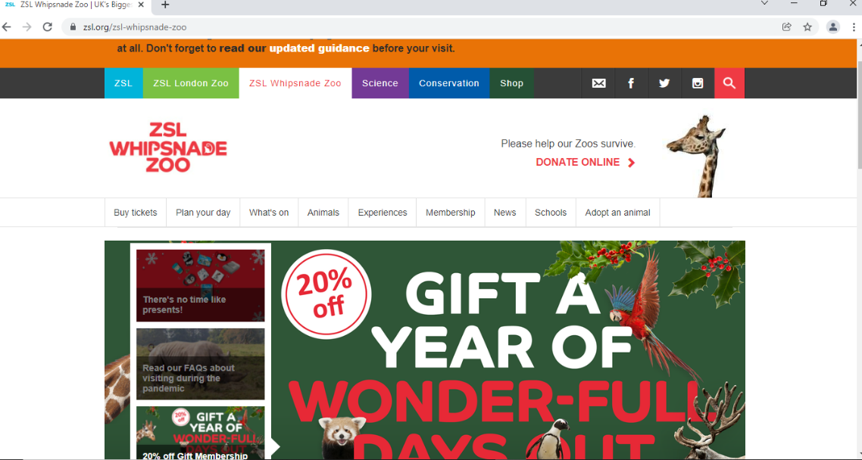



This is the website for Whipsnade zoo which mainly focuses on giving out information about the zoo to the people who are visiting the system. When you first visit the website you are approached with a home page which has a slideshow of all the latest information.

| **Positive attributes** | **Negative attributes** |
| --- | --- |
| The homepage is spaced out clearly and easy to read and extract information. | The bar above the zoo’s logo is too colourful and may confuse the user as the colour schemes to not associated with the headings that they lead to. |
| Picture slides on the homepage give a glimpse of what is going on within the zoo such as events etc and is very informative to the potential customers and maybe some potential sponsorships. | The background of the whole website is white which is plain, if parents show their kids this website they are not drawn into it, however if it had some colour it would. |
| Social media links are right at the top when you visit the page, this can give the customers a quick and easy access on in hand information about the zoo and how it is now, this can be seen through Instagram or Facebook posts. | There are two navigation bars on the homepage this confuses the user on where it will direct them to. |
| Horizontal navigation bar makes it easier for the user to navigate around the website as it has its own subheadings on specific areas. |  |
| Allows the user to sign up for email updates this is useful as it interacts with the user, if you want to join you can add your email address and you will be notified once everything is set in place and you are kept posted through your email. |  |
| The website is up and running 24 hours and has no issues. |  |
| Customers can purchase their tickets efficiently online under the title ‘’buy tickets’’ on the navigation bar which is very useful for the users as it does not consume time on spending most of the time trying to search where to buy the tickets. |  |

**Colchester zoo**

**Image one**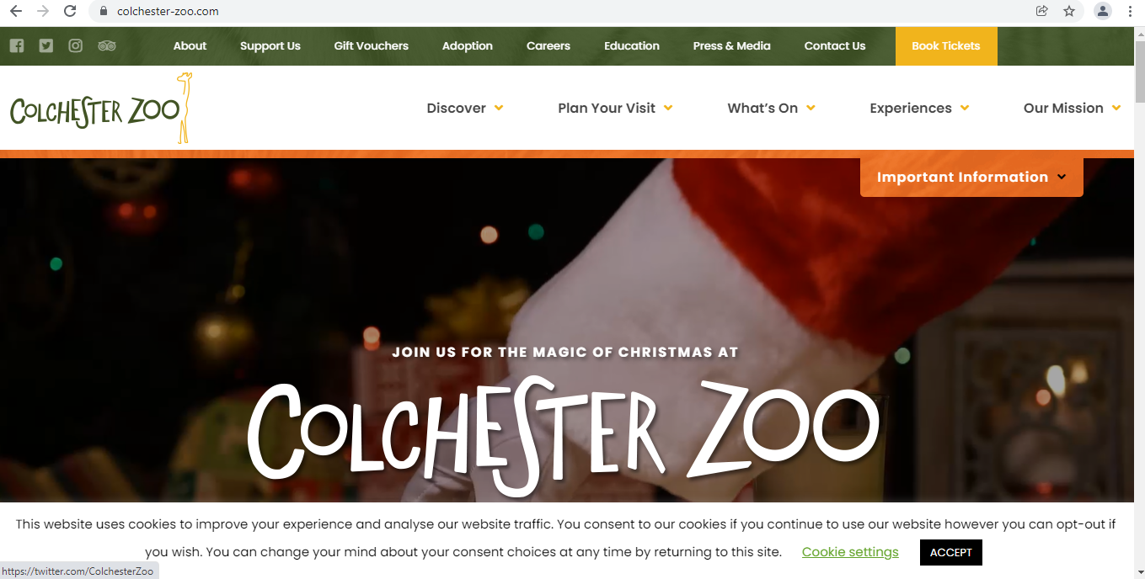



**Image two**  
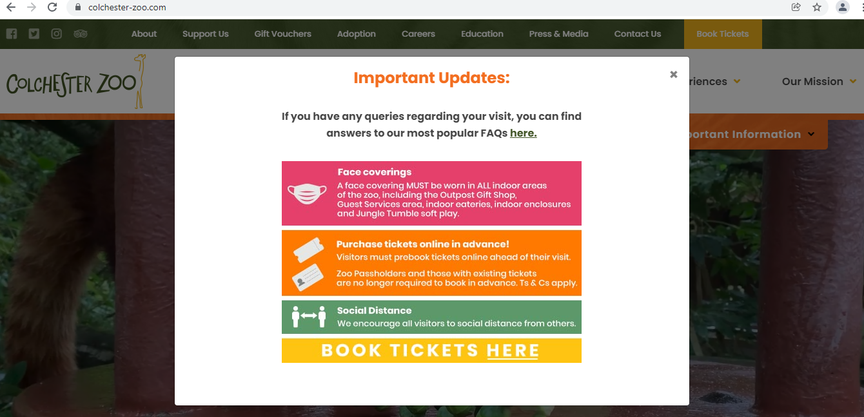

| **Positive attributes** | **Negative attributes** |
| --- | --- |
|  |  |
| Once you approach the website you are notified with an important update which states all the important information the user needs to take in before continuing. **(Image 2)** | Social media links that are on top of the main navigation bar are not as noticeable due to the colours used. |
| The important update includes FAQ’s which is attached to a hyperlink and takes you to the page with no problems as it loads straight away once clicked | There are a lot of buttons on the homepage which can be a bit daunting for the user as it is crowded and may confuse the user on what they have to click on the get information up |
| Video slideshow on the homepage this makes it engaging with the younger generation as it is visual |  |
| Drop down navigation bar makes the accessibility easier for the user |  |
| Zoo themed colour theme, this reflects a warm and friendly environment at the zoo |  |

**Chester zoo**

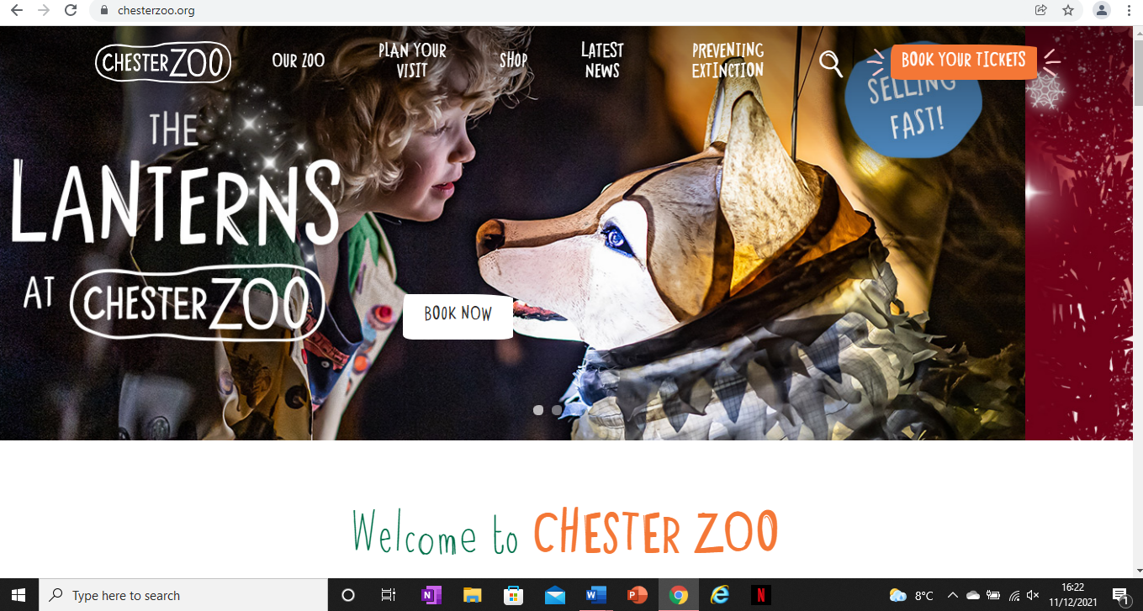



| **Positive attributes** | **Negative attributes** |
| --- | --- |
| Welcoming homepage, seen in the image above, this implies to the user that the zoo is friendly | The navigation bar is too close to the slides on the homepage which makes it overwhelming for the user as the font and colours are very similar |
| Colour and professional homepage unlike the other webpages, this makes more customers on board to come to the zoo due to the professionalism shown on the webpage | Pictures on the slideshow covers the circles the user chooses to navigate themselves onto the next picture on the homepage |
| colours that are on the website are seen as child friendly, this makes children more engaged and attracted to the page |  |
| The user can specially search for what they want by clicking on the magnifying glass right next to the drop down navigation bar |  |
| Once you go on the homepage you can take a quiz this is appealing for families to do together and attracts their target audience to come together |  |
| Book your tickets icon is colourful from the rest, this makes it quick and efficient for the user to book their tickets, also while you are at it you can sponsor an animal, this increases the zoo’s profit which we can use for the Claybrook zoo |  |
|  |  |

**ZSL London Zoo**

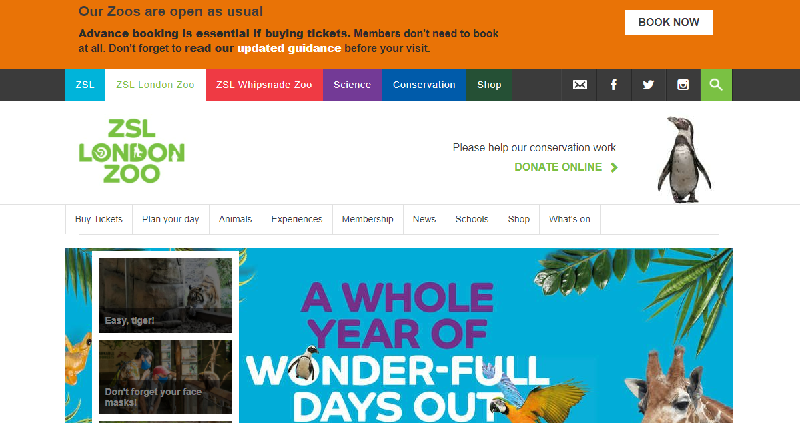



| **Positive attributes** | **Negative attributes** |
| --- | --- |
| Slide show on homepage lets the user take control such as going back and forth onto the slides | Navigation bars may confuse the user as there are two, it may lead them to not navigate affectively |
| Colourful navigation bar attracts younger target audience | Background colour of website is plain not as colourful as other competitor’s websites |
| Latest information about safety keeps customers safe and shows that customers are their priority | There is no login section for users to access and see their history purchases etc. |
| A map on how to get to the zoo for those who are travelling to get to the zoo |  |
| Zoo updates on website such as they announce new animals being born |  |
| FAQs answered and publicly displayed onto the website |  |

Furthermore, in order to gain an overview of the effectiveness of the different aspects on the comparable websites, the following table was developed.

The table below compares the effectiveness of the different aspects on competitor websites.

| **Feature** | **Whipsnade Zoo** | **Colchester Zoo** | **Chester Zoo** | **ZSL London Zoo** |
| --- | --- | --- | --- | --- |
| Usability | 4 | 4 | 5 | 4 |
| Layout | 4 | 4 | 5 | 3 |
| Speed | 4 | 4 | 4 | 4 |
| Navigation | 3 | 5 | 4 | 3 |
| Colour Scheme | 3 | 5 | 5 | 3 |
| Images | 3 | 3 | 5 | 4 |

**Key:** 1 = Not at all effective, 2 = Slightly effective, 3 = Moderately effective, 4 = Very effective, 5 = Extremely effective

## 2.1.3.1.3 Visitor Kiosk/Information Systems

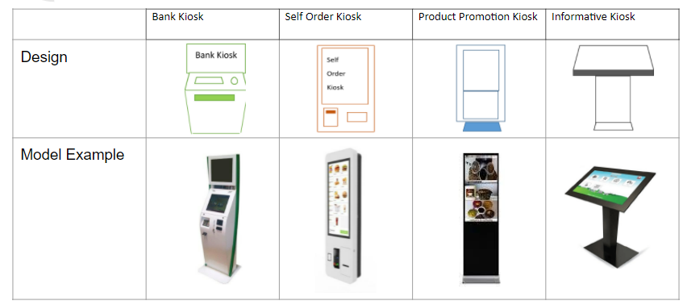

## 2.1.3.2 Development Relevant Legislation

The following section outlines the current laws which affect the current way data is handled at Claybrook Zoo. As a result, Synergy Solutions have come up with software products that abide by these laws.

**Data protection act 2018**

According to the GOV.uk website, the data protection act 2018 is the UK's implementation of the General Data Protection Regulation (GDPR). This controls how personal information is used by organisations, businesses, or the government. The data protection principles to follow are to make sure that the information is used

* fairly, transparently, and lawfully
* for the exact specified purpose
* in a way that is limited to what is necessary and relevant data

The data collected must be accurate and kept up to date and guaranteed the most appropriate security for the data including protection against unauthorised or unlawful processing, access, loss destruction or damage. There should also be stronger protection for sensitive information such as:

* Race
* Genetics
* Biometrics(which is fingerprints and face id)
* Health
* Sex orientation
* Ethnic background

There are separate legal requirements regarding criminal convictions and offences.

The customers have the right to:

* be informed regarding how their data is used
* have access to their personal data
* have access to correct any incorrect data
* have any data erased
* terminate/ restrict the processing of their data
* get and reuse their data for different services
* in certain circumstances to object to how their data is processed

**GDPR**

According to the guide-to-the-general-data-protection-regulation by the ICO (Information Commissioner's Office) "the GDPR applies to processing carried out by organisations within the EU and goods/services outside the EU". Therefore, due to Brexit Claybrook Zoo does not apply to the GDPR currently but decisions are still being made in the government so they may decide that the GDPR still applies. If so Claybrook Zoo can use the Synergy Solutions services again by contacting Kenneth Da Cruz. However, the key thing to note is the GDPR definition of personal data. This definition is a baseline of what Synergy Solutions will be considered personal data as if the Government decides to continue to follow the GDPR it is in the company's interest to know the defining factors of the definition of personal data. According to the ICO's guide to data protection, the meaning of personal data is "any information relating to an identifiable person who can be directly or indirectly identified in particular by reference to an identifier". Personal identifiers can be:

* A name
* Identification number (such as passport number)
* location data
* online identifier
* the way Claybrook Zoo or any other organisation collects information about people

This also applies to automated and manual filing systems.

**Child protective law GDPR**

Children have the same protective rights as adults over their own personal data even if they are unaware of that fact. This includes the right to:

* be provided with information that explains the process in which their data is being used and this must be clear and explicit (meaning you cannot imply any information)
* have any incorrect data corrected and incomplete data completed
* have their personal data erased if they wish

Even if a child does not know their own rights it is still their rights, not their parents or guardians however the legal age of contractual consent in England is 13 meaning and child 12 and below must have parents/guardians’ consent.

According to the NSPCC, the definition of a child in England is anyone who has not yet reached the age of 18 including children who are 16 and are:

* living independently
* in further education
* a member of the armed forces
* in hospital
* in custody

Therefore, even though the age of consent is 13, the customer should be considered a child until 18 for any relevant situations.

**Equality Act 2010**

According to the GOV.uk website "the Equality Act 2010 legally protects people from discrimination in the workplace and in our society"

There are different types of discrimination which are also known as protected characteristics. These include:

* a person's age
* a person's gender reassignment
* if a person is pregnant or on maternity leave
* if a person has a disability
* a person's sex or sexual orientation
* a person's religion or beliefs
* if a person is married or in a civil partnership
* race including their skin colour, ethnicity, nationality or national origin

The products that Synergy Solutions have created comply with all of these laws that have been stated above and remove any prejudice or discrimination that a customer may face, while also securely protecting the customer's data/ personal information. However, if Claybrook Zoo was to expand into other countries or even back into the EU there will be new laws to follow therefore they should contact Synergy Solutions through Kenneth Da Cruz and consult with the company on how to expand.

## 2.1.3.3 Visitor Questionnaire (Optional)

**Visitor Questionnaire**

Thank you for taking your valuable time to complete this online questionnaire designed to find out what you(an existing Claybrook Zoo visitor) feel about the current zoo visiting experience and also what you would like to see improved in the future.

Please be absolutely honest about your opinion on the following questions.

**Note:** Please keep in mind that any information that you provide in this questionnaire will be restricted to members of my team only. Your answers will remain confidential & your identity anonymous.

| **Questions** | **Strongly agree** | **Agree** | **Disagree** | **Strongly disagree** |
| --- | --- | --- | --- | --- |
| **About You** |  |  |  |  |
| I heard about the Claybrook zoo from your leaflet/advertisement |  |  |  |  |
| I heard about the Claybrook zoo from my family/friend |  |  |  |  |
| I visit the Claybrook zoo often |  |  |  |  |
| **About your visiting experience** |  |  |  |  |
| The staff members were really  approachable, friendly and helpful |  |  |  |  |
| I know about your current sponsors |  |  |  |  |
| The staff are very knowledgeable |  |  |  |  |
| I enjoyed my time at Claybrook zoo |  |  |  |  |
| My overall experience in buying the tickets at the ticket office was positive |  |  |  |  |
| The Claybrook has met my expectations as a visitor |  |  |  |  |
| **Future** |  |  |  |  |
| I would prefer to purchase the tickets on a website in advance rather than at the ticket office |  |  |  |  |
| I would consider sponsoring an animal |  |  |  |  |
| The zoo is an fascinating place |  |  |  |  |
| I would be interested to purchase merchandise from the gift shop |  |  |  |  |
| The overall visiting experience at Claybrook zoo is very positive |  |  |  |  |
| I would recommend Claybrook zoo to my family and friends |  |  |  |  |
| Are there any other improvements or changes that you want to see in the future? |  | | | |
| Before you submit the questionnaire, please let us know how you would rate the questionnaire overall?  ☆☆☆☆☆  Please provide any additional feedback: | | | | |
|  | | | | |

Thank you for completing the questionnaire. We genuinely appreciate your views on the questions and will use your comments to improve the visiting experience of our zoo.

We hope you have enjoyed completing this questionnaire.

This questionnaire was distributed to 100 current visitors of the Claybrook zoo on the 7th of December 2021. The questionnaire was sent to the visitors via email, requesting them to complete the questionnaire.

Following is an example of the email sent to a visitor. The same email format was used when sending the questionnaire to all the visitors.

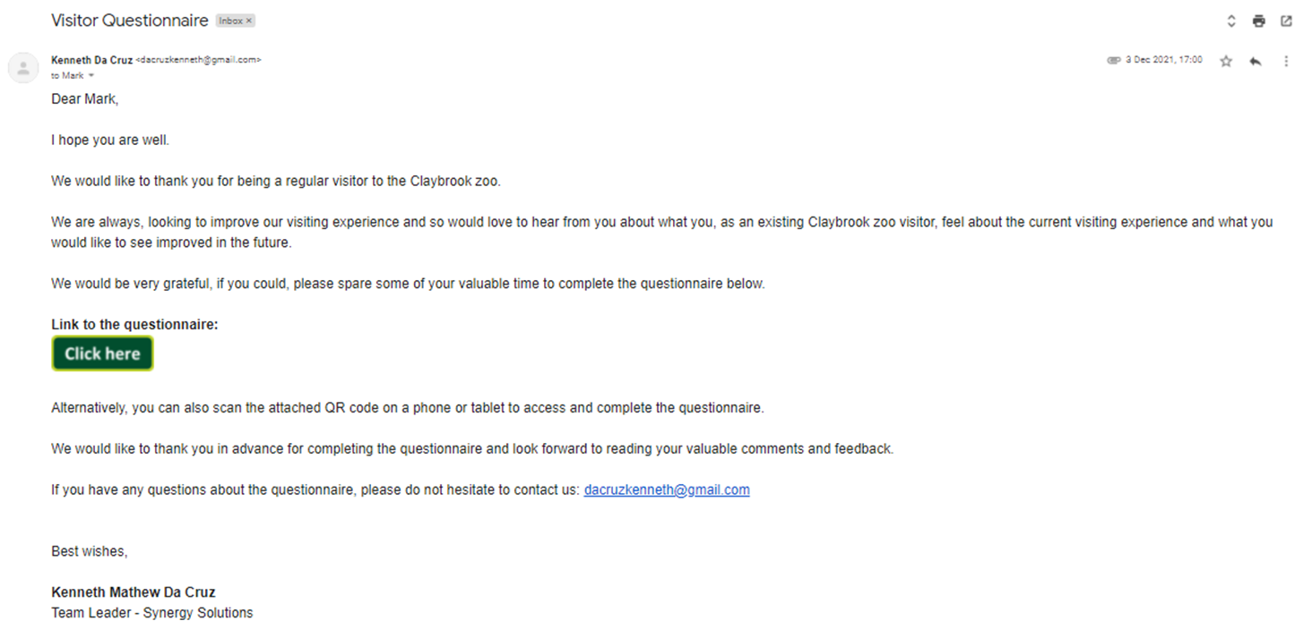

## 2.1.3.4 Visitor Questionnaire Results Analysis

In this section, we will discuss the results obtained from the questionnaire and analyse responses to each of the questions in detail, using pie charts.

The questionnaire was distributed to 100 current visitors of the Claybrook zoo on the 7th of December 2021.

The following results were obtained:

| **Questions** | **Strongly agree** | **Agree** | **Disagree** | **Strongly disagree** |
| --- | --- | --- | --- | --- |
| **About You** |  |  |  |  |
| I heard about the Claybrook zoo from your leaflet/advertisement | **25%** | **25%** | **50%** |  |
| I heard about the Claybrook zoo from my family/friend | **30%** | **20%** | **50%** |  |
| I visit the Claybrook zoo often | **30%** | **20%** | **20%** | **30%** |
| **About your visiting experience** |  |  |  |  |
| The staff members were really  approachable, friendly and helpful | **90%** | **10%** |  |  |
| I an aware about the current sponsorship scheme for animals at the zoo. | **25%** | **25%** |  | **50%** |
| The staff are very knowledgeable | **85%** | **10%** | **5%** |  |
| I enjoyed my time at Claybrook zoo | **95%** | **5%** |  |  |
| My overall experience in buying the tickets at the ticket office was positive | **10%** | **20%** | **70%** |  |
| The Claybrook has met my expectations as a visitor | **85%** | **10%** | **5%** |  |
| **Future** |  |  |  |  |
| I would prefer to purchase the tickets on a website in advance rather than at the ticket office | **100%** |  |  |  |
| I would consider sponsoring an animal | **30%** | **20%** | **20%** | **30%** |
| The zoo is an fascinating place | **85%** | **10%** | **5%** |  |
| I would be interested to purchase merchandise from the gift shop | **85%** | **15%** |  |  |
| The overall visiting experience at Claybrook zoo is very positive | **90%** | **10%** |  |  |
| I would recommend Claybrook zoo to my family and friends | **100%** |  |  |  |
| Are there any other improvements or changes that you want to see in the future? | **Updated signage and use of technology and interactive exhibits to make the visitor my exciting for my children (x10)** | | | |
| Before you submit the questionnaire, please let us know how you would rate the questionnaire overall?  ☆☆☆☆☆ – 4.5 average review  Please provide any additional feedback: | | | | |

Below we have illustrated the results obtained from the questionnaire using pie charts in a table format, and analysed results for each question in detail. The following gathered data will be incorporated into the development of new systems.

| **Questions** | **Graph** | **Analysis** |
| --- | --- | --- |
| I heard about the Claybrook zoo from your leaflet/advertisement |  | As, you can see, from the pie chart, it clearly shows that there is lack of outreach for the zoo. The implementation of the zoo website will resolve this issue. It will allow the zoo to advertise the key events taking place at the zoo and also use other social media platforms, to advertise key events and other promotions such as discount on tickets, to the wider members of the public. |
| I heard about the Claybrook zoo from my family/friend |  | The pie chart clearly shows that fifty percent of the people heard about the zoo from a family or friend. From this we can infer that the current zoo visitor experience is positive, as the visitors are informing their loved ones about their experience, therefore encouraging them to visit the zoo. Furthermore, this means that the zoo is gaining publicity due to the attractions that it has to offer. However, due to the fact of the lack of technology implemented it means that the zoo cannot advertise to the wider members of the public, through website for example, therefore limiting outreach. |
| I visit the Claybrook zoo often |  | This pie chart shows that the fifty percent of the visitors don’t visit the Claybrook Zoo often. This could be due to the long queues at the ticket’s office and due to the lack of advertisements of the events that are taking place at the zoo. |
| The staff members were really approachable, friendly and helpful |  | This pie chart clearly shows that hundred percent of visitors agree that the staff members at the Claybrook Zoo are friendly and helpful, which is a big positive, as it attracts more visitors, as the visitors feel valued and welcomed. This pie chart/illustration could be potentially displayed on the website, as an advertising point, to show that the Claybrook zoo, as a matter of fact, value its members. This will result in attracting new visitors to the zoo. |
| I am aware about the current sponsorship scheme for animals at the zoo. |  | This pie chart shows that the fifty percent of current visitors of the zoo, are not aware of the current sponsorship scheme for animals at the zoo. This is potentially because this information cannot be accessed electronically online and the information regarding the sponsorship and the benefits it offers is not available to the general members of the public.  To resolve this issue, we will develop a website, which will include a sponsorship page, where we will include all the information about the sponsorship scheme that will be able to all members of the public. |
| The staff are very knowledgeable |  | The pie chart clearly shows that 95 percent of visitors agree that the members of staff at Claybrook zoo are very knowledgeable. This is exceptional because it emphasises the fact that the zoo is actively providing educational content and resources for the members of the public, in order to significantly enhance their visiting experience. |
| I enjoyed my time at Claybrook zoo |  | This pie chart shows that hundred percent of visitors agree that they enjoyed their time at the Claybrook Zoo. This is great, as it emphasises the fact that the current visitors really enjoy their time at Claybrook Zoo, which is a tremendous positive for the zoo. |
| My overall experience in buying the tickets at the ticket office was positive |  | The pie chart clearly shows that seventy percent of people disagree that the overall experience in buying the tickets at the ticket’s office was positive. This is because of the long queues, that frustrate the visitor.  To resolve this issue, the website developed, will include a section where the visitor will be able to view and buy tickets online very easily.  This will solve the issues about the long queues at the ticket’s office of the zoo. This will also improve the overall visiting experience of the visitors of the zoo. |
| The Claybrook has met my expectations as a visitor |  | This pie chart shows that ninety five percent of the visitors agree that the Claybrook zoo has met their expectations as a visitor. This emphasises the fact that the zoo meets the expectations of the visitor. However, five percent of the visitors could be affected by the long queues at the tickets office, which affect their overall visiting experience. |
| I would prefer to purchase the tickets on a website in advance rather than at the ticket office |  | The pie chart shows that hundred percent of the people strongly agree that they would prefer to purchase the tickets on a website in advance rather than at the ticket office. This is significant as it means that the website developed will have a section where the customers will be able to purchase tickets online, avoiding the long queues at the tickets office. This will improve the overall experience of the visitor. |
| I would consider sponsoring an animal |  | This pie chart shows that fifty percent of visitors would not consider sponsoring an animal. This means that the zoo needs to consider other alternative solutions to encourage the visitors to get involved in the zoo. |
| The zoo is an fascinating place |  | The pie chart shows that ninety five percent of the visitors agree that the zoo is an extremely interesting place to be. This is really encouraging as it means that the current visitors agree that the zoo is a very interesting place to be. |
| I would be interested to purchase merchandise from the gift shop |  | This pie chart shows that hundred percent of visitors agree that they would be interested to purchase merchandise from the gift shop. This is great, as it means that the zoo, can get additional revenue from this shop. |
| The overall visiting experience at Claybrook zoo is very positive |  | The pie chart shows that hundred percent of visitors agree that the overall visiting experience at Claybrook zoo is very positive. This is encouraging, as it emphasises that the visitors agree, that their visiting experience is positive. |
| I would recommend Claybrook zoo to my family and friends |  | Finally, this pie chart shows that hundred percent of the visitors would recommend Claybrook zoo to their family and friends, which is a major positive. We can infer that they had a positive experience at the zoo, the last time they visited it, which is why they were able to recommend it to their family and friends. |

The results overall are key, in terms of understanding the current visitor’s and attitudes towards the zoo. They provide information on the current visiting experience and the experience of the zoo as a whole. We can use this data collected, to build software systems, that will help enhance the visitor’s experience at the zoo.

## 2.2 Requirements Specification

Now that we have gained an in-depth understanding of the problem domain, in this section, we will develop the requirements specification documentation for this project. This will include an in-depth explanation of the existing business operations, using flowcharts, to effectively outline the flow of information in the company. Furthermore, we will also outline a brief summary of the existing business limitations.

## 2.2.1 Problem Domain Description

One of the main problems that Claybrook Zoo currently faces are the loss of staff, animal, and visitor- data stored in the zoo since the current system is paper-based. The paper-based system is a major limitation to the zoo’s business as it prevents the proper representation of the zoo’s data and prohibits the zoo from analysing the data to further improve the business. Another factor to the problems within Claybrook Zoo is the lack of technology. The earth is currently in a digital age and because of the lack of technology within the zoo, Claybrook Zoo is not fully taking advantage of the benefits technology provides which in turn creates a decrease in potential visitors. Furthermore, due to the lack of technology within Claybrook Zoo, the amount of funds expended for hard labour is substantially higher than what it should be if they had the technology. For example, Claybrook Zoo has to manually change the signage within the zoo instead of using technology that could change it in an instant. Another issue that Claybrook Zoo has is its lack of outreach due to its lack of technology, potential customers are unaware of Claybrook Zoo’s existence because Claybrook Zoo has not reached them technologically; however, Synergy Solutions has created solutions that will help combat this problem and help the company boost profits and sales.

## 2.2.1.1 Existing Business Operation

The current business operations are operating at an incredibly slow rate that is causing customers to turn away from the zoo. 70% of the current visitors do not like the current operations as seen in the questionnaire in (reference questionnaire). Fundamental operations within the business are the animal cycle, sponsorship cycle and membership cycle. The membership cycle below (reference member flowchart) shows the basic process of one of the key operations. The other key operations within the business- the animal cycle and the sponsorship cycle- show the process of the paper-based system in more detail. From this Synergy Solution noticed that the longest stage of the process is getting the file from the paper-based system and updating it. By cutting down the wait time between requesting a file and changing any details, Synergy Solutions’ proposed solution will increase the operations within Claybrook Zoo and will in turn create an increase in the effectiveness within the zoo.

## 2.2.1.1.1 Animal Life-Cycle

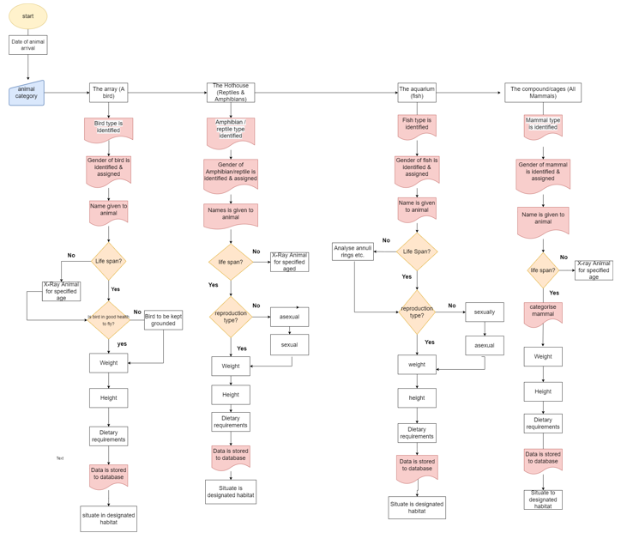

This shows the lifecycle of when an animal has been added to the zoo along with their species identification, name given to them, their current health with their reproduction type and specifications such as height weight which will go in accordance with their feeding variety. This is information supplied via interviews from the key stakeholders at the zoo which is looking to be viewed from the perspective of a computer making the process much simpler and efficient for those who are partaking within the process of the animal life cycle.

## 2.2.1.1.2 Sponsorship Life-Cycle

The sponsorship process is basically a yearlong sponsorship agreement, sponsorship runs from the 1st of January to the 31st of December each year for the full calendar year on the 1st of January. - The first thing that happens is that the sponsors are invited to the sponsors event to celebrate the new year of sponsorship, this takes place at the zoo the clients can bring their families. The named person, who is the business owner, is invited. They can pass their tickets onto somebody else but they normally say how many tickets would you like for your family. People have been known to take advantage of this benefit and ask for ridiculous number of tickets, but the zoo would normally tell a business that they would be entitled up to around 10 tickets,and ask them, in advance before turning up on the day, if they can arrive, the zoo will do a little bit of a party atmosphere with few drinks and sandwiches, the usual sort of corporate events style and they can see their signage. So as you know at the moment in the current business all animals have a specified signage which is printed out in advance of the first of the year and then the new signage for new sponsors is reportedly or if the sponsor hasn't changed their signage the zoo will keep it from year to year to avoid the cost of people what's the signage is open running sponsorship sponsor initial events the next key date in the business process is the 1st of August where the renewal process starts. Jonathan goes to the filing cabinets were all of the sponsorship agreements, ask her and go through he will pull out the sponsorship he will send the renewal form to the client which basically says do you want to renew or not and the period of the 1st of August to the 15th of September is where all of the renewal data needs to be captured same. In that period, there is a number of weeks where the client is initially contacted and they are given two weeks to buy stop text around about 14th. If there's no reply the zoo administration office sends a reminder letter the week after, the 24st of August no reminder also no response by that then the zoo administration office sends send a letter saying that they assume that the master contact source, within the next period by the 15th of September to renew that, does not wish to do. So in the business model, By the 15th, the zoo administration office would definitely have a list of those that will be renewing and those that are no longer continuing because they correctly told us they don't continue or they haven't provided us with the relevant documents from the 16th of September to 15th of October. We then start the recruitment for sponsors, so there are advertisements in the zoo and they use the local press to say the following animal need a sponsor and on the 1st of October we run a event called Sponsor Ball, where the zoo tells anybody who's interested to come along and type on, and hopefully encourages people to sponsor the outstanding animals. At present the zoo has actually sponsored around 700 animals or animal groups that are all sponsorship, and that of those seven hundred, only around 5% are not sponsored, so hopefully with the improvements of the information on the sponsorship scheme available online the sponsors all those who agreed to sign up will be given the documentation and explain how to pay and then the final deadline for those who haven’t already 30th November the worst came to the worst if somebody had said that they were going to pay and become a sponsor but hadn’t by the 30th November then we wouldn't have a sponsor that anymore but yeah cause from the 1st of December we have to design the new signage and has to be sent off by the 15th  and the reason why it has to be sent off on the 15th of December is it takes approximately 2 weeks to get it produced shipped back to the zoo so it's actually ready on the 1st of January so there are some strict deadlines with reminders that we provide but that is the deadlines and the key points within the sponsorship scheme and obviously all the paperwork gets filed with each of our sponsors response the paperwork for the animals is alphabetically and based on the sponsors name and those are stored in relevant filing cabinets and if a sponsor no longer continues with us then we keep the sponsor records in our dormant filing cabinet which basically no longer sponsors and we keep that for two years after the sponsorship agreement has ended and after two years we will destroy both paper records for the ones that sponsors but that no longer sponsors with the zoo so that is the sort of deadlines.

“We've got some buildings in the zoo, specifically for storage, our filing system, so if we were able to convert these to an electronic format that would have a massive impact on the efficiency of the business. You know, if a customer rang in and said, can you tell me, when my sponsorship scheme is ending, I need to arrange payment, at the moment we are going down to the files and we are getting the information. If it was an electronic screen and our administrators could say, yeah, no problem, give me your details and get the information immediately, that would increase the efficiency of the business. ” - **Mathew Jones**

“ Yeah, it's very very outdated, because as previously on the form, everything is stored in a paper file format and you will also see there's a sponsorship form as well, but it's exactly the same structure. We've got the forms, we write in the details and having all our paperwork like this is rubbish to be absolutely honest. I mean, it leads to lots of problems, we could lose case papers, when we get them out, to update them, they get filed incorrectly, we’re using a massive storage area at the moment for all the animals and sponsorship records and visitor records. So, the actual physical space that we are using is crazy. - So there's lots and lots of potential limitations with paper at the moment, that we want you to solve..” – **Mathew Jones**

## 2.2.1.2 Summary of existing business limitations

## In this section we have carried out analysis on the information collected in the interviews with the clients, in order to briefly identify the problems or issues with the current system that require effective resolutions.

The table below outlines the problems that were identified within the current system.

| **Existing business limitations** | * Requires a large physical space in the zoo buildings to store the paper-based files/documentation. * Possible loss of the paper-based files. * Time consuming to input and extract data. * Lack of technology implemented- less outreach. * Data stored prone to damage & weak security * Less attraction due to the lack of publicity. * High costs & environmentally damaging |
| --- | --- |

Table 2.2.2.1 Identified limitations in current business model

The paper documents can take up a considerably large amount of space with the quantity of it increasing day by day. With this being said, it would have to be stored close to hand so that it can be easily accessed, which again it’s an issue in regard to space within the business that could be used for better instances.

Additionally, to retrieve documents upon request takes a while as the documents have to be collected from filing cabinets. To edit the documents, it will take long and more time you’d have to write the whole thing again which means it’d have to be repeated every single time you want to make corrections

Paper records systems are very prone to being misplaced, lost and even as well as being stolen. This can cause high security and data protection issues with data being mishandled or in the hands of the wrong people with no permission. It can also be damaged in the sense where if there were to be an incident such as a fire or if water were to be exposed to the cabinets, the whole paper system would be ruined and there would be no way of retrieving these documents as there are generally no back-ups. Additionally speaking, ink tends to wear out over time and paper gets old, therefore some information can also be interpreted wrongly or erased full stop.

The lack of technology within the system means poor or little to no communication between staff, customers and partners. Due to lack of technology and no social platforms available this means less outreach for more customers or sponsors, which in turn doesn’t help with the increase of revenue and exposure for the company.

It is not aesthetically pleasing in news age as most establishments require a social media face to boost its publicity

Lots of costs involved for tones of papers, printers, inks, stationary, photocopier office supplies etc.

It is environmentally damaging in the sense that using more paper is bad for the environment and it won’t help much to boost the company’s green credentials. As in today’s day and age many of today’s employees, customers or even partners want to work for businesses that provide sustainability.

## 2.2.2 Functional Requirements

## In this section, we will detail the functional requirements for the software suite of products: RMS, website and visitor information technologies that will be developed. It will detail what the new software systems will do in order to effectively solve the problems that were highlighted by the key stakeholders.

## 2.2.2.1 Records Management System

In the following section of the report the aim is to outline and explain the functional requirements so what the system will do what it will contain and how it shall work for the Record management system.

The software features needed within the solution system.

Below is a list of the Software requirements collected from both the interview and the given brief. The functional requirements are laid out clearly below.

* The New system cannot be paper based and must be digital.
* The system should automatically send newsletters, marketing, and emails to customers.
* The codes given to classify the documents should be implemented on the new system.
* There needs to be an internal animal code given to each animal.
* The system should have a login for staff so it's secure and only seniors or top-level administrators should be able to have access to everything and others should be restricted to what they can access.
* Files should easily be able to be shared easily and efficiently through the internet.
* Senior Administrators Need to be able to have full access rights so they need to be able to add, Edit, Delete, Archive all documents.
* Staff need to have Partial access to the Record Management System (RMS). So, they need to be able to edit some files as well as add files.
* Staff should Be able to filter, Search for animals and records based on specific categories.
* There needs to be security measures to protect the data in the RMS.
* All systems will need to be catered for all age groups and types of people.
* The HR system must not be converted.
* Training will need to be offered for the new system, so the staff knows what they're doing.
* Add instructions and a help page in the system to help staff.
* All paper documents need to be easily transferred to a computer system.
* The information and details about the animals such as what they like to eat, habitat etc need to also be stored on the RMS.
* The RMS should have customer emails on where the system will send newsletters/advertisements to the customers.
* Sponsors' data needs to be stored on the RMS in addition they need to be easily accessible.
* There needs to be a progress bar to show you how long you’ll have to wait for uploads.
* All documents should be stored in alphabetical order with the surname as the primary name used.
* The signage needs to be updated yearly so it should be easy to update.
* There needs to be an option on the rms to remove/archive documents as well as permanently deleted.
* The rms needs to hold all the details about the customer such as personal and sensitive data such as contact details and bank details.
* The RMS should have the option to filter sponsors by how long they have left on their sponsor and when they need to renew it.
* The designs for the new signage need to be able to be stored on the RMS and updated through there.
* Updating the documents and sharing need to be an option.
* A form which can be filled out electronically needs to be available so paper documents will not need to be used every time a sponsor wants to sponsor.
* Documents that are more than 2 years old should automatically be destroyed and removed.
* There should be backups of the documents to avoid data loss.
* records management system to send out all the reminders automatically and let him know when renewals come through
* For documents such as the signage you should be able to store drafts, share and make dynamic changes.
* The RMS needs to give notifications when renewals for the sponsors have been made or if they need to be made.
* The RMS should record the income made from sponsorships
* The RMS should record the income made from Memberships.
* The RMS should have a search bar to search for animals, sponsors, and other documents.
* Every document should be given a number relating to their sector such as memberships should be given a membership ID number.
* For the RMS there should be security measures such as encryption, passwords, logins, and security protocols to protect the data.
* The RMS should give a notification if someone is trying to attack the system.
* The RMS needs to comply with the GDPR/FCA.
* Staff need to have training on how to use the RMS.
* There should be a help page.
* Every time a customer becomes a member or books a ticket their information needs to be automatically added to the RMS.
* If a sponsor should be able to becomes a sponsor via a website or other methods. If they become a sponsor through the website their data should automatically be added to the RMS.
* The RMS search criteria should be by  animal location, what animals are in a given location, animal name, animal code individual code
* The sponsors should fill out their own forms electronically primarily with the option of doing it by paper and these documents should be directly added once the customer fills out each of their required details.
* The system should have appropriate backups one option could be backing up on a Hard drive however a cloud service would be much better.

Accessibility table

Below is an access table to show who can access what parts of the Record management system.

| Operation | Senior Admin | Staff |
| --- | --- | --- |
| Add | Create and add new records | No access |
| Delete | Remove/delete records of errors in the RMS. | No Access |
| Archive | Remove records which are no longer needed in the archive section. | No access |
| Amend | Change/edit documents. | Able to edit and amend certain documents. i.e zookeepers can edit and change medical records for an animal. |
| Display | Display all records when a section or document is clicked. | Can display and view documents however the only documents that they need/have access to. i.e zookeepers cannot view customer details. |
| Search | Search for the records needed by typing in the search bar specific record details. | Documents can be searched for by specific information about the required document. i.e animal records can be searched by name or animal identification number. |

Attributes table.

Below are tables to show the attributes of some of the pages and what each page will contain .As some of the pages are very similar the attribute tables which are below are for the main pages. They highlight the entity so what needs to be entered what format the input should be in as well as an explanation on each entity.

Login page.

Below is the attribute table for the Login Page.

| **Entity name** | **Format Type** | **Notes** |
| --- | --- | --- |
| Username | Integer | A primary key given to staff. |
| Password | Encrypted String | A password for the staff to log in. |
| Forgotten Password | Button | Button to reset password. |

Animal records.

Below is an attribute table for the animal records. As well as the tables which follow are additional attributes which add on depending on the animal chosen.

| **Entity name** | **Format/type** | **Notes** |
| --- | --- | --- |
| Species_Name | String | The specific species name. |
| Animal “given” Name. | String | The name given to the animal for example the low back gorilla name is Redwill. |
| Animal_Code | Integer  Format (6 digits) | A specific animal code given to each animal. |
| D.O.B_Animal. | Integer  Format (6 digits) | The date of birth of the animal. |
| Gender | Boolean | What gender the animal is. |
| Average_Life_Span | Integer | The average life span of the animal which will be in years and months if appropriate. |
| Species_Category/Classification. | String | The specific classification/category of the species. |
| Dietary_Requirements. | String | The dietary habits of the animal. |
| Natural_Habitat_Description. | String | The natural habitat of the animal |
| Global_Population_Distribution. | Integer | The global distribution of the animal. |
| Date_animal_joined. | Integer | This is the date the animal joined the zoo. |
| Typical_animal_dimensions | Decimals | The typical dimensions of the animal which will consist of things like height,weight. |
| Picture of Animal | JPEG | The image of the animal |

Specific species Birds

| **Entity name** | **Format/Type** | **Notes** |
| --- | --- | --- |
| Nest_Construction_Method. | String | How the bird constructs the nest. |
| Clutch_size. | Decimal | The clutch size of the birdwhich will be measured in cm. |
| Wing_span. | Decimal | The wingspan of the bird in cm. |
| Ability_to_Fly | Boolean | Can the animal fly this will be a yes or no option. |
| Plumage_colour_variants. | String | The colour variants of the bird. |

Specific species fish

| **Entity name** | **Format/Type** | **Notes** |
| --- | --- | --- |
| Average_body_temperature. | Decimal | The average body temperature of the fish. |
| Water_type. | String | What water type the fish lives in eg salt water or clear water. |
| Colour_variants | String | What colour variants there are of the fish. |
| Gender | String | The gender of the fish if applicable. |

Reptiles’ amphibians

| **Entity name** | **Format/Type** | **Notes** |
| --- | --- | --- |
| Reproduction type. | String |  |
| Average Clutch Size. | Decimal |  |
| Average number of offspring. | Integer |  |

Mammals

| **Entity name** | **Format/Type** | **Notes** |
| --- | --- | --- |
| Gestational_Period. | Decimal | The Gestational period of the animal. |
| Mammal_Category | String | The mammal category the mammal belongs to. |
| Average_body_temperature. | Decimal | The average body temperature of the mammal. |

Sponsor Page

Below is the entity table for the sponsor page.

| **Entity name** | **Format/Type** | **Notes** |
| --- | --- | --- |
| Client/Company_Name | String | The client or company name of the sponsor. |
| Existing_Customer | Boolean | Is the sponsor a current customer at the zoo. |
| ID | Integer | The ID number to be given to the sponsor. |
| Primary_Telephone_Number | Integer | The primary phone number of the sponsor. |
| Secondary_Telephone_Number | Integer | The secondary/backup phone number of the sponsor. |
| Client_Address/Contact_Details | String | The client address and the contact details such as an email. |
| Animal(s)_sponsored | String | The animal/animals to be sponsored. |
| Animal_location | Integer | The location of the animal which will be sponsored. |
| Sponsorship_Band | Boolean | Which sponsor option the sponsor has chosen the sponsor bands are from A-E |
| Total_Price | Decimal | The total annual price the sponsor option costs. |
| Period_of_agreement | Integer | How long the sponsor will be sponsoring the animal for. |
| Special_Notes/Requests | String | Any additional notes or requests the sponsor wants from the Zoo. |
| Customer_Agreement | String | The customer agreement form that the sponsor reads and fills out. |
| Payment_Details | Integer | The payment details for the sponsor. |
| Payment_Received | Boolean | Was the payment received this is a yes or no option which is a drop-down box. |
| Sponsorship_Review_Date | Integer | The sponsor review date when the sponsor needs to review the sponsor. |
| Signed/Date | String | Date and signed by the sponsor. |

Membership Record.

Below is the entity table for a membership.

| **Entity name** | **Format/Type** | **Notes** |
| --- | --- | --- |
| First_name | String | The first name of the member. |
| Last_name | String | The last name of the member. |
| Membership_ID | String | The membership ID given for the member. |
| Company_name (optional) | String | The company name if there is one for the member. |
| Country / Region | String | The country/region that the member is lives in. |
| Street_address | String | The street address of the member. |
| Postcode | String | The postcode of the member. |
| Phone | Integer | The phone number of the member. |
| Email_address | String | The email address of the Member. |
| Date_Joined | Integer | The date the customer became a member. |
| Membership_Type | String | The type of membership. |
| Renewal_Date | Integer | The renewal date for the member. |
| Payment_Method | String | The payment method of the membor. |
| Picture | JPEG | A picture of the member to put on the Membership card. |

Software data input details/format and associated error messages.

Below are tables for some of the main pages which show how they work as well as what inputs are required and if the error messages which will be shown if an incorrect input is entered.

Login page

| Page | Records Management System – Login Page |
| --- | --- |
| Functionality Description | This page allows authorised personnel to login to the RMS.  Additionally This page allows:   1. A request password reset |
| Page Inputs | The page displays these input fields:   1. Username 2. Password   Once these fields are entered the user can <Log In> to login to the RMS.  Also the page Displays a <Reset Password> option. |
| Operation/Error Messages | The Login Page gives error messages Based on the credentials which are entered if they are wrong this also checks access. All login pages will be the same. After 3 attempts if the login details are entered incorrectly the login is blocked and a number to call is shown: -   | Username | Password | Message/Output/Action | | --- | --- | --- | | Correct | Correct | Successful access to main user dashboard –**Screen/Page: EN-RMS-02 – Home Page** | | Incorrect | Correct | Error message "Incorrect Log in - <Reset Password> to change password" | | Correct | Incorrect | Error message "Incorrect password  -  <Reset Password> to change Password" | | Incorrect | Incorrect | Error message "Unknown username and/or password - <Reset Password> for support" | | Incorrect x3 | Incorrect x3 | Error message ”Locked please call 0800221541 or Contact senior admin” - | |
| Confirmation/feedback Messages | The system provides a Confirmation to say Login has been successful.   “Welcome [Name]” |
| Additional Outputs | If the client selects <Reset Password> the system takes the user to the page **EX-RMS-07 – Reset Password Page** |

Animal Page

| Page | Records Management System – Animal Page |
| --- | --- |
| Functionality Description | This page shows all the animals.  Additionally, this page allows:   * Search for animal * Filter for animal * View animal * Add To animal * Remove * Edit animal * Return to home page * Change pages. |
| Page Inputs | The page displays these input fields:   * Animal details Such as name, ID etc..   Once these fields are entered the user can <Search Animal> to find a animal.  Also the page Displays  <Animal Records> To view all animals.. |
| Operation/Error Messages | If nothing is found due because credentials are entered a message will be shown “Nothing found”:-   | Search | Message/Output/Action | | --- | --- | | Correct | Successful search filters all the animal information and shows the animal searched – **Screen/Page; EN-RMS-04.01-Animal page** | |  |  | | Incorrect | Incorrect search “**Nothing found**”. | |
| Confirmation/feedback Messages | Once a animal is chosen user is taken to  **Screen/Page; EN-RMS-04.1-Animal page** |
| Additional Outputs | **n/a** |

Animal page 2 for specific animals:

| Page | Records Management System – Login Page |
| --- | --- |
| Functionality Description | This page allows authorised personnel to View specific animal records it will have all their details on.  Additionally, this page allows:   * Editing Animal Information * Editing signage * Save information * Remove files * Add new sections |
| Page Inputs | The page displays these input fields:   * Search * Species Name * Animal “given” Name. * Animal Code * Date of Birth of Animal. * Gender. * Average Life Span. * Species Category/Classification. * Dietary Requirements. * Natural Habitat Description. * Global Population Distribution. * Date animal joined the zoo. * Typical animal dimensions. * Picture of Animal * Gestational Period. * Mammal Category * Average body temperature.   If the user decided to search for a new animal the user types in the <search bar> and are taken to another page.  If any of these fields are entered the user can click <Save>  to save all the updates and changes. |
| Operation/Error Messages | The animal page will give error message “Invalid Input” if the incorrect format is typed or option is chosen.   | Format for entity | Message/Output/Action | | --- | --- | | Correct | Successful input no error updated. | | Incorrect | Error message "Incorrect Format should be numerical only - <Re enter> in numerical only " | |
| Confirmation/feedback Messages | The system provide a Confirmation to say that the File has been updated “Successfully saved”. |
| Additional Outputs | n/a |

Software processing logic.

In this section Flowcharts have been used to show how to view files and edit them and how to create and add new files ass the format is the same for every other page such as membership sponsor the examples below are just for the animal page however the format for the other pages are identical.

Add New document.

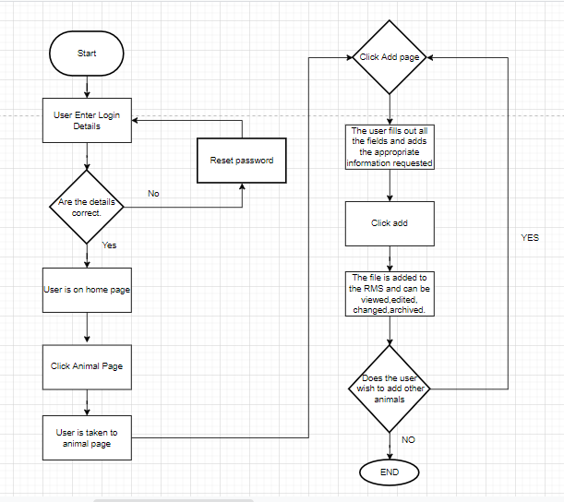

View files for the animal and edit/change.

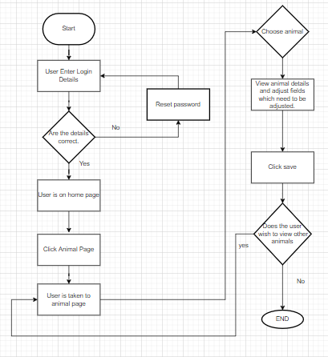

Customer tickets booking process.

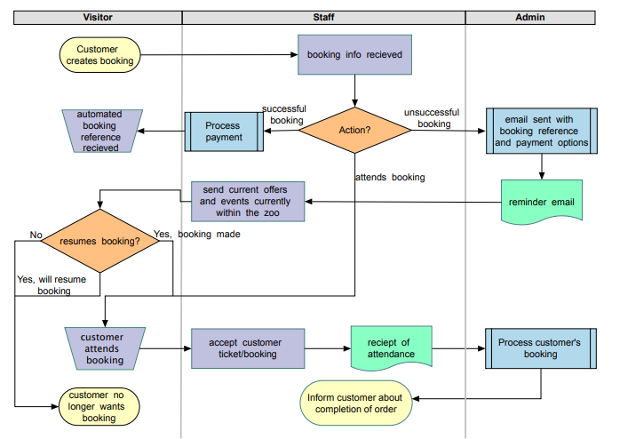

Emails

Below are emails examples of emails which will be sent to staff aswell as customers addressing certain issues.

Reset Password.

Below is an email sent to staff to Reset their password.

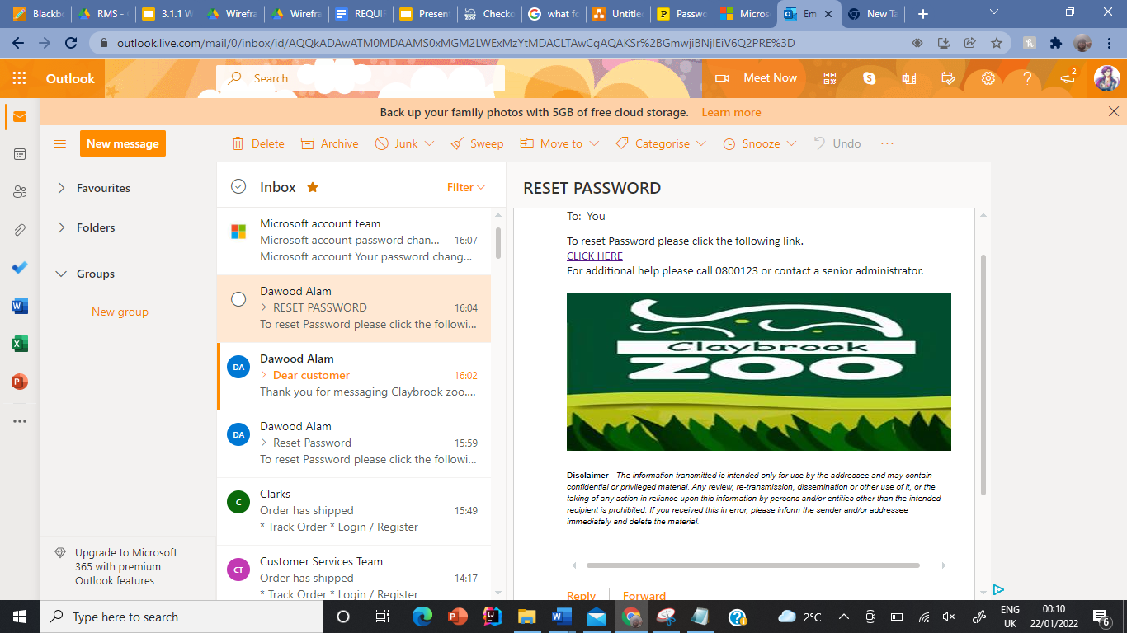

Customer question email.

Below is an email sent to a customer once they have filled out a contact us form on the website.

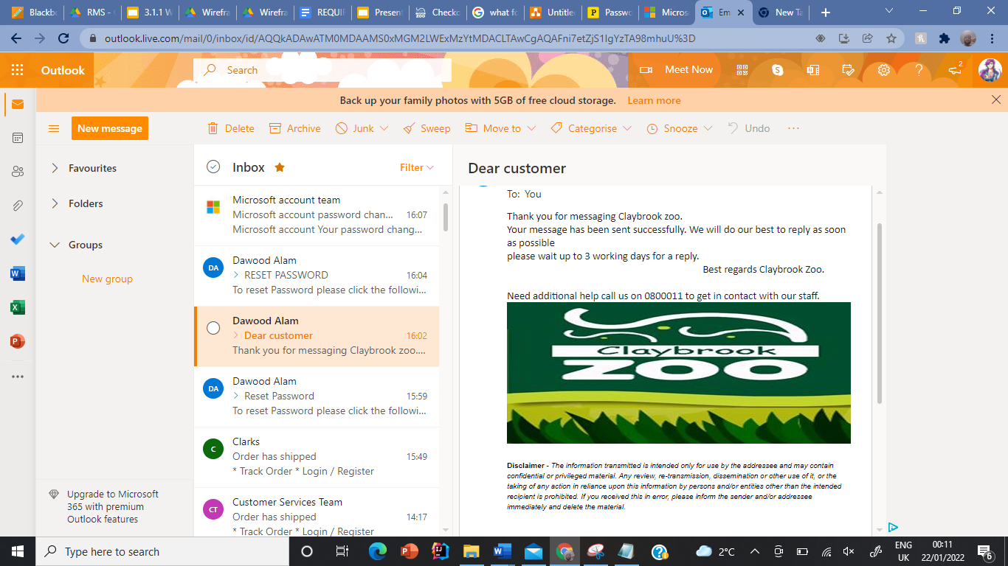

## 2.2.2.2 Zoo Website

There are various of functionalities the website of Claybrook Zoo entails. Firstly, the website needs to be accessible to everyone and easy to use for all age groups along with all the systems catered for all age groups and types of people. The website should also give a better outreach to the public, also as the main function of the website will be bringing more customers abroad, we will be placing social media links onto the website to attract more customers to the door, this will be by them seeing how great the service and experience is at the zoo leading them wanting to fulfil this exciting and fun experience within the zoo. Leading onto another functionality of the website is promoting events, the website will advertise the oncoming events that will occur on the website which will keep the public and customers updated on the events that will be taking place, the content will also be frequently updated on seasonal basis.

In addition, the website will have a drop-down approach which makes the user want to explore and makes it very interactive to the user, the website of course will be child friendly with the graphics and games as our main target audience is families. If an individual is interested into becoming a member of Claybrook Zoo, they can sign up to be a member on the membership sector of the website, this goes the same for those who want to become a sponsor for Claybrook Zoo, once they sign up, out of one of these or both options, they can sign in the Login page using their personal login details and have all the information stored into the database where they can access it anytime. If the user forgets their password or login details they can ask for a new one by clicking “forgotten password,” if the user inputs the wrong details for example an incorrect username but a correct password a correct password a message will appear on the screen saying ‘’Username not recognised please try again’’ and if they input the wrong details three times it will automatically lead them to the help page stating what they need to do next. If there are any errors formed onto the website an error message will be displayed onto the screen or it will go back to the previous page the user was on, this functionality is effective due to it not only informing the software but also the user that what they have clicked on or what they have inputted as led for this message to appear.

Furthermore, Customers will be able to purchase merchandise and tickets anytime of the day, the Claybrook Zoo’s website will in addition allow many amount of purchases to be made at the same time without it affecting the websites capability. With more than half of the purchases of merchandise and tickets to be bought off the website, the website will be able to provide monthly reports on the sales that Claybrook Zoo have received, not only it will provide statistics on the merchandise and tickets, it will provide specific figures on the memberships that have been purchased and how many the zoo has, along with the amount of sponsors they have and how many are willing to be a sponsor.

Accessibility table

Here is the accessibility table for the Claybrook website, it shows the numerous of functions the website will have and who has access to it. There are some functions that staff do not need but the members and visitors do.  It shows examples that the functions offer to the, members, visitors and staff.

| **Function** | **Members** | **Visitors** | **Staff** |
| --- | --- | --- | --- |
| Display | Show all the deals with tickets, products they have access to | Show all the information about the zoo, how to become a member and also show tickets along with merchandise | Login page |
| Set up | Additional account for more family members | Create a members account | N/A |
| Search | Search different types of memberships they can purchase | How to navigate around the zoo and how to get there, also search how to become a member or a sponsorship | Search their own personal data |
| Payment | Make purchase for products they want to purchase | Make purchases for products displayed onto the website, this can be done without having an account | N/A |

**Become a member and uploading your picture on the website flow chart.**

The flow diagram below is the process on how the user can become a member. It shows every single process that needs to be implemented and it also shows if the user inputs wrong details for example a non-valid email address it will take the user back to the page where the user needs to insert all their personal information, this also goes the same for adding the picture however if it is authenticated the picture is uploaded and a file record is generated.

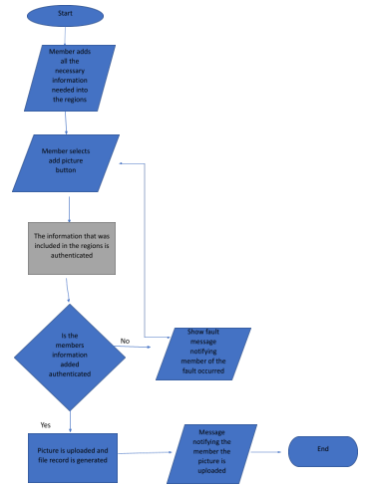

**The following is a newsletter signup confirmation email that the user will receive when they sign up to the newsletter on the website:**

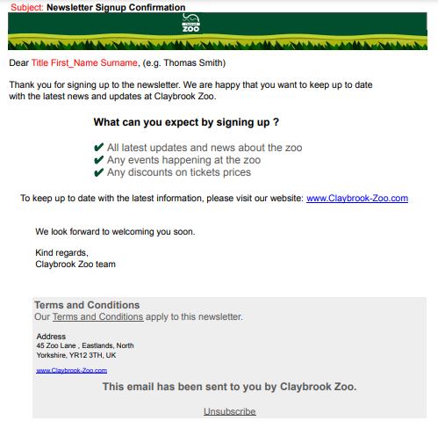

**The following is a Ticket confirmation email that the user will receive when they book the tickets on the website:**

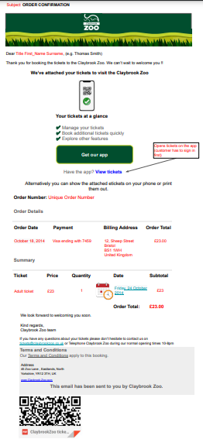

## 2.2.3.3 Visitor Kiosk Information System

## The purpose of the new kiosks system is to decrease the high level of queuing outside the zoo and to create better flow within the zoo. The new kiosk systems are created to be accessible to all customers including people who are not able-bodied. Key pages that Claybrook Zoo will be about to see on the new kiosk system are: the tickets page that will be a simple and easy way to purchase tickets (this will help decrease the ques to enter the zoo); the events page which will tell new customers what events are happening during the week (this list will be updated when a new event is happening in the week such as during holidays); the members page which will be a way for current members to get temporary passes if they lose their membership card( this is an alternative way to have the members prove that they are members if Claybrook Zoo are not able to invest in the mobile app) and the basket page. The basket page will be the page where visitors can see what they have purchased, and it is also the opportunity to ask customers if they want to become a sponsor. The kiosks will be colourful, bright, and family-friendly. This is to give a family orientated aesthetic for customers to see that the main focus of the zoo is a fun family day. The shopping kiosk also will have a page of all the items that customers can buy with a navigation diagram on the side for customers to easily navigate through the system. This will also be another way for the zoo to boost their sales and create another stable source of income in order to create more profit.

**Payment kiosk flowchart**

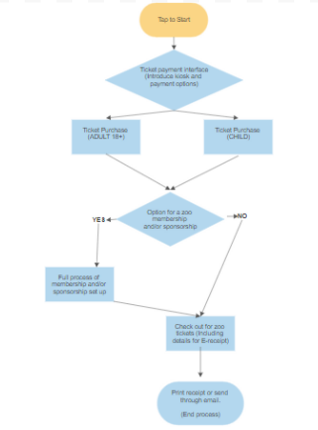

**Shopping kiosk flowchart**

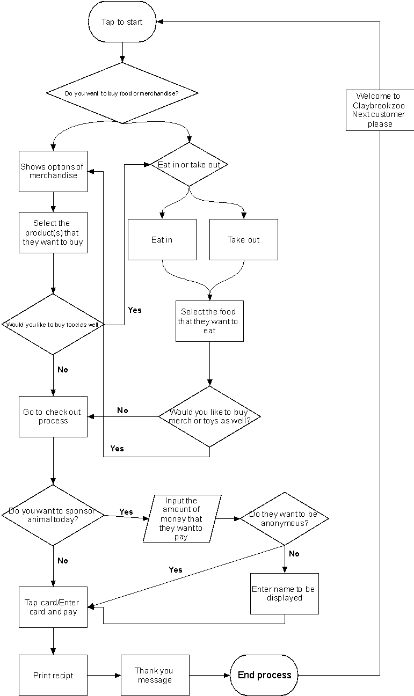

Mobile App

The purpose of the mobile app is to provide customers of the zoo access to zoo information easily and from anywhere. This app has many benefits for members but is aimed at all guests. One key page of the mobile app is the membership information page that allows the member to view the information that they have given to the zoo such as their phone number and email address as well as being able to change and correct information. The members page also allows members to see how long they have left in their membership and provides a quick and easy way to renew their membership including the feature of taking their own photos. Other key pages are the events page and the tickets page, like the kiosk those pages will allow people to book tickets (this is so that they can buy tickets for other family members that are visiting which will be helping the zoo’s family friendly appearance) and allow them to look at the key events that are happening in the Zoo. Furthermore, the customers will be able to pre-order merchandise like T-shirts, toys and much more, this will boost the Zoo’s sales and allow them to create another source of income. The app will also have a map of the zoo with GPS location so that new visitors could look at the app and find out how to go to the specific animal that they want to see this feature will also have a QRF card game to make it more appealing to teens as well. The QR card game idea that the Synergy solutions team has come up with is to make a collectable QR card that will have a 3D video of a zoo animal appear on the screen and the animal will pop up on the zoo. This collectable it will be a unique way of getting children involved in viewing and exploring the zoo. This is just one game idea that Synergy Solutions have but will hopefully be in talks with Mathew Jones about implementing other game ideas to have within the mobile app.

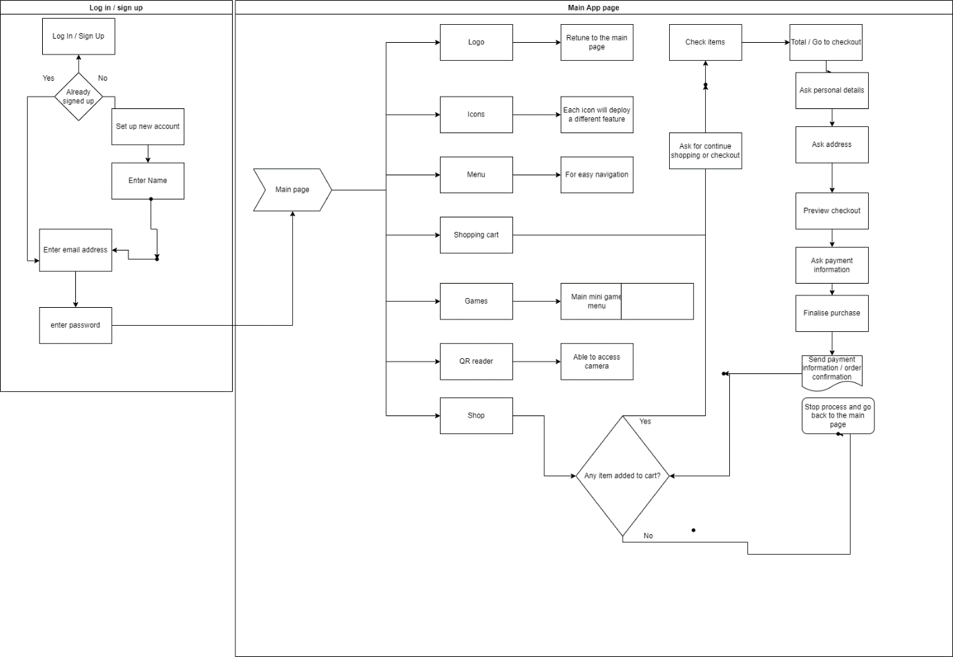

Accessibility table for all information

|  | Visitor Information | Animal Information | Sponsor Information | Kiosk Main frame | App information |
| --- | --- | --- | --- | --- | --- |
| Senior Admin | **Have access** | **Have access** | **Have access** | **Have access** | **Have access** |
| Admin | **Have access** | **Have access** | **Have access** | **No access** | **Have access** |
| Sponsor | **No access** | **Have access to their specific animal** | **Have access to their own information but no other sponsors information** | **No access** | **No access unless it is their specific account** |
| Visitor/Member | **Have access to their own information but no other visitor’s information** | **No access** | **No access** | **No access** | **No access unless it is their specific account** |

## 2.2.3 Performance Requirements (Records Management System)

## In this section, we will outline the performance requirements for each of the software systems that will be developed. We will address four performance requirements for the proposed system which includes speed, capacity, reliability, and usability.

## The following are the performance requirements for the Record Management System.

## 2.2.3.1 Speed

Throughput - A high throughput will provide us with an excellent starting point for testing to ensure that the database is well optimised. The database should be capable of processing 60 transactions per second and 120 records per second in batch mode.

Response Time - A DBMS should be able to locate any record in under half a second by searching through queries. This is the typical response time for several of the most popular search engines. This is due to the fact that anything above this will be seen by the user. One second is a small amount of time. However, it is slow in this context and will annoy the user, possibly driving them away from the system.

## 2.2.3.2 Capacity

Capacity requirements refer to the level of information or services that can be handled in the system. These are essential because they establish the way that the system can be utilised. If the capacity needs are not clearly defined, an underestimate may occur, and the users will find the system unusable. On the other hand, developers might provide too many resources, making the system expensive and resource intensive. For example: -

* The system would be able to support 50 simultaneous users.
* The system would be able to manage up to 20,000 employee records.”

## 2.2.3.3 Reliability

The RMS reliability is often defined by how the system will run without failures and malfunctions for a specific time period under particular conditions. It is often represented by a “portability percentage”. For example, if the system has a 75% reliability per month then there is a 75% chance the system will not experiences severe failures during this time period.

## 2.2.3.4 Usability

Usability is a non-functional requirement that describes the difficulty it is to use the product. There are 5 main categories of usability:- **Learnability.** How fast is it for users to complete the main actions once they see the interface?

* **Efficiency:** How users are able to do their tasks.
* **Memorability:**  Users can step away from the activity on the system, return after some time and continue efficiently.
* **Errors:** How often efforts occur and the amount of mistakes users make.
* **Satisfaction:** How good is the design to use.

## 2.2.4 Performance Requirements (Zoo Website)

Below, we have discussed the 4 essential performance requirements for the proposed part of the software system: website.

## 2.2.4.1 Speed

The website response time will need to be quick, maximum of 3 seconds. The website must load quickly, within three seconds.

The user must be able to open/access and switch between the sub-web pages on the website very quickly.

The user must be able to book tickets and pay for them very quickly, securely, and effectively.

The user must also be able to easily sign up to the newsletter very quickly and get a response, such as signup email confirmation instantly, informing them that they have signed up to receive the newsletter.

## 2.2.4.2 Capacity

The website must be able to handle at least a minimum of 2000 visitors at any one time. This is key especially during peak times, where the website must be able to handle at least two thousand visitors at the same time, without the entire website slowing down or crashing.

## 2.2.4.3 Reliability

The website must be reliable. The users must be able to carry out certain tasks, such as complete a membership signup form, without the website crashing. As discussed with the clients, there will be times where the website will be unavailable for the members of the public. The downtime of the website will be on Sunday nights going into early Monday morning, maybe 11am to 3pm, would be best, unless its peak time, for general maintenance and to make any necessary updates to the contents of the website, such as updating information about the key events coming up at the zoo, so that it is up to date with the latest information.

## 2.2.4.4 Usability

The time taken for the user to learn the software website will be determined by the user group category that they fall into. However, overall, the website that will be developed, will be very easy to use/operate, as it will be very intuitive.

Below I have defined the different user group categories and also indicated how long it will approximately take for each user group to learn how to use the website.

* Beginner user

A beginner computer user should be able to navigate through the website and understand how to carry out essential tasks, such as finding contact details of the zoo and be able to book tickets on the website and sign up to the newsletter, in no more than 10 minutes.

* Intermediate user

An intermediate computer user should be able to navigate through the website and understand how to carry out essential tasks, such as finding contact details of the zoo and be able to book tickets on the website and sign up to the newsletter, in no more than 8 minutes.

* Expert user

An expert computer user should be able to easily navigate through the website and understand how to carry out essential tasks, such as finding contact details of the zoo and be able to book tickets on the website and sign up to the newsletter, in no more than 5 minutes.

Overall, the website, will be very easy to use. All users will be able to easily find key information such as contact details of the zoo, on the website.

2.2.5 Performance Requirements **Kiosk Performance requirements.**

To understand what makes an up to standard kiosk Synergy Solutions will be presenting a few categories that improve and capitalise on customer satisfaction.

**Speed**

Speed in any business is key, so with the inclusion of several kiosk systems in Claybrook Zoo customers can purchase tickets within minutes of arriving at the zoo. It was recently surveyed that 85% of customers believe a self check out service is typically quicker than a cashier guided checkout(joel reference).

**Capacity**

Placement is vital for any product or service, interactive kiosks are designed to inform and update customers on live events. Synergy’s kiosk interface comes with multiple tools as the company looks to benefit all customers, including a magnifier tool and audio descriptive speech for the visually impaired.

**Reliability**

As was explained before the zoo would have a large capacity of kiosk systems to endure customer contentment, with the inclusion of multiple systems customers can find it easier to leave feedback without the drawback of having major queues piling behind them. It is fairly known that a kiosk system is quite reliable, there are drawbacks with cashier checkouts, a clerk may be expected to miscount customers payments while rushing, or even fall ill before shift which drops productivity. It was also found that 48.7% of customers use a kiosk “all the time”* **(****Reference: See reference for performance requirements of kiosk****),** which also feeds into satisfying customers.

**Usability**

Usability often describes the effortless use of a system that allows consumers to navigate with ease. In the sense of a kiosk, the childproof systems can ensure that multiple customers can purchase tickets, be an animal sponsor or even start a membership without the hassle of being in long queuing lines.

## 2.2.5 Performance Requirements (Visitor Information System) (Mobile App)

On the below subcategories, we will focus on finding the best system to have a high performance. We will focus on creating the app to be compatible with the **IOS** and **Android** system to increase the compatibility across devices.

## 2.2.5.1 Speed

* The app needs to start in 1-2 seconds
* The logo icon needs to be responsive and activate the app
* Needs to be able to process a transaction in 3 seconds
* All the system databases needs to be up to date
* Ensure minimum memory consumption for the app to run fast and smooth
* The server down time, will be once a month for installing additional updates and run a main system check

## 2.2.5.2 Capacity

As the app will be connected to the same database the website will be using, the capacity will be limited by the same limitations as the website.

## 2.2.5.3 Reliability

* Needs testing for high battery time consumption
* Will be available 160 hours per week out of 168 hours
* Payments will be available 365 days out of 365

## 2.2.5.4 Usability

Determined time that will reflect on how long does any category able to learn how to use the app

The groups of users mentioned below reflect how much time has taken each group to use the app.

* Beginner user

In less than 10 minutes, a novice phone user should be able to navigate through the app and learn how to perform basic tasks, such as discovering the zoo's contact information and booking tickets using the app.

* Intermediate user

In less than 8 minutes, an intermediate phone user should be able to navigate through the app and learn how to perform basic tasks, such as discovering the zoo's contact information and booking tickets using the app.

* Expert user

In less than 5 minutes, a novice phone user should be able to navigate through the app and learn how to perform basic tasks, such as discovering the zoo's contact information and booking tickets using the app.

## 2.2.6 Design Constraints (All software components)

In this section we will discuss the design constraints for the project. These are non-functional requirements that will constrain how the three software systems are built. The design constraints were imposed by the clients.

The following issues were discussed and reviewed with the project’s clients during the interviews and the information obtained is recorded below.

* **The operating system**

The latest operating system of Microsoft Windows 10 will be implemented, as the clients had no preference or background technical knowledge, on what operating system they would like to implement.

* **The hardware requirements**

The clients said that we can assume the hardware requirements as again, they don’t have the technical knowledge.

* **The Front-end graphic styles (Claybrook zoo defined colors etc..)**

In terms of the front-end graphic, the clients would like to keep the corporate colors, such as the colors of the logo. As you can see, the logo of the zoo is on the left, which has been provided by the client. We will make certain to implement the key corporate colors in the three systems that we will develop. 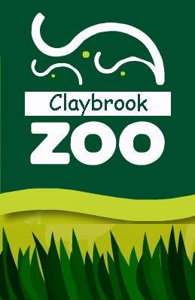

* **Any specific programming languages to be used**

The clients did not have any specific requirements on the programming languages that they would like us to use. We will be using the java programming language to develop the systems as according to our research it is one of the most common programming languages used to create applications.

## 2.2.7 Commercial Constraints (Total Project)

We have taken into account the following estimations when calculating the commercial constraints for the project.

* Cost estimations
* Project time scale estimations

We have carried out some basic calculations, to calculate the potential cost of the project. The calculations were based on estimated factors such as:

* The estimated staff costs and the total hours of work that is required to complete the work.
* The project costs/resources
* The required profit margin

Below is a table that provides the complete breakdown of the costs involved in the project. We carried out an in-depth research, when calculating the project costs.

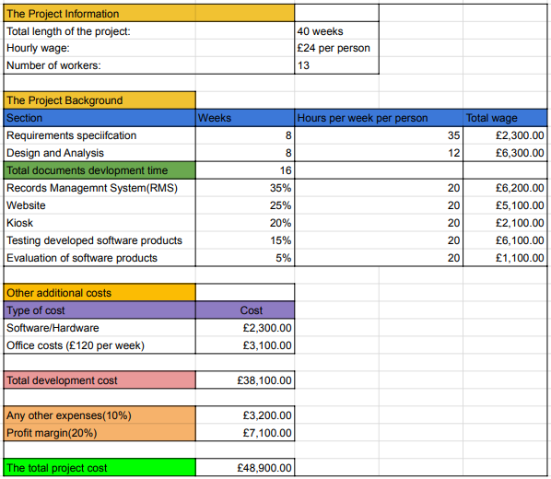**The table above shows the calculated costs of the project.**

As you can see, we have calculated the total project costs. The total cost of the project will be £48,900.00. We have split the costs clearly, so that the clients can see the various costs involved in the project, and how these costs add up to the total cost of the project without any ambiguity.

# 3 System Interface Designs

Now that we have gained an in-depth understanding of the features that each of the software systems must have and the functionalities that it must include, we will start developing the interface designs for each of the three systems. We will start with draft interface designs for each of the systems, which are the wireframes. The wireframes will be a simple sketch of what the layout of each system screen will look like and behave.

## 3.1 Draft Interface Designs for RMS

The following section shows the wireframes designs for the Record Management System, the navigation diagram for the system, the screen mock-ups and the system activity event diagrams.

## 3.1.1 Wireframes

Following are the wireframes developed for the RMS system.

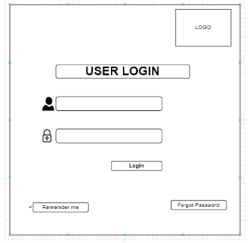

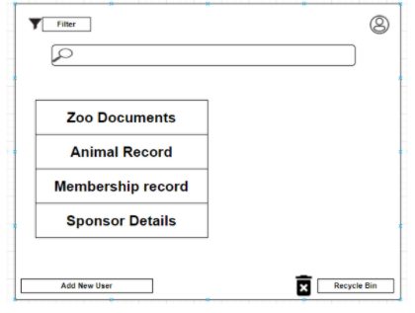

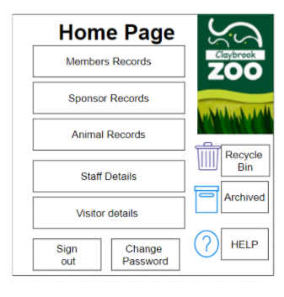

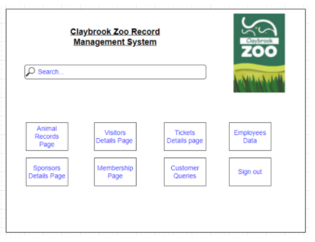

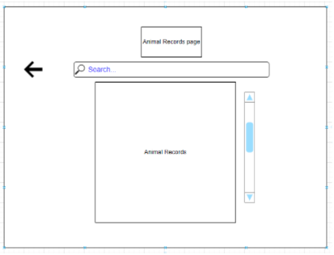

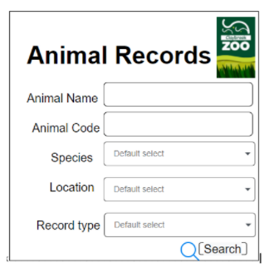

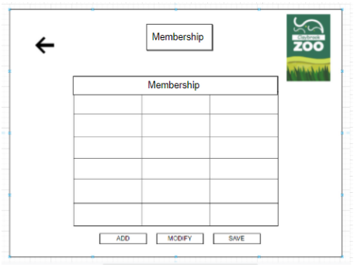

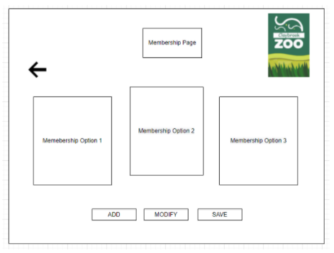

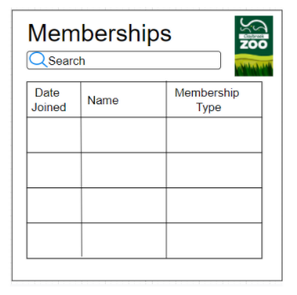

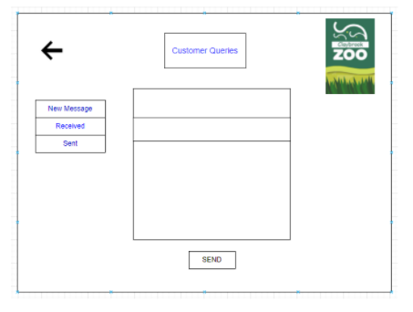

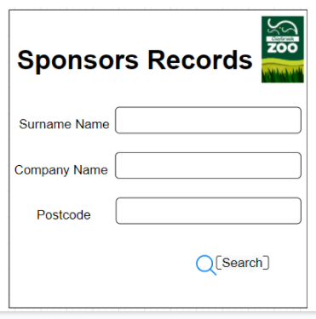

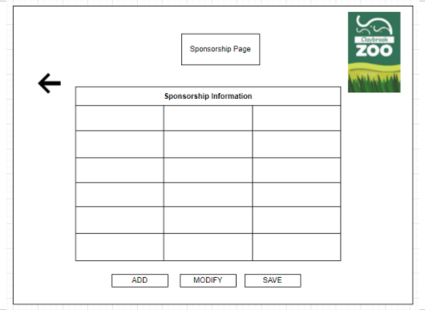

## 3.1.2 System Navigation Diagram

Below is the navigation diagram for the Record Management System.

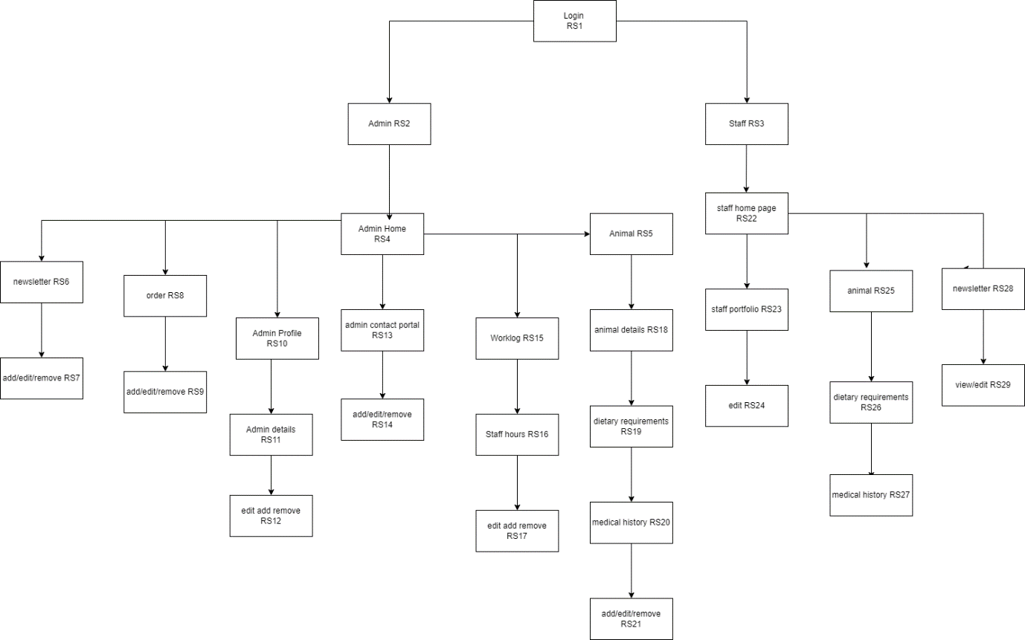

This shows the interface produced to staff and admin via the records management system. As Mathew requested, all access is available to admin whereas the staff portal, viewing and minor edits is accessible to staff members. This makes the manoeuvring between one page to another simple for all staff members which in turn requires less training needed and in turn less expenses made towards training all together. This also allows quick and efficient adding, removal and editing for documents in regards to sections such as sponsors, animal and even staff members as opposed to current systems which most likely requires searching for documents within file cabinets and potentially rewriting the whole document constantly when it is required an edit and results in heavy time consumption and inefficiency. Synergy solutions has created a system navigation diagram which produces a mock up of what the website navigation would make the accessibility more efficient for all staff members whether it be admin or general staff members.

## 3.1.3 System Screen mock-ups

Following are the screen mockups developed for the RMS system.

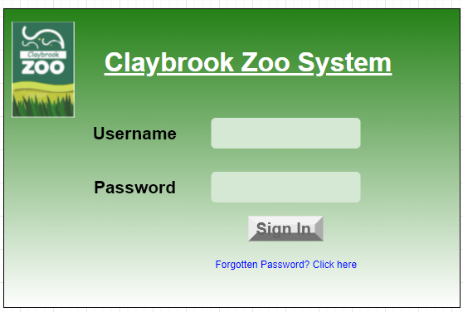

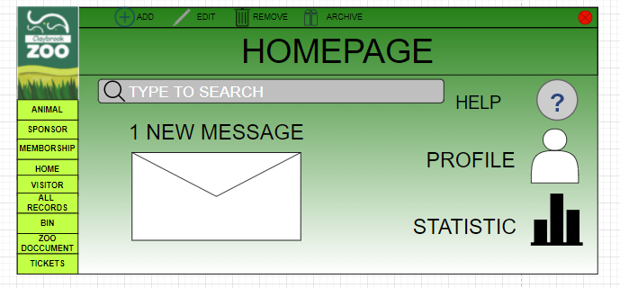

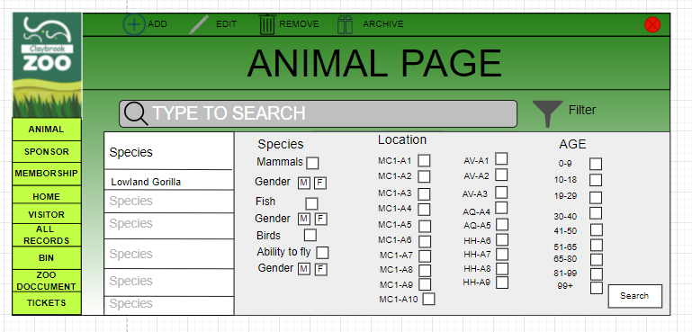

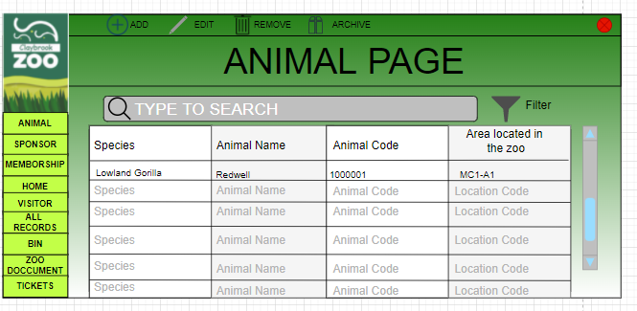

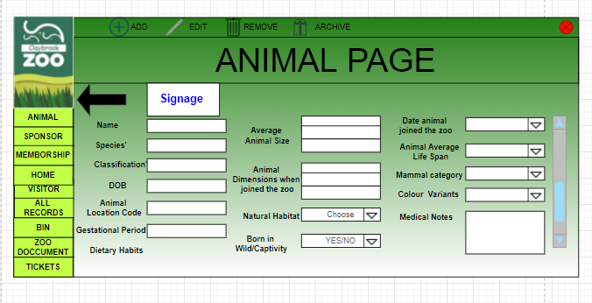

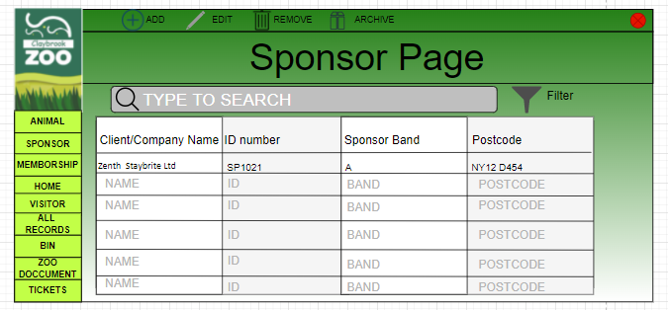

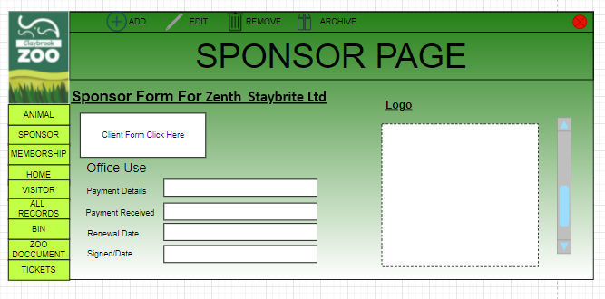

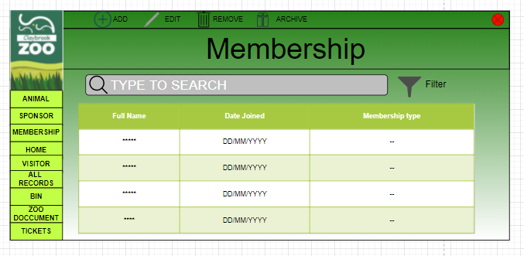

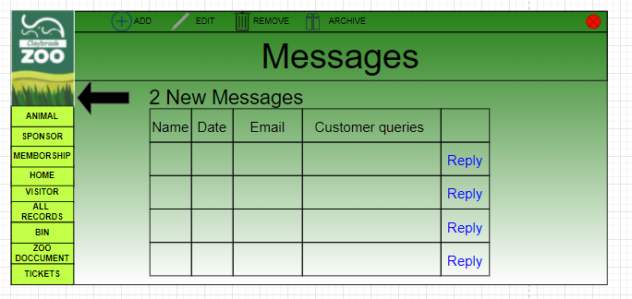

## 3.1.4 System Activity Event Diagrams

Below are system activity event diagrams for the Record Management System.

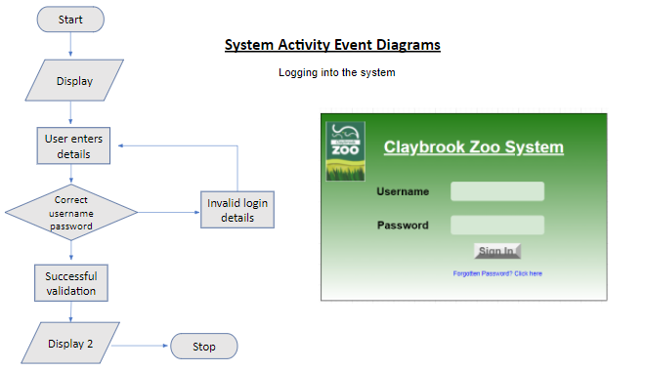

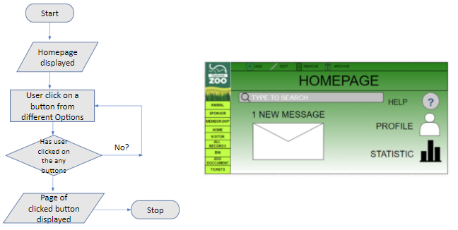

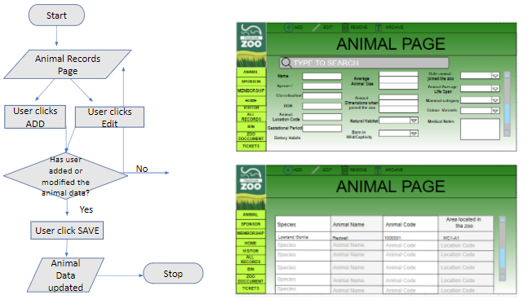

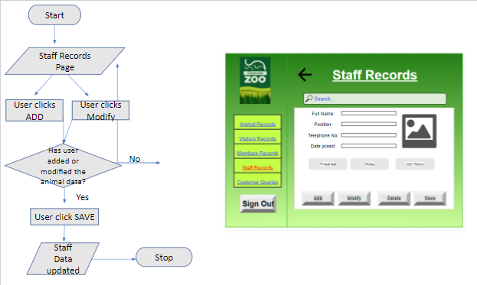

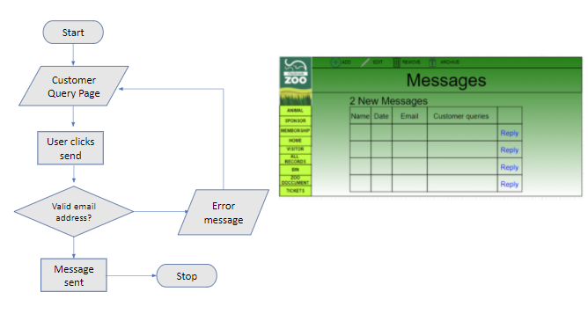

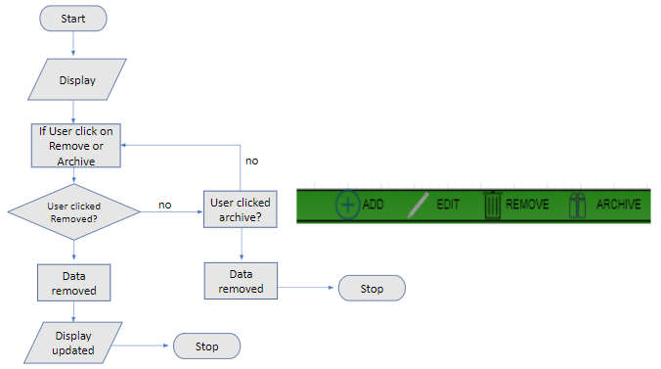

## 3.3 Draft Interface Designs for Zoo Website

The following section shows the wireframes designs for the website, the navigation diagram for the system, the screen mock-ups and the system activity event diagrams.

## 3.1.1 Wireframes

Following are the wireframes developed for the website.

**Home Page –** The client liked a combination of both versions of the wireframes for the Home Page, so a combination of the two versions were developed.

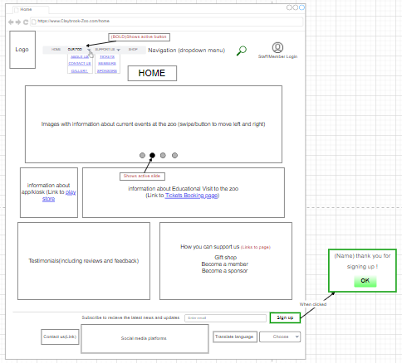

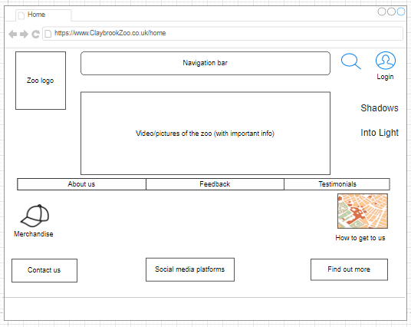

**About Us Page**

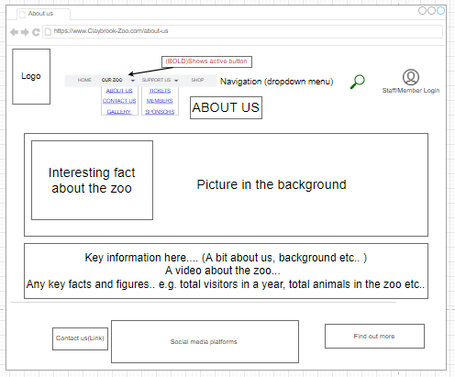

**Contact Us Page –** The client liked a combination of both versions of the wireframes for the Contact Us Page, so a combination of the two version were developed.

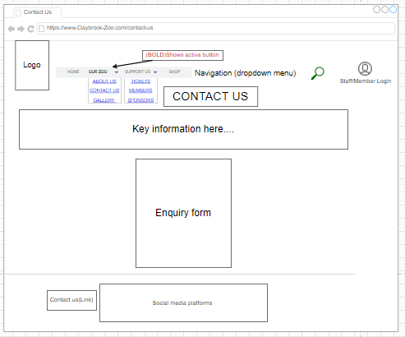

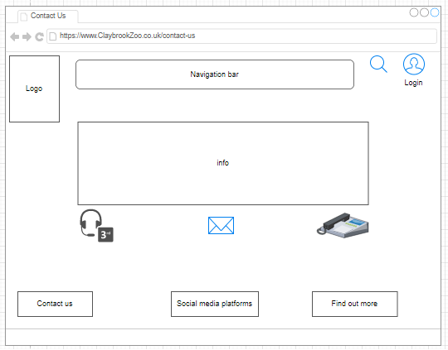

**Getting here Page**

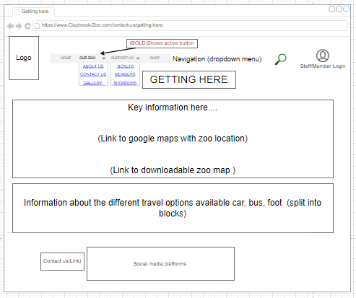

**Tickets Booking Page –** The client liked a combination of both versions of the wireframes for the Contact Us Page, so a combination of the two version were developed.

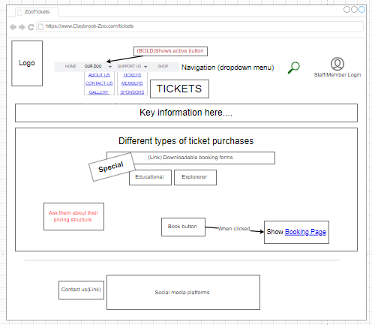

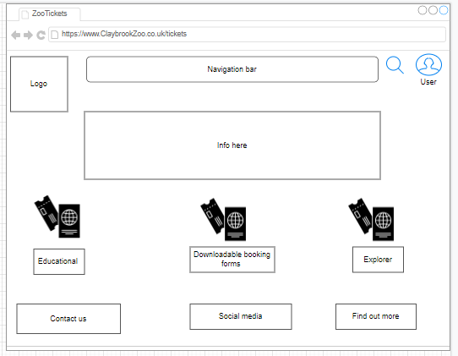

**Members Page**

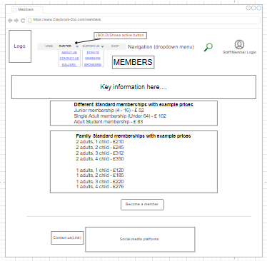

**Sponsor Page**

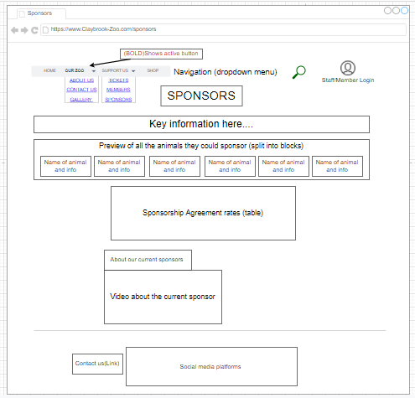

**Search Page**

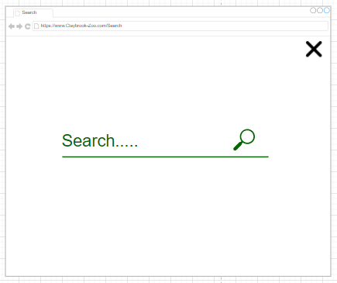

**Gallery Page**

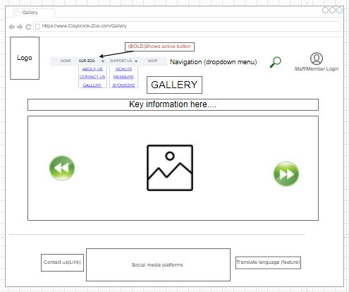

**Calendar Booking Page**

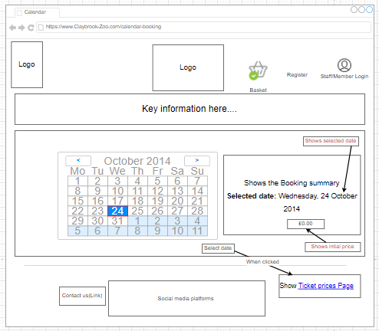

**Tickets Prices Page**

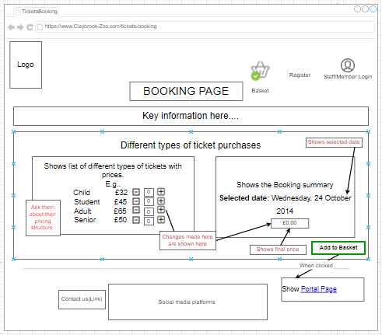

**Add-products-to-basket Page**

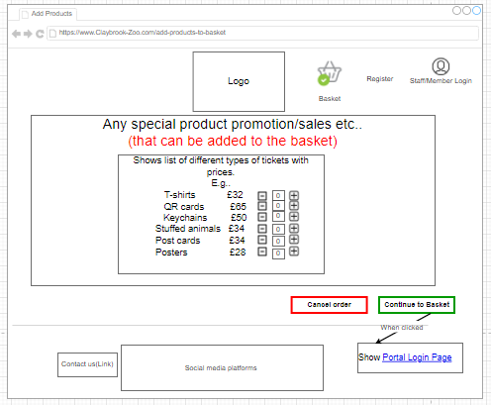

**Shop Page**

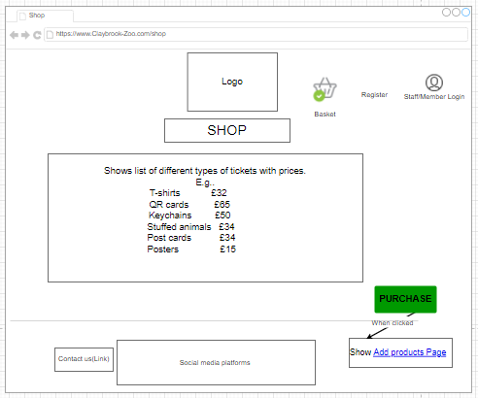

**Portal Login Page**

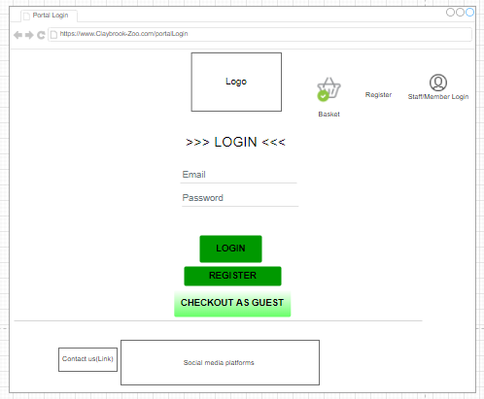

**Guest Checkout Page**

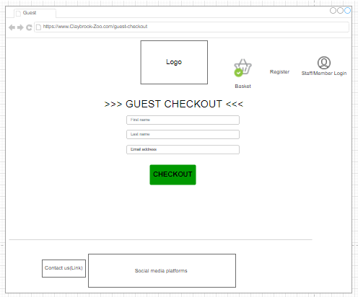

**Portal Registration Page**

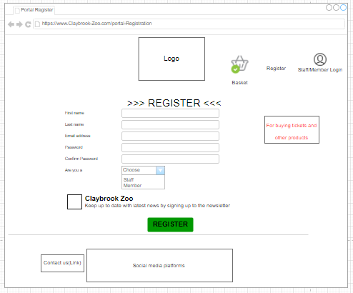

**Order Confirmation Page**

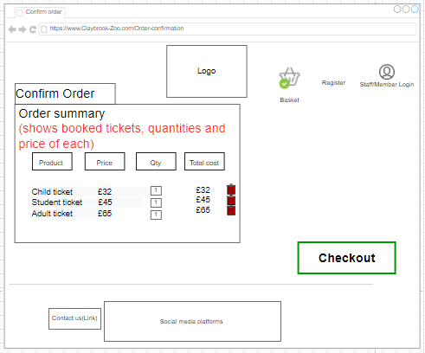

**Checkout Page**

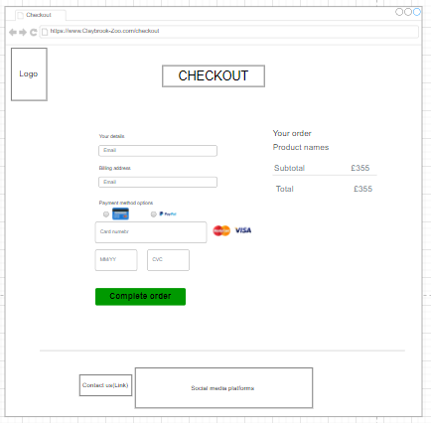

**Order Completed Page**

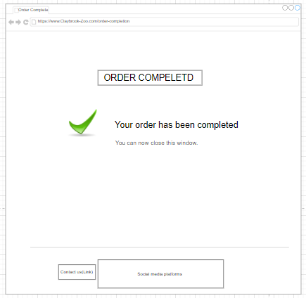

**Become a Member Page**

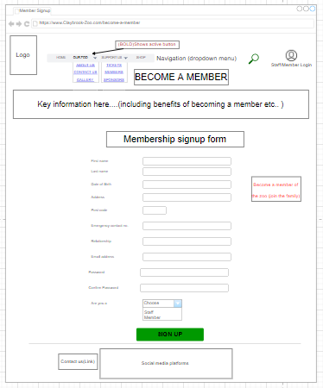

## 3.1.2 System Navigation Diagram

Below is the navigation diagram for the website. It shows how a user can navigate through the website. 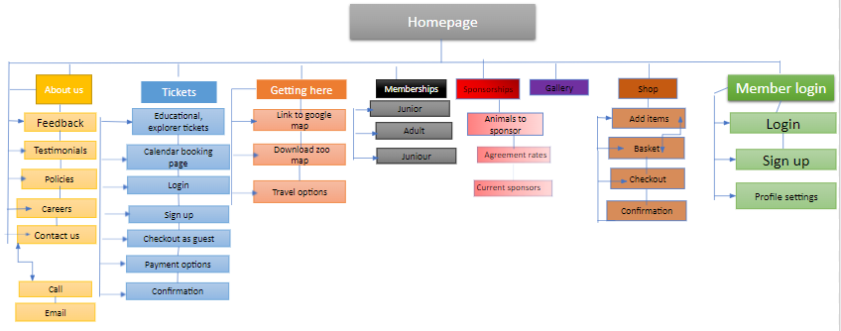

## 3.1.3 System Screen mock-ups

The key features that the website mock-up include are:

* All the requested webpages, with the key information on each of the pages
* Sign Up to the newsletter feature
* Social media icons to allow more outreach
* Key events coming up at the zoo
* Renew membership on your account online
* Leave a comment feature on the home page
* Animal of the week

Following are the screen mockups developed for the website.

**Home Page**

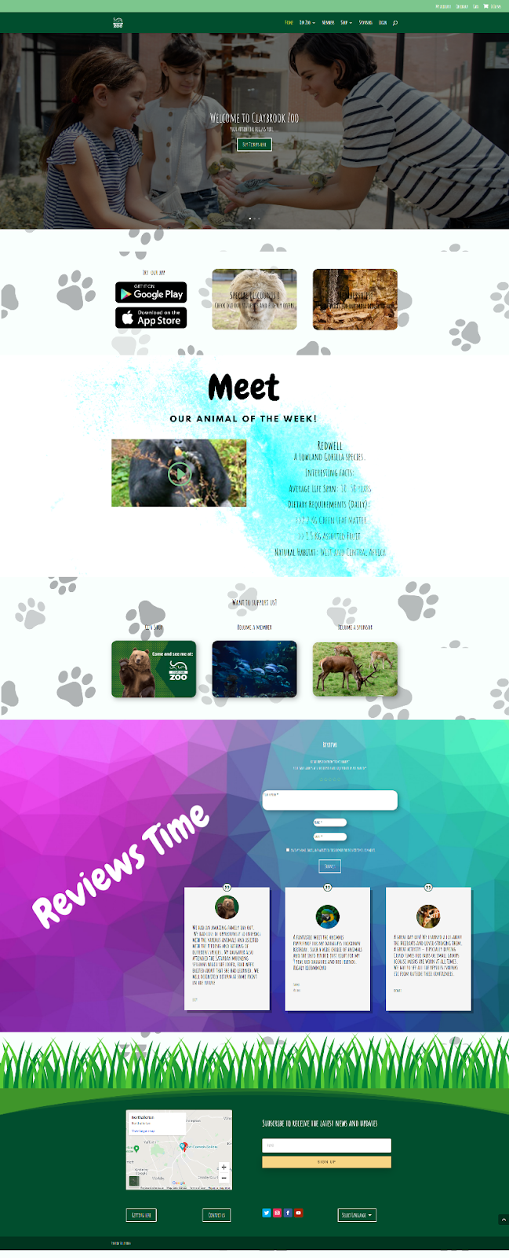

**About us Page**

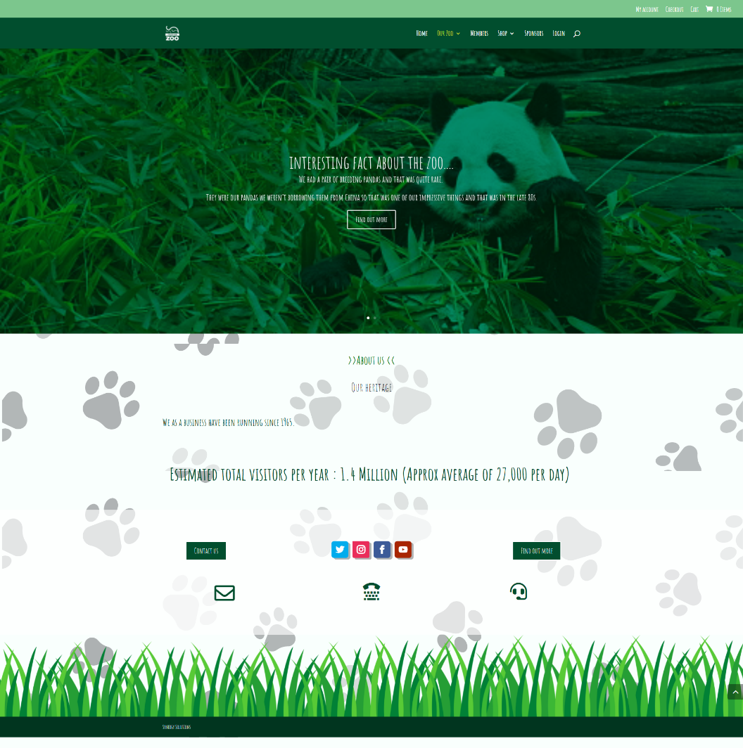

**Contact us Page**

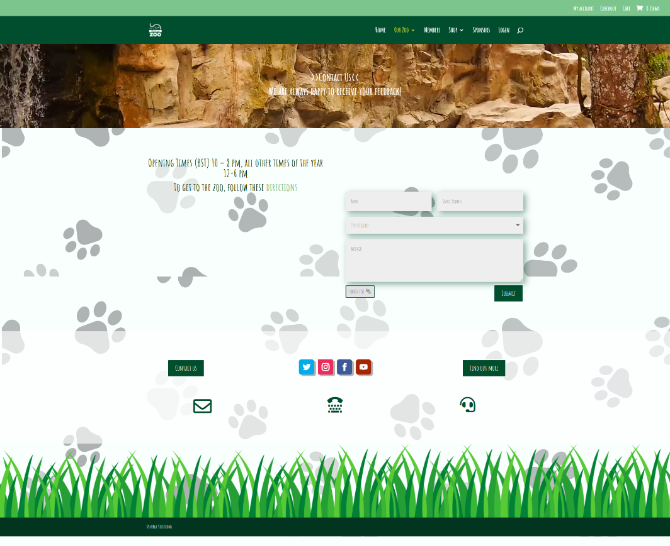

**Getting Here Page**

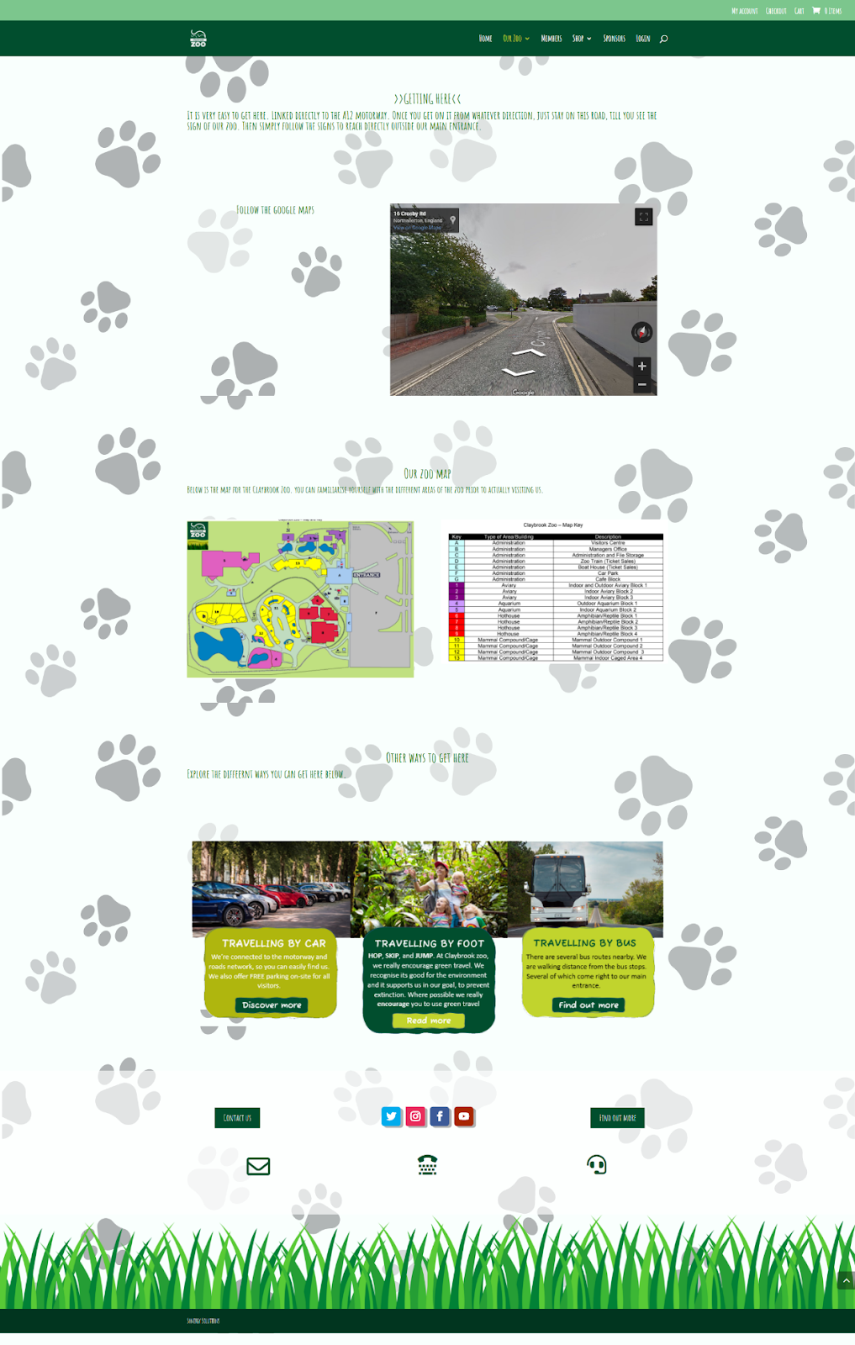

**Gallery Page**

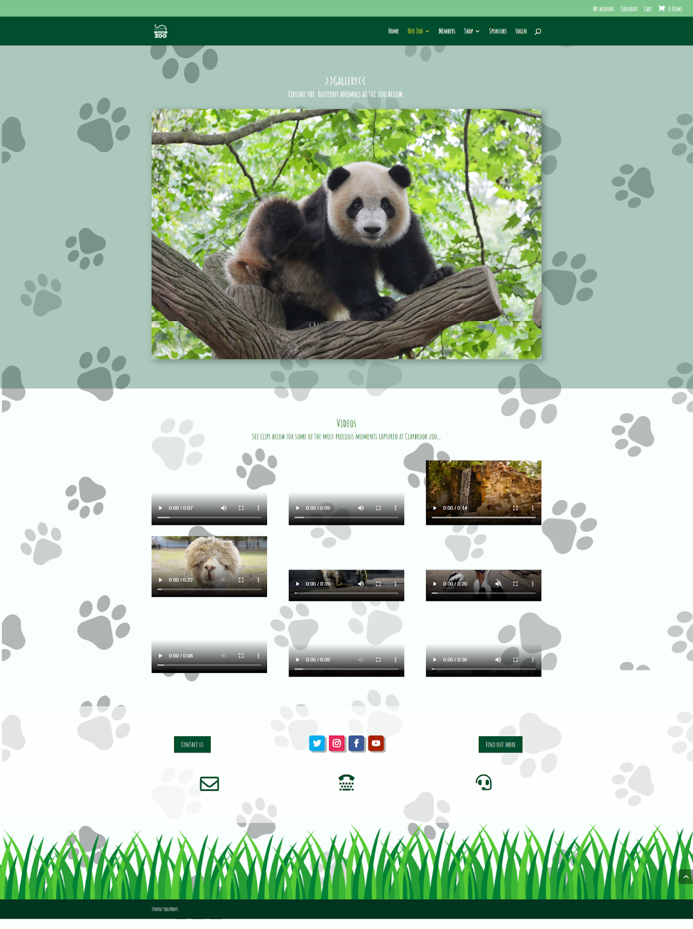

**Members Page**

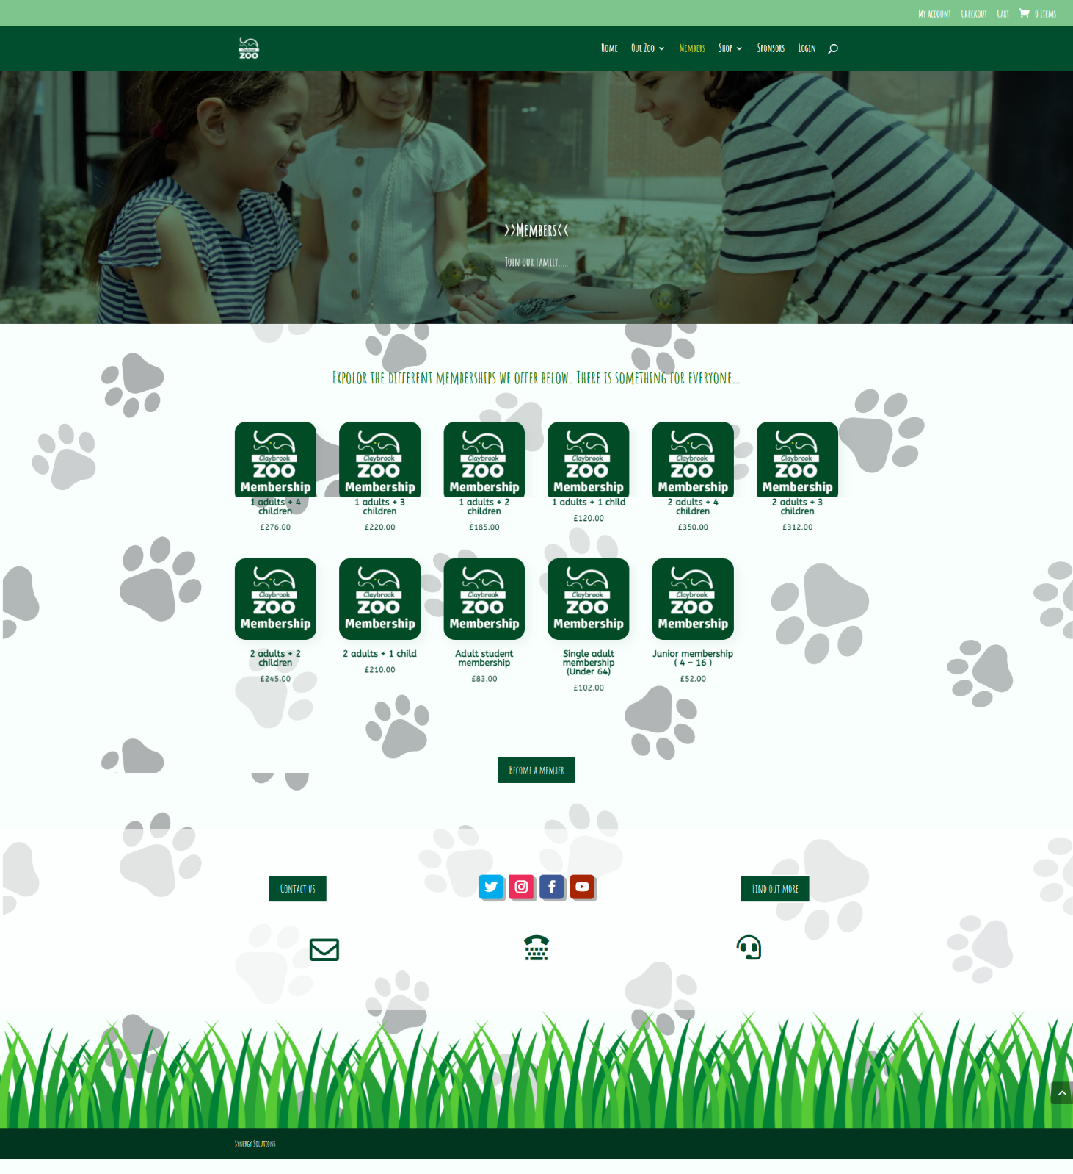

**Gift shop Page**

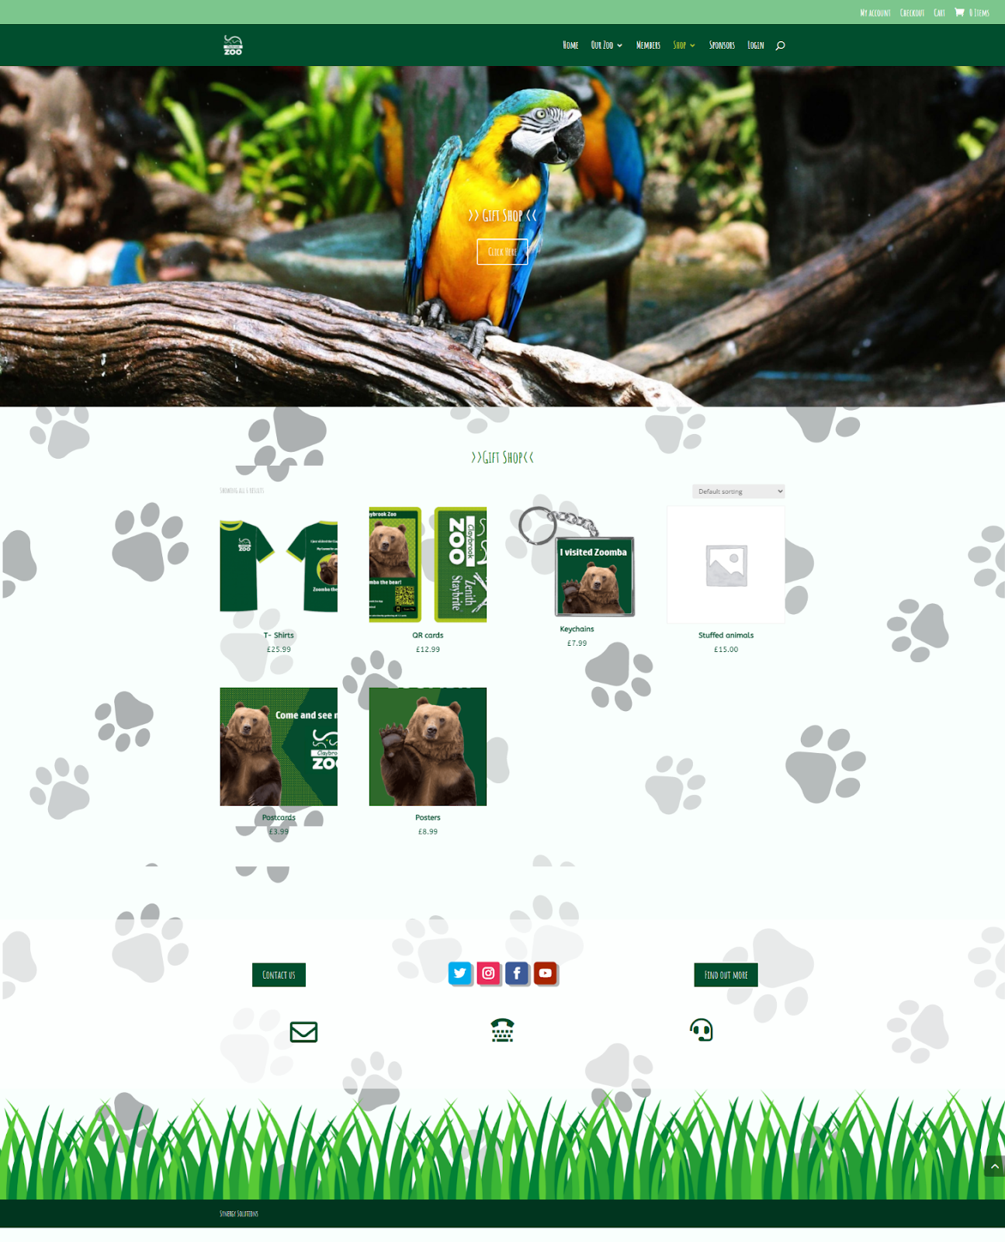

**Tickets Page**

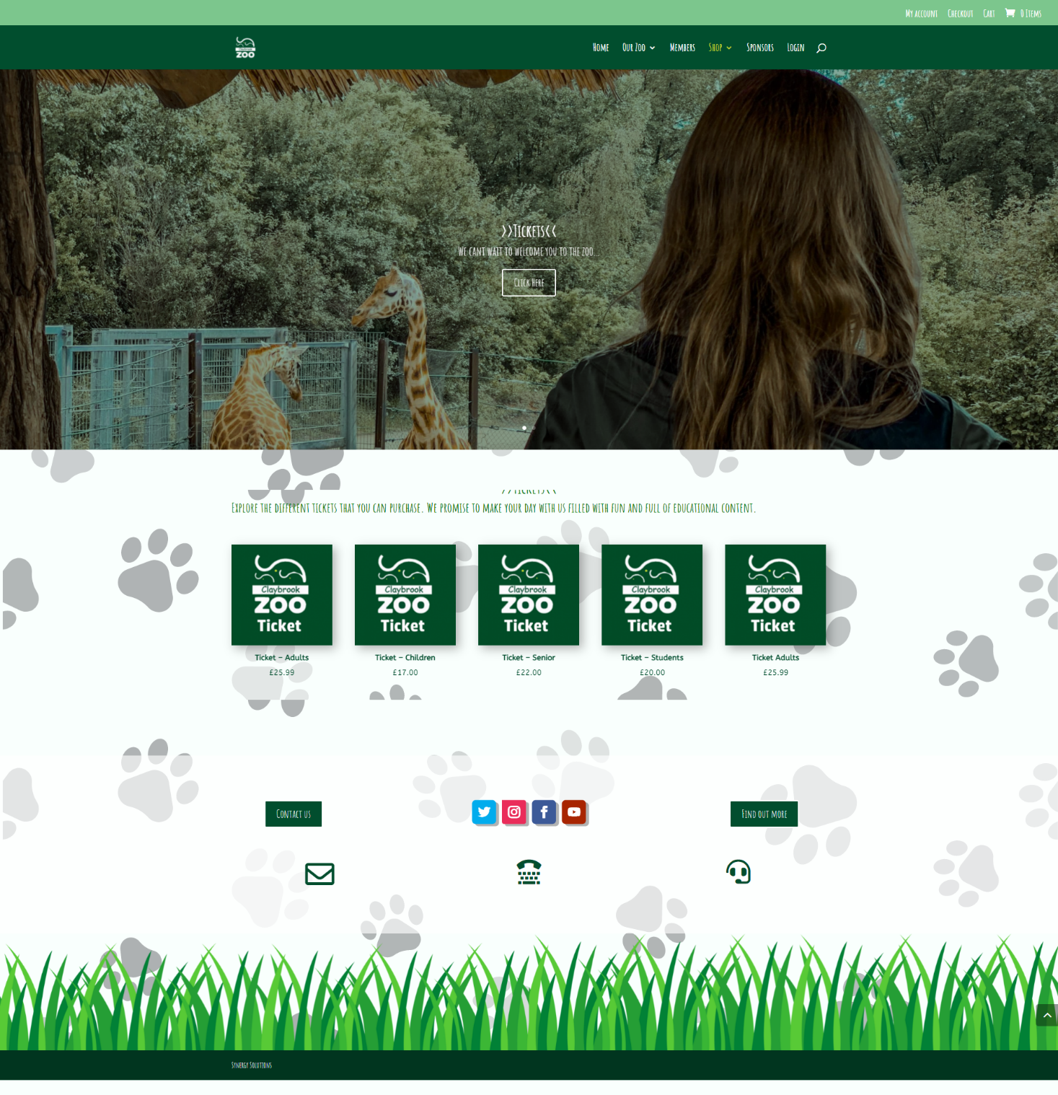

**Sponsors Page**

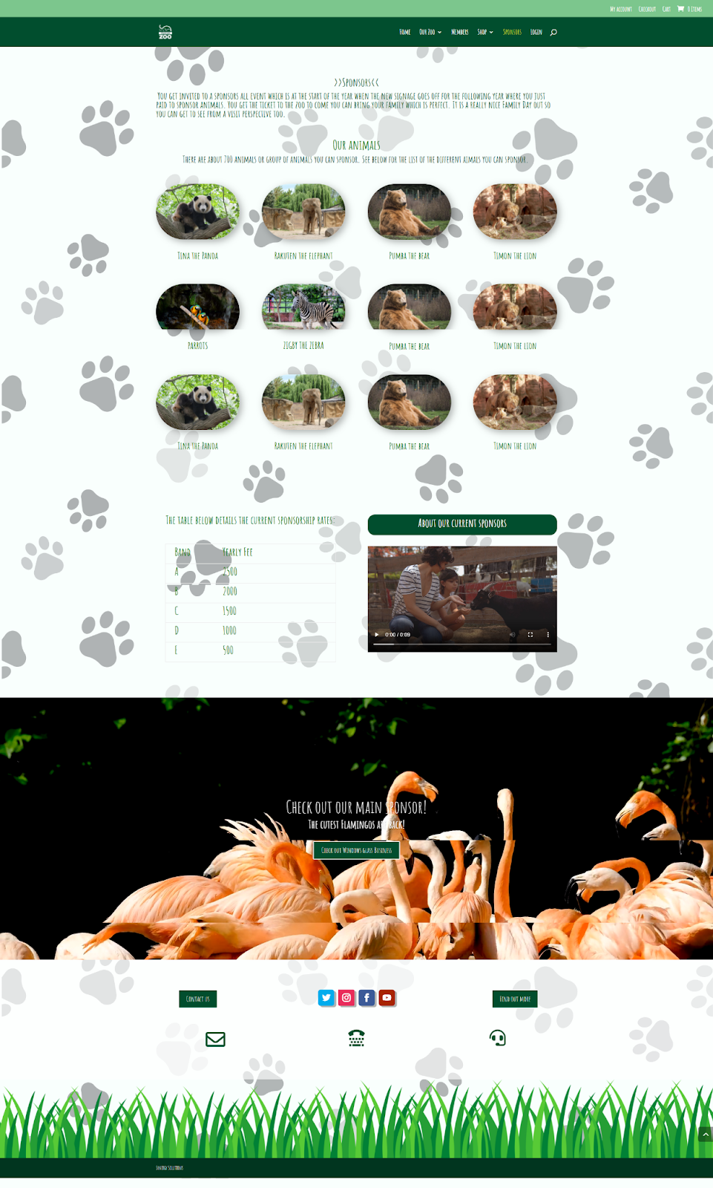

**Login Page**

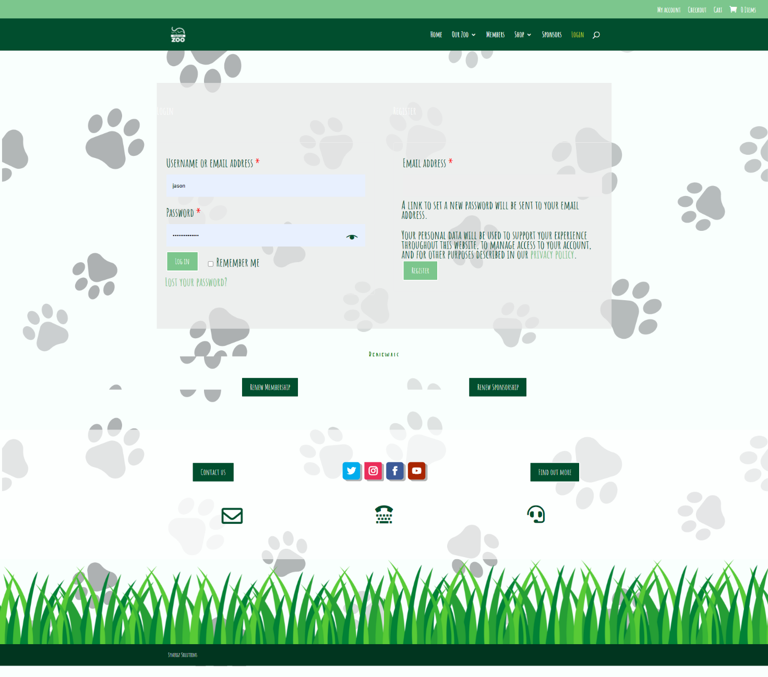

**Checkout Page**

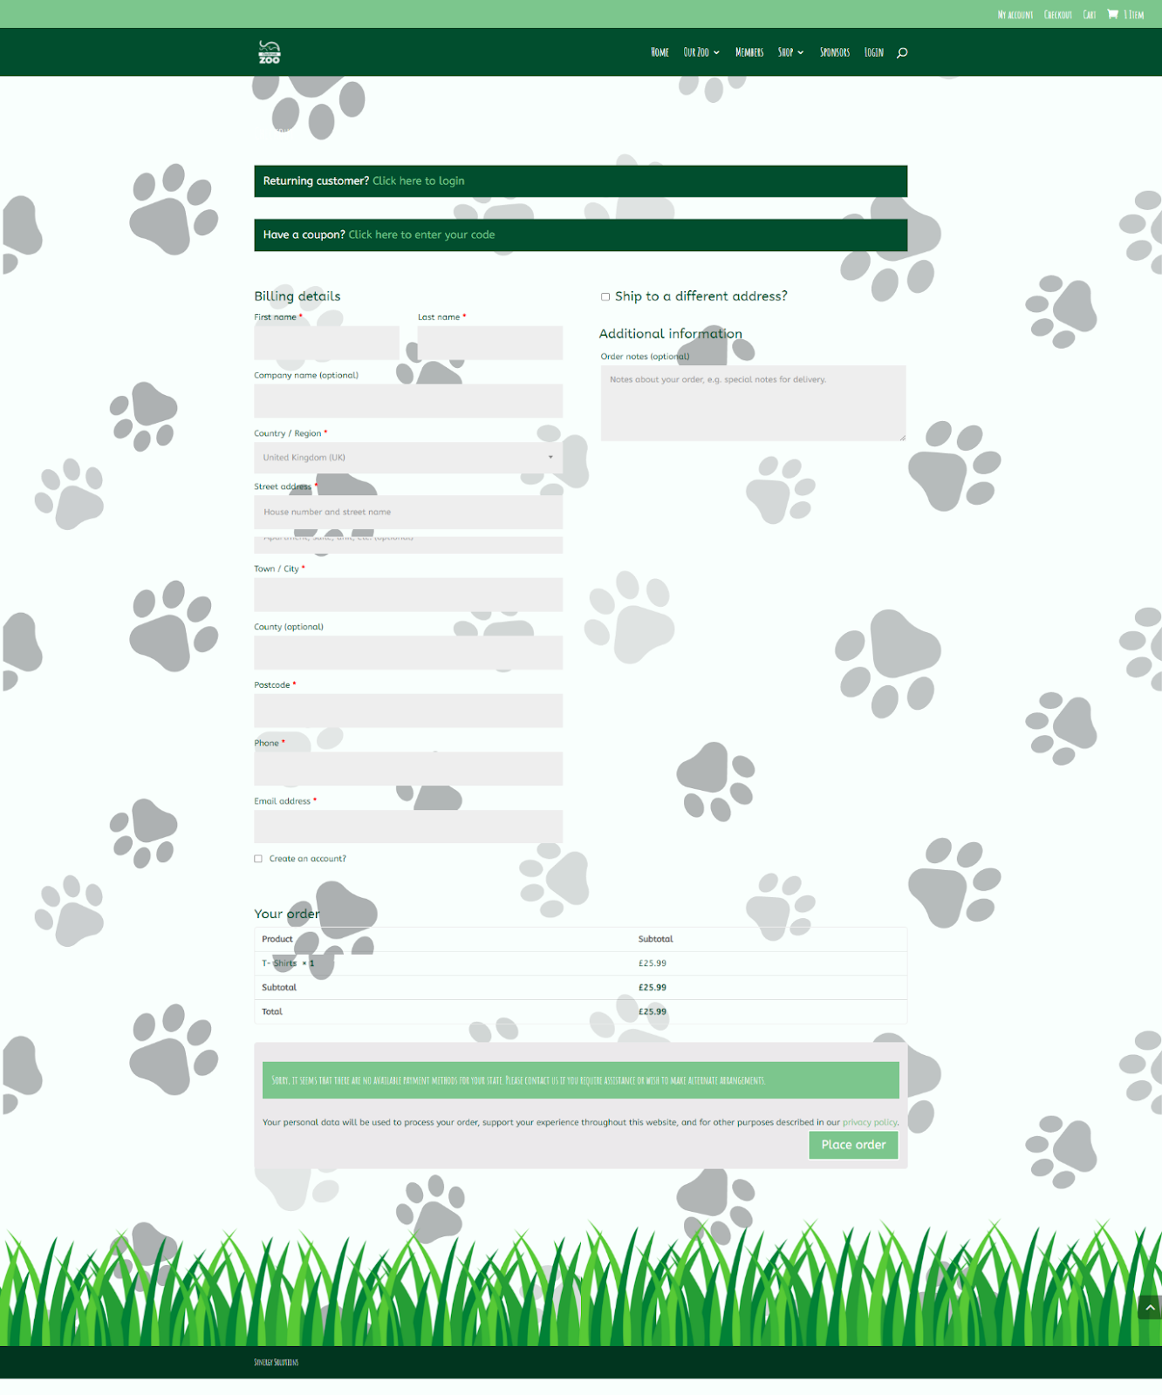

## 3.1.4 System Activity Event Diagrams

System diagrams are usually used for key system events, in this instance, below is the process of logging into the system for the member and the process of a customer filling out a testimonial form. This diagram shows the step-by-step process of what the system does when this happens. There are different directions the diagram can go in for example, if the testimonial form doesn’t have past 80 characters, then there’s a testimonial error where the member has to fill it until there are enough characters for the form, however when it passes 80 characters the testimonial is successfully submitted.

Below are the two key system activity event diagrams for the website.

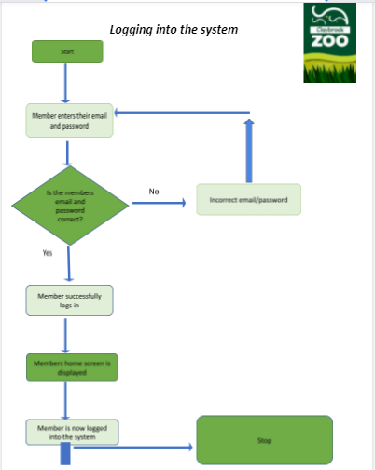

The diagram above highlights how the user would log in to the RMS and shows different errors in logging in.

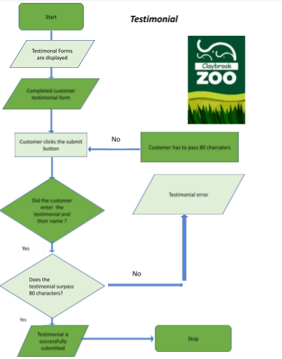

## 

The diagram above shows the testimonial process for the record management system.

## 3.1 Draft Interface Designs for Kiosk/Visitor Information

The following section shows the wireframes designs for the Kiosk, the navigation diagram for the system, the screen mock-ups and the system activity event diagrams.

## 3.1.1 Wireframes

Following are the wireframes developed for the kiosk system.

**Kiosk start page**

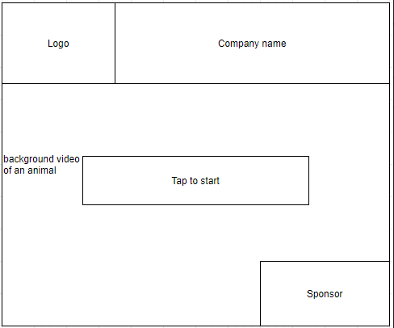

**Kiosk main page – design 1**

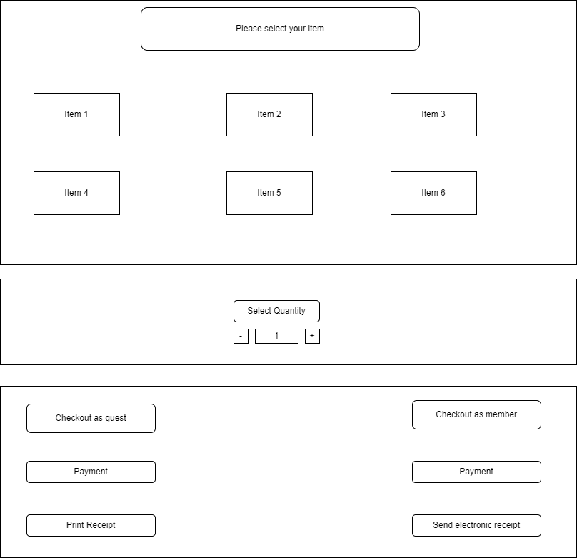

**Kiosk main page – design 2**

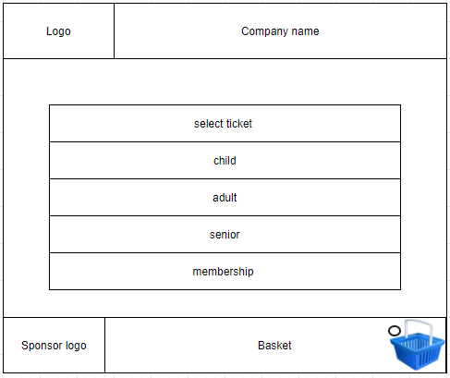

**Kiosk – shopping kiosk page 1**

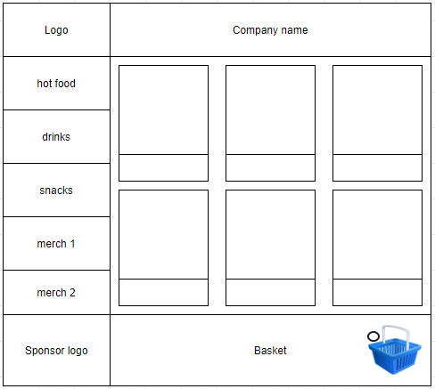

**Kiosk – shopping page 2**

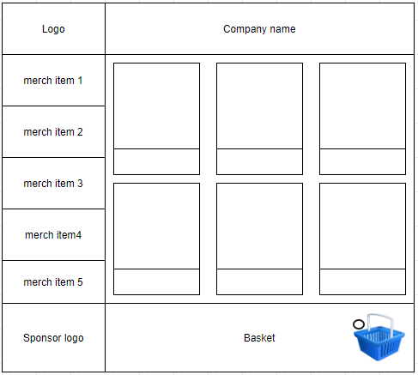

**Check-out screen**

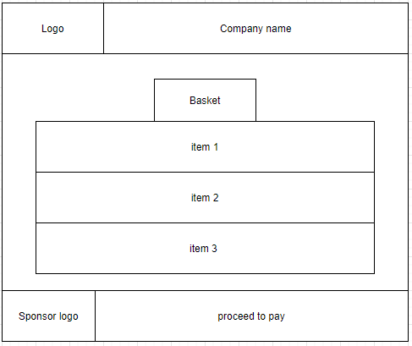

**Do you want to sponsor an animal screen**

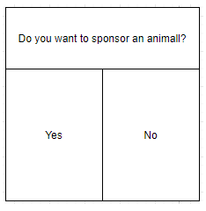

**Mobile app –**

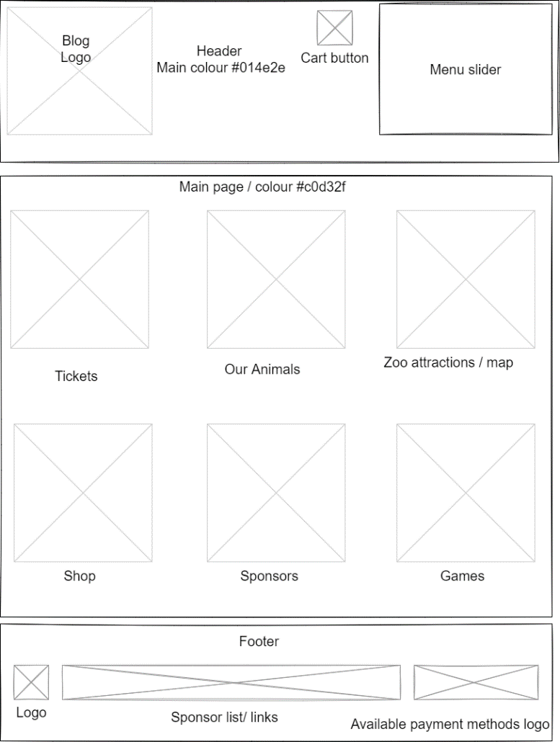

**Floor Plan(1)**

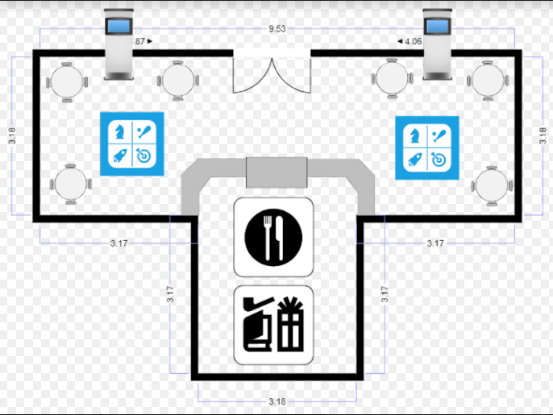

**Floor_Plan 2**

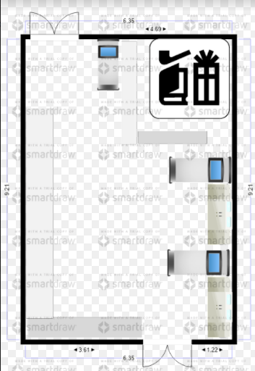

**Mobile app UI design**

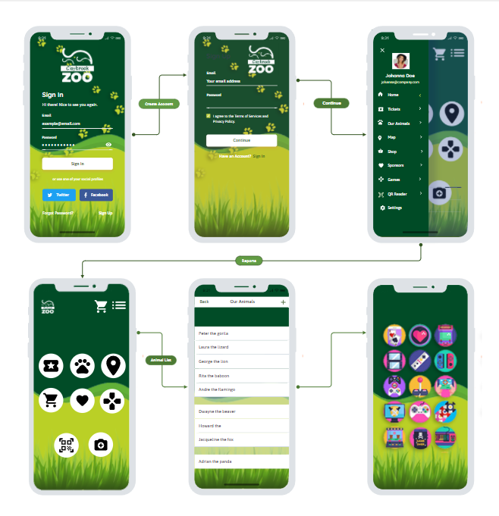

## 3.1.2 System Navigation Diagram

Below is the navigation diagram for the kiosk system and the app.

**Kiosk**

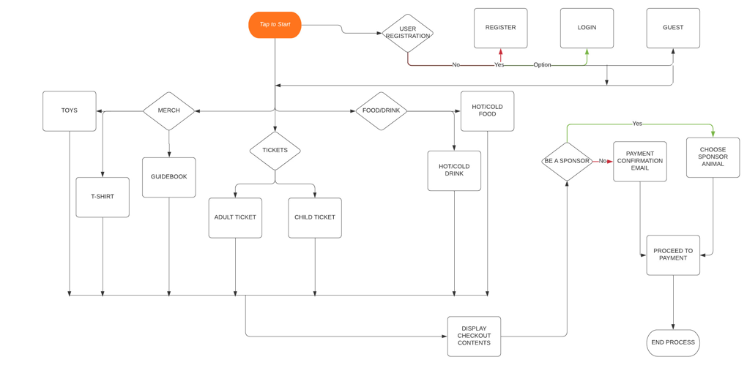

**App**

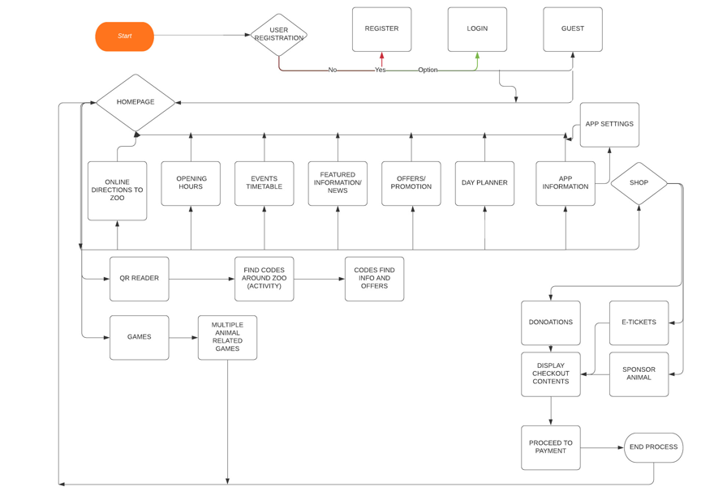

**Ticket kiosk**

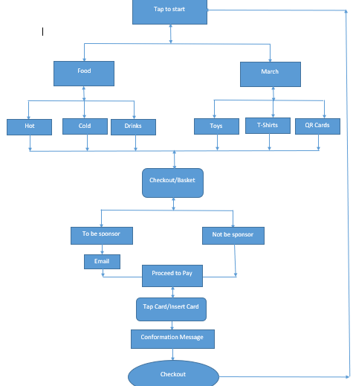

## 3.1.3 System Screen mock-ups

Following are the screen mockups developed for the kiosk system and the app.

**Kiosk**

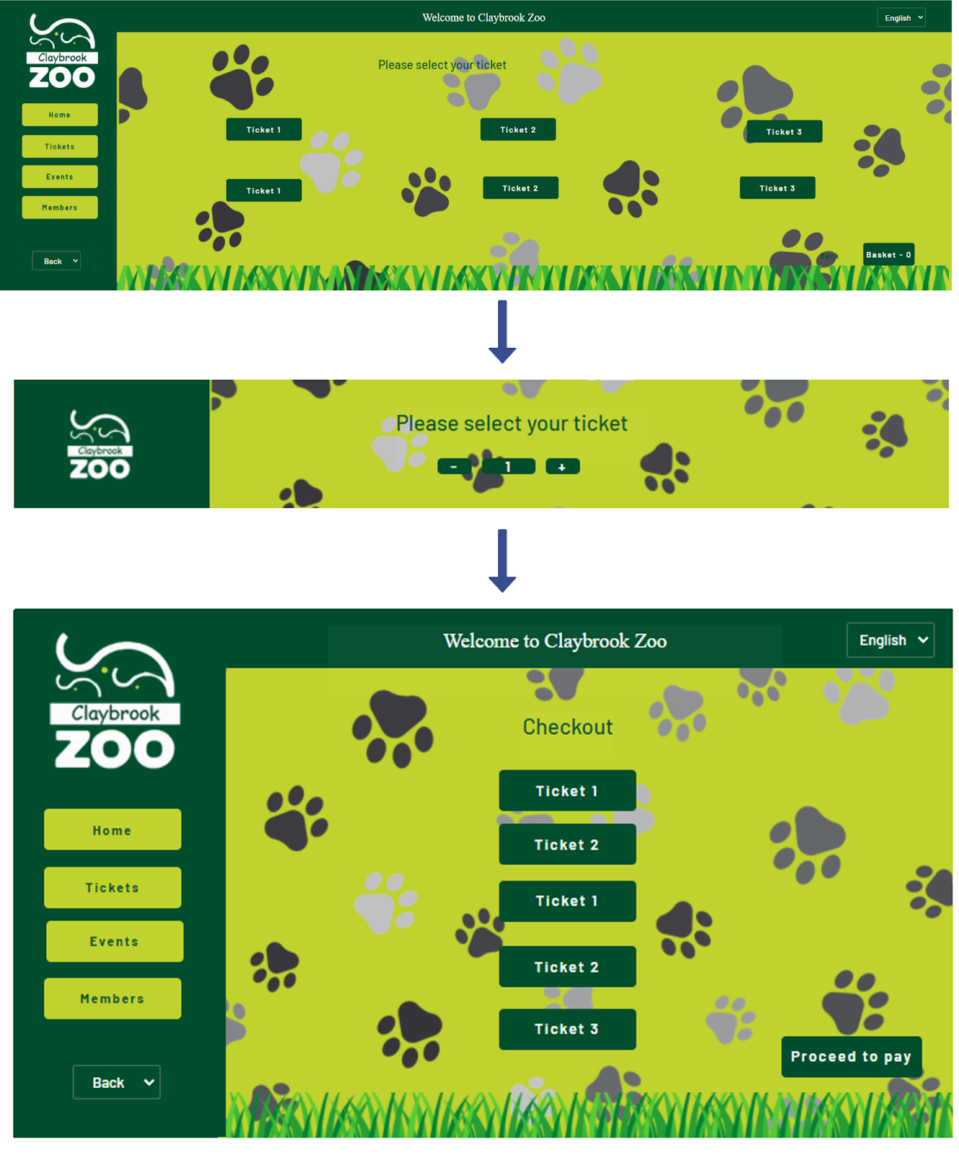

**Kiosk – mobile app**

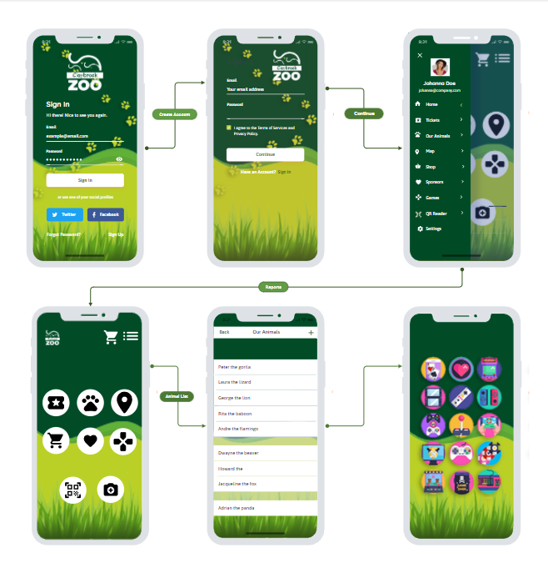

**Proposed shop - Playground area**

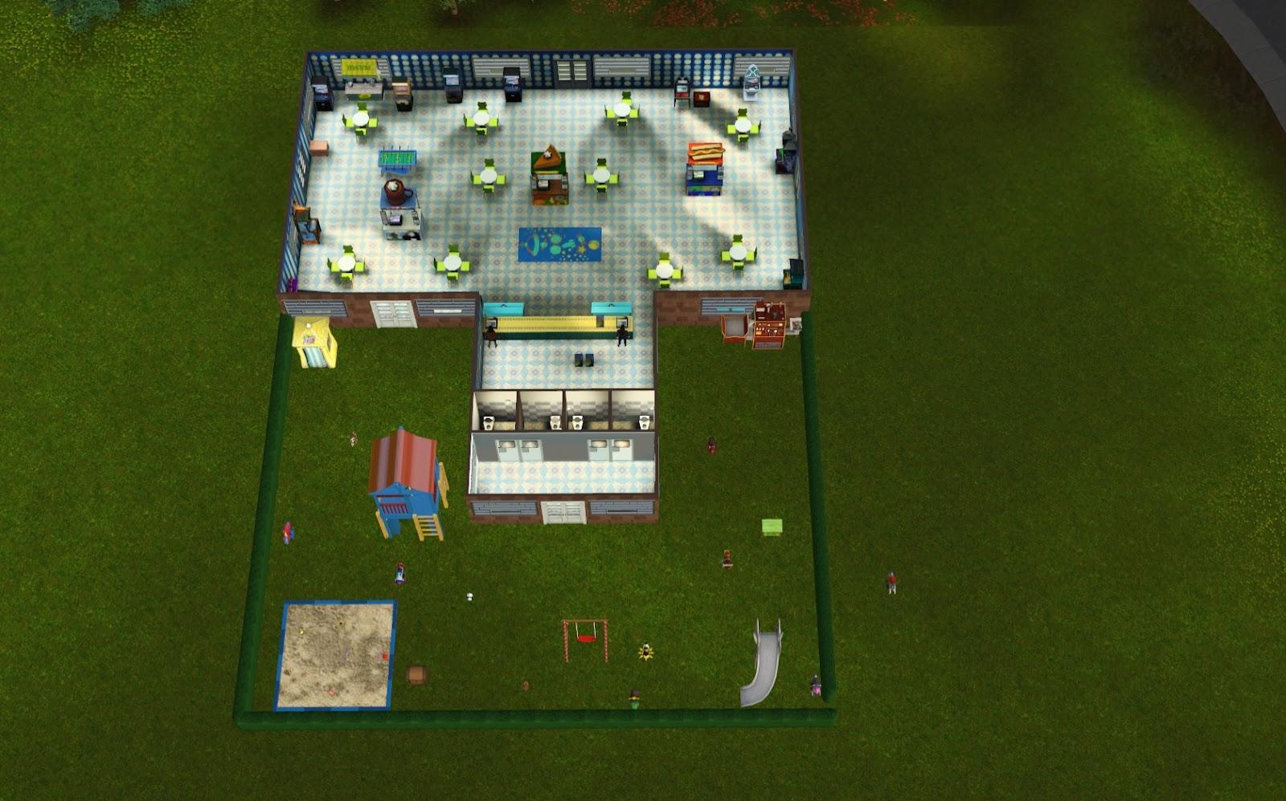

**Inside venue**

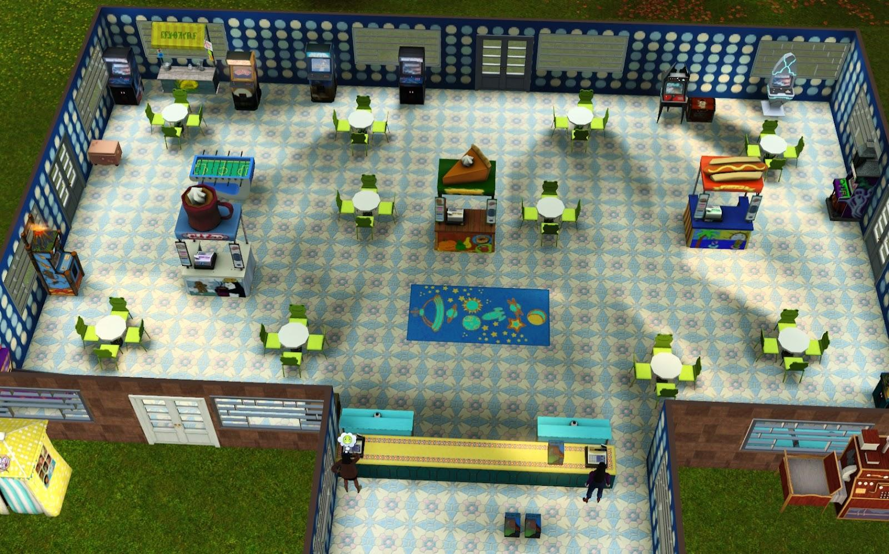

**Gift shop**

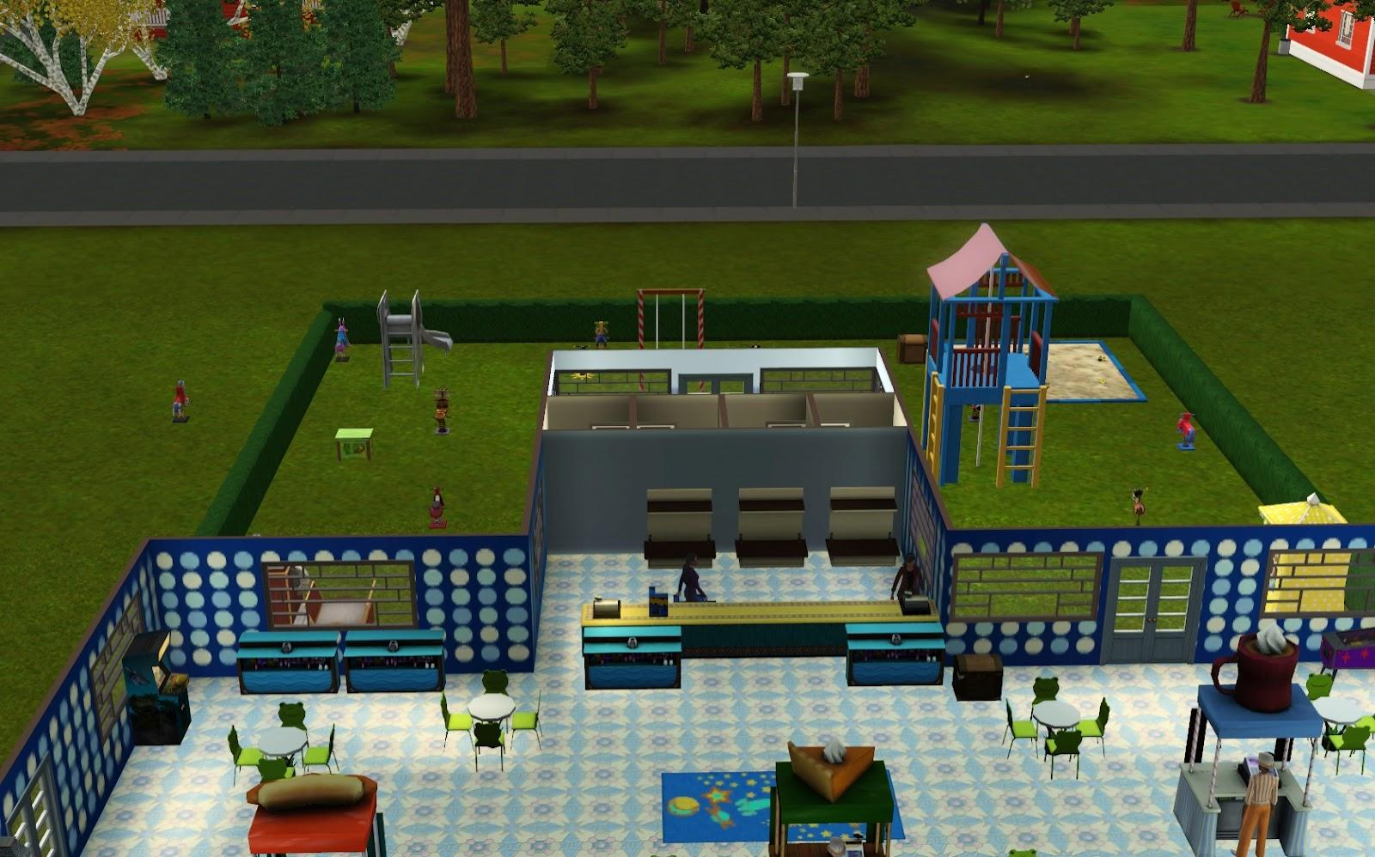

## 3.1.4 System Activity Event Diagrams

Below are system activity event diagrams for the kiosk system.

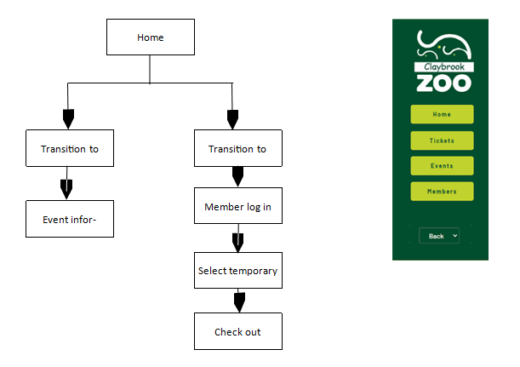

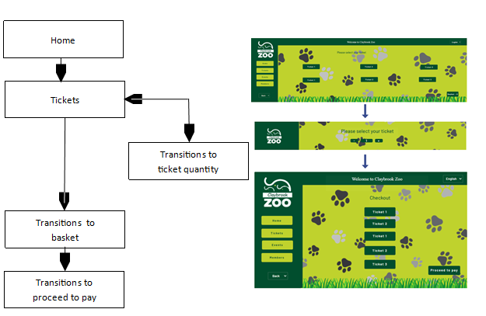

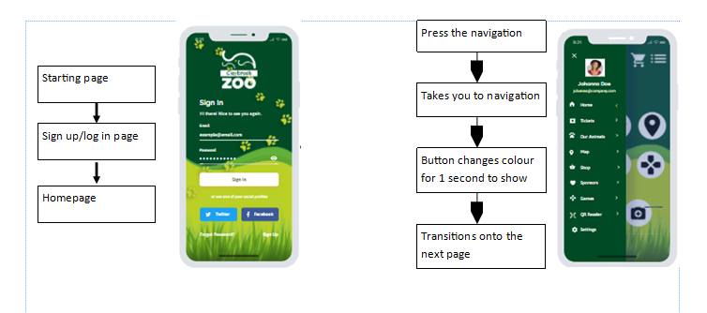

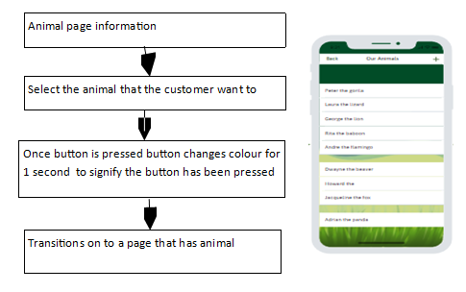

# 4 Analysis and Design Records Management System –

In this section, Synergy Solutions will be discussing the analysis and design Records Management System.

## 4.1 Preliminary Analysis Stages

In this section, Synergy Solutions will be discussing textual analysis, significant event analysis and Class-Responsibility-Collaborator(CRC).

## 4.1.1. Textual Analysis

We are using textual analysis as a technique to identify the potential classes within the specification for Claybrook zoo brand new records management system. So, for that I will search closely at the functional/performance requirement we came up with.

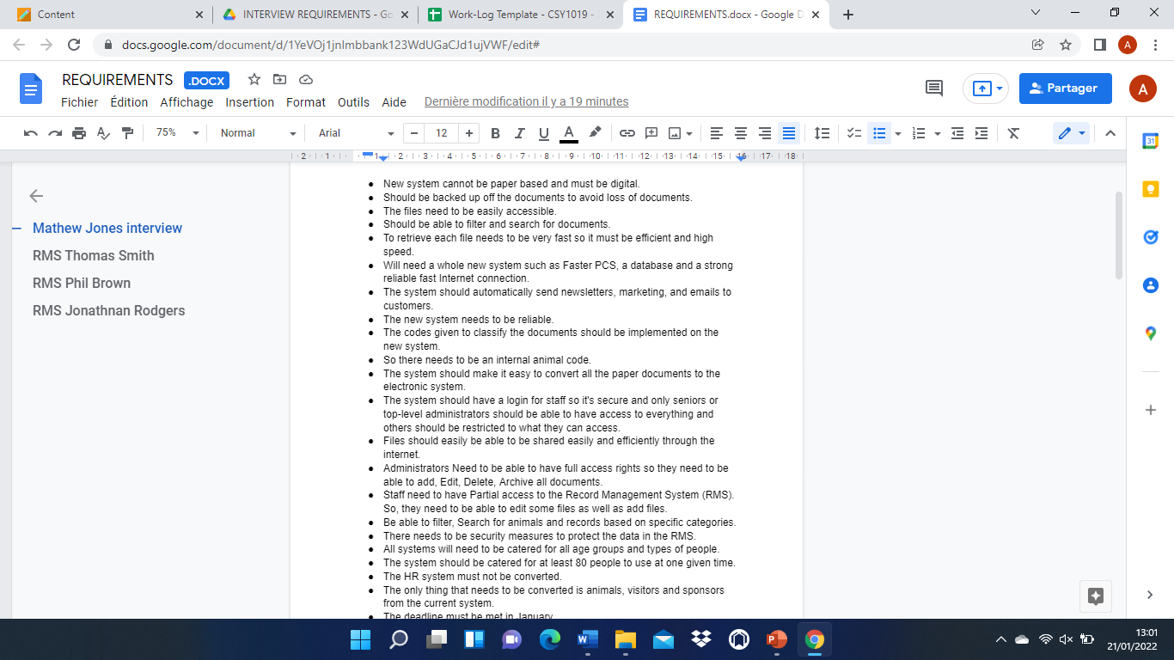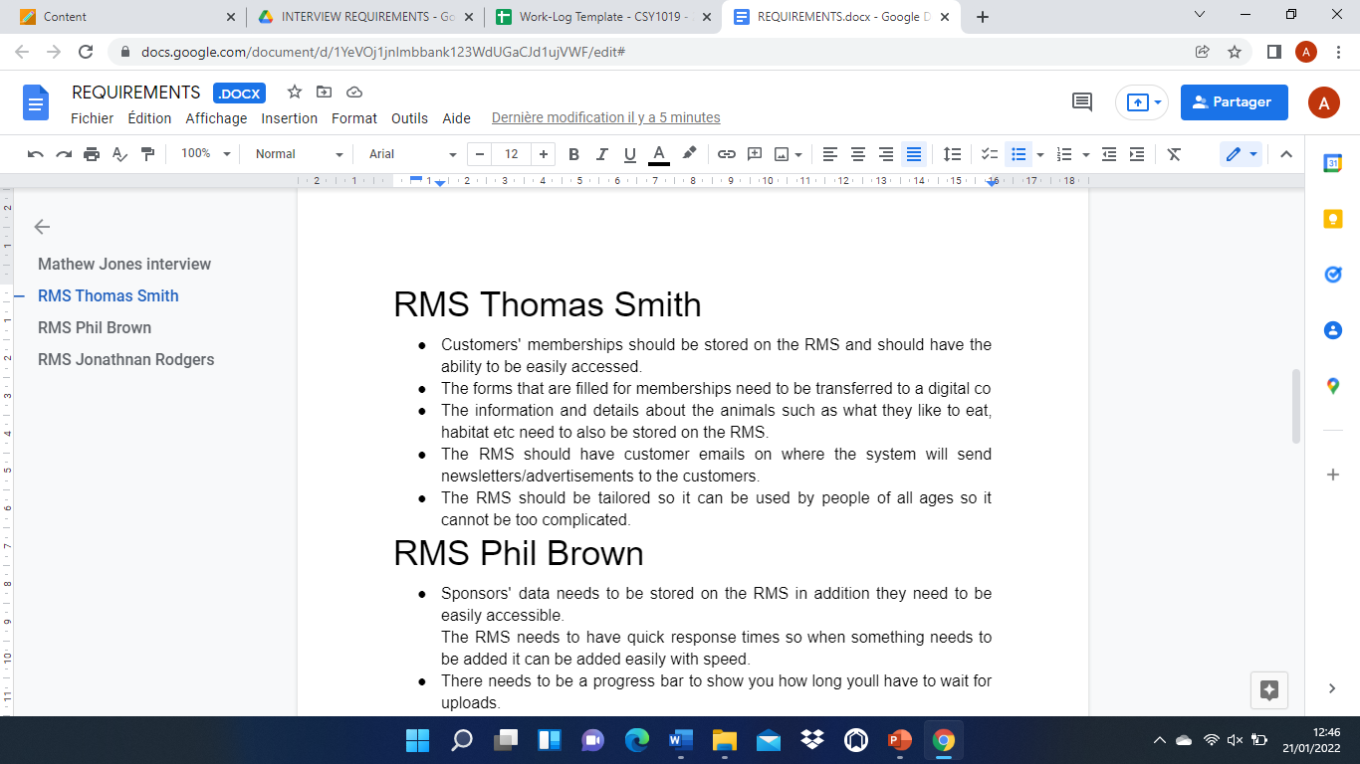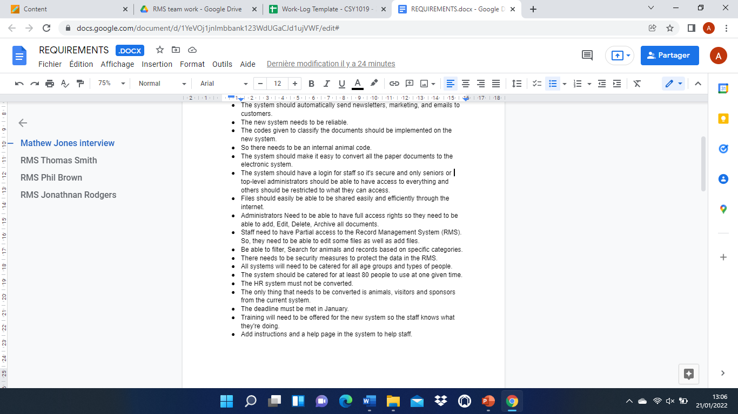

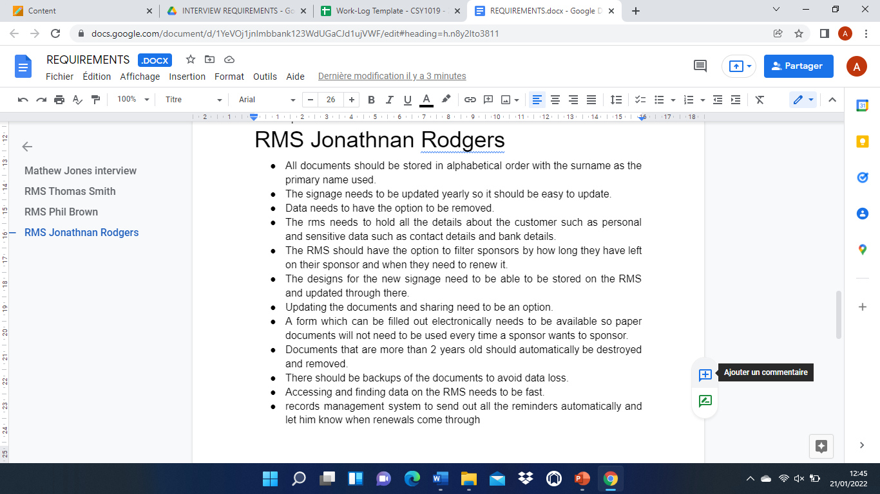

We are using textual analysis as a technique to identify the potential classes within the specification for Claybrook zoo brand new records management system. So, for that I will search closely at the functional/performance requirement we came up with.

The nouns/noun-phrases within the specifications for the records management system provide us with several candidate classes including Customer, staff, HR system, visitors, animals, files, signage, administration, database.

The verbs within the specifications for the records management system suggest several responsibilities for the candidate classes including Store, Access, Remove, update, Save, Add, Edit, Archive, Filter, Destroy and Find.

| **Candidate Class** | **Candidate Routines** |
| --- | --- |
| **Visitors**  **Animals**  **Administration**  **Staff**  **HR System**  **Signage** | **Store**  **Search**  **Access**  **Remove**  **Update**  **Save**  **Add**  **Edit**  **Archive**  **Filter**  **Find** |

## 4.1.2. Significant Event Analysis

These are the main significant events that can be performed using the record management system. There are many other events that can be done but less significant and these are: viewing animals records, deleting animals’ records, editing animals’ records, and archiving animals’ records these are performed by zoo administration and zookeepers. Viewing, modifying, and deleting staff members can only be performed by zoo administration staff.

| **Significant Event** | **Performers** | **Attributes** |
| --- | --- | --- |
| Add an animal record to the record management system | Zoo Administration Staff  Search bar for Record  Filing System  Zookeepers | * Species Name * Classification * Animal size * Date of Birth * Location Code * Habitat * Dietary Habits * average life span * Colour Variants * Joined date * Staff ID * Staff Name |
| Add a staff member to the RMS | Zoo Administration Staff | * Staff name * Position * DOB * Date joined * Job History * Staff photo |
| Reply to a customer query | Zoo Administration Staff | * Staff ID * Staff Name * Visitor name * Visitor email |

## 4.1.3. Class- Responsibility-Collaborator (CRC)

| **Class Name - Zoo** |
| --- |
| **Responsibilities**     * **Conservation**      * **Research**      * **Education**      * **Recreation** |
| **Collaborators**     * **Customers**      * **Sponsors**      * **Employees**      * **Government**      * **Suppliers**      * **Shareholders and Owners** |

## 4.2. Detailed Static System Designs

In this section, Synergy Solutions will be discussing the first draft of the BON System Architecture Diagram, BON System Chart, BON Cluster Charts and the BON Class Charts.

## 4.2.1. First Draft BON System Architecture Diagram

This System Architecture displays the way the RMS system will work internally.

Following the main screen mock this flowchart will present how each button will communicate with the internal system.

The main buttons displayed will function as displayed in the structure.

The first step the user will see will be the login panel, after entering the user details, the system will communicate with the data base sending a search signal into the User database to look for the user, if the user is found in the database the system will move on and show the main dashboard, if the user is not in the system it will be redirected to the login page again.

The animals button will display the main frame image from the mock and will communicate with the database prompting a search for the filters inputted in the animals record system and will return the data found in that filter back and display a list of the animals.

The zoo document button will communicate with the database and will prompt the animal and zoo records to search for the filters selected.

All records will display on the page all the documents that are stored in the database.

The Home button will redirect the user back to the dashboard from any page he is on.

The visitor button will let the user access the database and prompt basic information regarding the customers that interacted with the system without having an account.

The Sponsor button will communicate with the database and search a sponsor based on the filters or displays all the sponsors.

Tickets button will display the user the tickets prices and offers them the ability to change the product records.

The Membership button will access the database and displays a search record of the filters inputted or a list of all members.

The bin button will check if there are any items stored in the bin, if there are items in the bin it will display the items inside, if the bin is empty the system will display a message telling the user that the bin is empty.

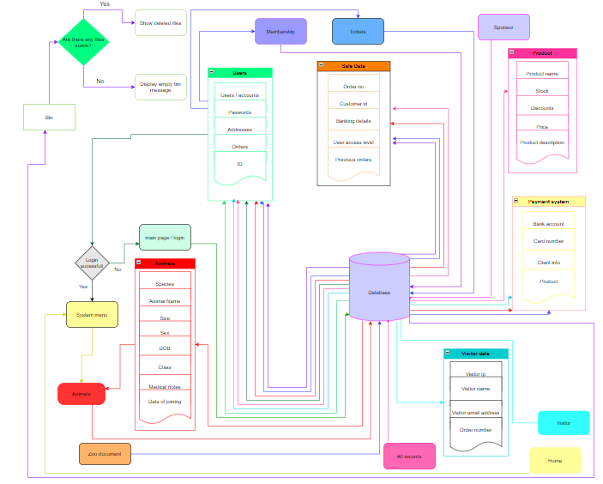

## 4.2.2. BON System Chart

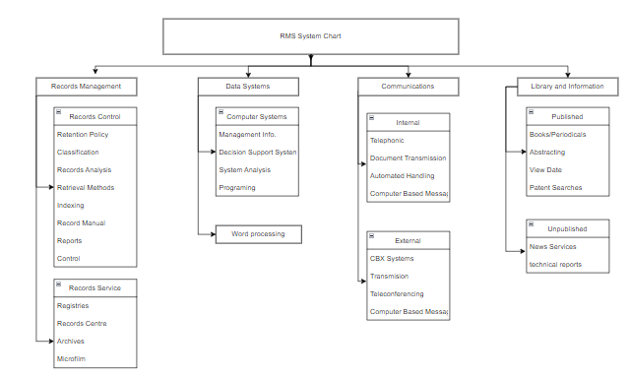

## 4.2.3. BON Cluster Charts

## 4.2.4. BON Class Charts

# 5 Report Conclusion

In this section we will provide a brief summary of the outcomes and also the implications of the work that has been produced. We will discuss the strengths and the weaknesses of the work. A discussion of whether the original aims and objectives of the project have been met and if not, then why not. If the original problems have been solved. Finally, a summary of the changes that we would implement if we were to carry out this project again and the enhancements that we would make to the project.

The key strengths of the work are, that we were able to carry out all the required activities as outlined in the introduction. One key strength of the work is that we were able to work together as a group to carry out all the elicitation activities, such as effective interview plans for the client interviews and extract the key required information, including the functional and performance requirements for the three systems from the clients. Another key strength of the work is that we were then able to us the information obtained from the client interviews to develop effective solutions, screen mockups, for the three software systems which are: Record Management System, website, and the visitor information technology, such as a kiosk system and the Mobile Application. We spent significant amount of time on the screen mock-ups, making sure that we include all the functional requirements, outlined by the clients for the three systems. The group was very successful in achieving this as the final screen mock-ups produced for the three software systems were consistent in terms of implementation of the corporate colours across the three systems and they included all the functional requirements outlined by the clients. The reason we were able to achieve this is because, we asked each other for feedback on the screen mock-ups produced and the feedback received, was then used to enhance the mock-ups produced. As a group, we were able to implement our creative skills and imagination to come up with the best possible mock-ups for the three systems.

There are a few key weaknesses of the work which include time constraints such as testing the new systems, and this can be very time-consuming. Also, the implementation of advanced technologies such as the physical kiosk in the zoo could have an adverse effect on the visitors because it could potentially mean that the zoo is now lacking human interaction, due to the advanced kiosk system implemented. However, the new kiosk system is crucial in creating a better flow within the zoo and Claybrook zoo can maintain that sense of human connection through special events taking place at the zoo, such as animal feeding, a possible photo booth and the potential shop. With regards to the time constraints issue, testing is necessary because this is the first suite of software products that will be implemented in the zoo. Therefore, the set of products will be the deciding factor in how the visitors react to any further technological advances that the zoo implements, so they must exceed the visitor’s expectations in order to create a positive outcome.

We believe that the original aims and objectives of the project have been met. This is because, as although we have not built the software systems, we have developed very effective screen mockups, which includes a customer facing zoo website, which will provide more outreach to the members of the public, attract new visitors to the zoo and feature interactive content that is aimed at the target audience.

In terms of internally facing visitor information technologies, the aim was to create a better flow of information within the zoo. To achieve this aim, an effective system has been developed to buy tickets. The visitors can purchase their tickets through the app and also at the zoo through the kiosk system that will be implemented. Another key aim was to create an additional income, so that the zoo doesn't only have to rely on ticket sales alone for income, so we implemented the shop. This will generate more revenue for the zoo, making the business very successful.

For the zoo records administration/content management system, the key aim was to develop an electronic records management system that will allow key business records for the zoo to be effectively managed. The aim was to transfer from a paper-based system to an electronic database so that all the staff, visitor and animal data can be stored securely electronically and remove any liability that the zoo may face. The record management system that has been designed, allows the staff members at Claybrook zoo, to easily add the records to the system and effectively manage them. It also allows the staff members to make changes to the signage, within a couple of seconds. Therefore, the original aims for the record management system have been met effectively.

The original problems have been solved; this is because we were able to implement technology to resolve the key concerns of the clients. The three main problems included: concerns about loss of staff, animals and visitors’ data stored in the zoo, due to it being paper based. The lack of technology implemented, which limited outreach and the problem regarding the signage, as it was updated once a year, as it is not technical.

We implemented technology available to solve the three key original problems. To solve the concern about loss of staff, animals, and visitors’ data in the zoo, due it being paper based, we developed the mock-up for the record management system, which allows the staff members to store all the records electronically. Furthermore, even if the staff members, deleted a record by accident, this can be easily recovered, which effectively solves the problem about the loss of staff, animals and visitors’ data stored in the zoo. To solve the problem of a lack of technology implemented, we have developed a customer facing and very user-friendly mock-up of the website. The website will provide more outreach and allow the Claybrook Zoo, to advertise the key events taking place at the zoo and attract more visitors to the zoo, therefore increasing the revenue of the zoo. Finally, to solve the problem of the signage, only updated once a year, as it is not technical, we have implemented a function in the mock-up of the record management system, where the members of staff at the Claybrook zoo, can easily update the signage within minutes, by simply editing and updating the signage with the new information, to be displayed at the entrance of the Claybrook zoo.

In the future, if we were to undertake this project again, we would implement a few enhancements such as we would make the website more interactive, by including a section, where the kids can play zoo games, therefore making the website more engaging and interactive for the visitors of the zoo. In terms of the record management system, we would make amendments to the layout of the different screens of the record management system, so that it is more user friendly, therefore allowing the members of staff at Claybrook zoo, to carry out the different functions very easily, such as adding a new animal record.  As for the kiosk department, they would implement a kiosk system that shows the layout of the zoo as a more accessible way of seeing the zoo instead of using the mobile app. It would be designed like the information kiosk(see kiosk comparable systems table).This would create a more immersive feel within the zoo however the mobile app would still be there to enhance the visitors’ experience through the use of the interactive QR cards.

# 6 References

* **Legal references:**
* GDPR

<https://assets.publishing.service.gov.uk/government/uploads/system/uploads/attachment_data/file/711097/guide-to-the-general-data-protection-regulation-gdpr-1-0.pdf>

* Child law

<https://learning.nspcc.org.uk/child-protection-system/children-the-law#:~:text=In%20each%20UK%20nation%2C%20the,the%20same%20or%20different%20gender>.

* Data Protection Act 2018

<https://www.gov.uk/data-protection>

* **Reference for performance requirements of kiosk:**

<https://www.forbes.com/sites/forbesbusinessdevelopmentcouncil/2021/03/15/how-self-service-checkouts-can-improve-the-in-location-experience/?sh=3a025d9237ad>

* **Client briefs**
* **Any specific programming languages to be used reference:**

<https://online.maryville.edu/blog/programming-languages-for-software-developers/#:~:text=Although%20Java%20and%20Python%20are,is%20the%20most%20popular%20choice>.

# 7 Appendix

**The link to the mockup website developed:**

<https://thestoreshack.com/zoo/>

**The pictures used on the mockup website developed(The Claybrook zoo needs to take their own pictures(example copyright free images used on the mockup of the website):**

<https://pixabay.com/videos/id-80438/>

<https://pixabay.com/images/id-1789577/>

<https://pixabay.com/images/id-4381666/>

<https://pixabay.com/images/id-6032121/>

<https://pixabay.com/images/id-21668/>

<https://pixabay.com/images/id-4736008/>

<https://pixabay.com/images/id-937039/>

<https://pixabay.com/images/id-5426755/>

<https://pixabay.com/images/id-1107397/>

<https://pixabay.com/images/id-3635305/>

<https://pixabay.com/images/id-3532181/>

<https://pixabay.com/images/id-6877388/>

<https://pixabay.com/images/id-4332113/>

<https://pixabay.com/vectors/baby-pooh-winnie-2028307>

[Giraffe Head Ossicones - Free photo on Pixabay](https://pixabay.com/photos/giraffe-head-ossicones-artiodactyl-2222908/)

[Macaw Bird Animal Blue And Yellow - Free photo on Pixabay](https://pixabay.com/photos/macaw-bird-animal-320006/)

[Raccoon Animal Mammal - Free photo on Pixabay](https://pixabay.com/photos/raccoon-animal-mammal-nature-fur-3538081/)

[https://www.bing.com/images/search?view=detailV2&ccid=P%2bcAw4Oh&id=EB21C1E1AA](https://www.bing.com/images/search?view=detailV2&ccid=P%2bcAw4Oh&id=EB21C1E1AAF6FAD6F9305F973F8A5E0FFFF41A61)

[F6FAD6F9305F973F8A5E0FFFF41A61](https://www.bing.com/images/search?view=detailV2&ccid=P%2bcAw4Oh&id=EB21C1E1AAF6FAD6F9305F973F8A5E0FFFF41A61)

[zoo gifs - Bing images](https://www.bing.com/images/search?view=detailV2&ccid=ZRXx%2f2dj&id=83F1733291E035E838B31D2D71FF7EC24890FEA8&thid=OIP.ZRXx_2dj2JRHWrTgdnsMfgAAAA&mediaurl=https%3a%2f%2fmedia.giphy.com%2fmedia%2fl0ExqCt2fIDQBK7MA%2fgiphy.gif&cdnurl=https%3a%2f%2fth.bing.com%2fth%2fid%2fR.6515f1ff6763d894475ab4e0767b0c7e%3frik%3dqP6QSMJ%252b%252f3EtHQ%26pid%3dImgRaw%26r%3d0&exph=350&expw=350&q=zoo+gifs&simid=608012290934572142&FORM=IRPRST&ck=5F7F2DDC9DDBE0183680530784A88241&selectedIndex=30&ajaxhist=0&ajaxserp=0)

**Newsletter example:**

<https://drive.google.com/file/d/1Y2YlASzaaY1oRc9iKD6_b_zXEag7Bjwh/view?usp=sharing>

**Membership card:**

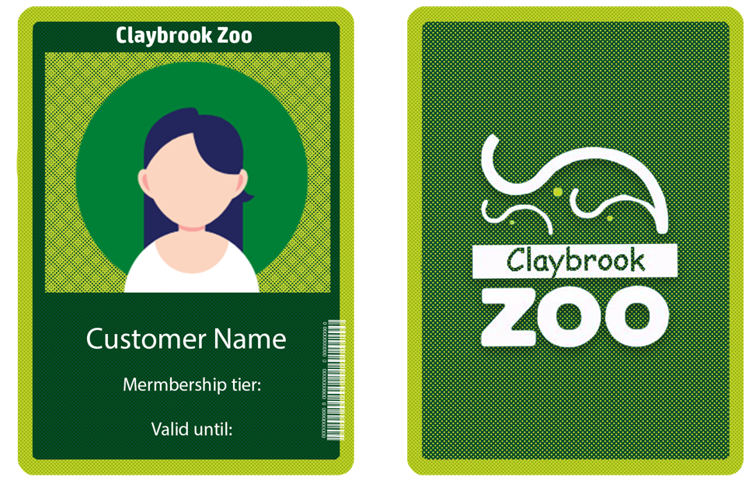

**Link to the presentation:**

<https://docs.google.com/presentation/d/1IzbA2hoX6sjbZQ1gzyQW79VHGN4aAJy9XhvWy2K9r1Y/edit?usp=sharing>

**Additional wireframes that were not used in the final mock-up:**

* **RMS**

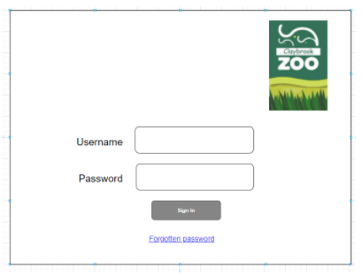

* 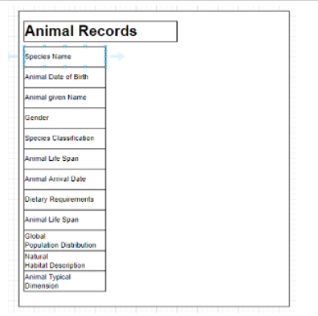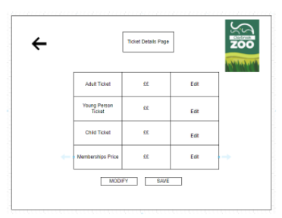

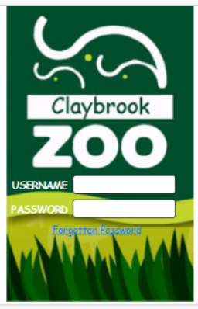

**These are the improved RMS wireframes that were developed after feedback from clients. The following wireframes were used to build the final RMS mock-up.**

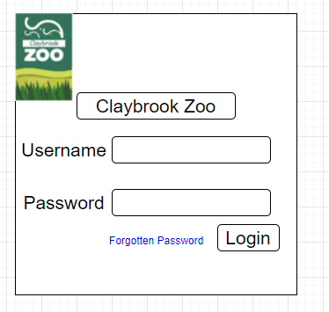

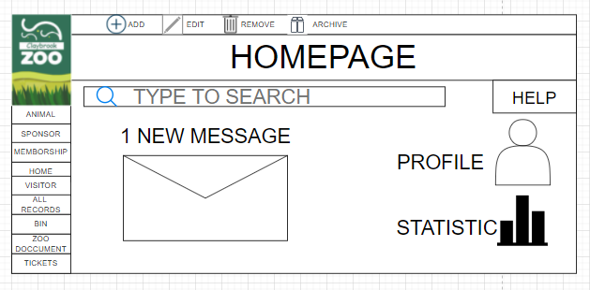

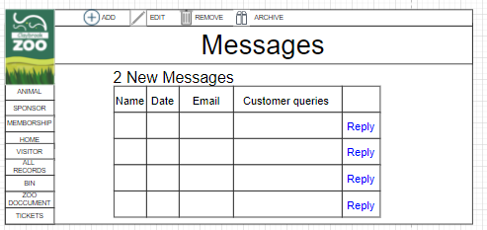

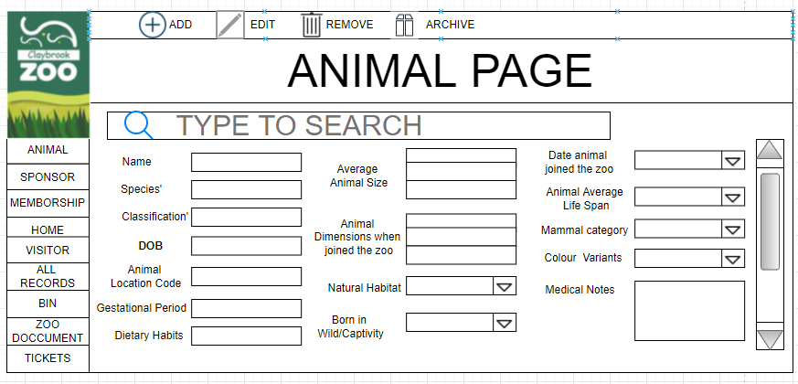

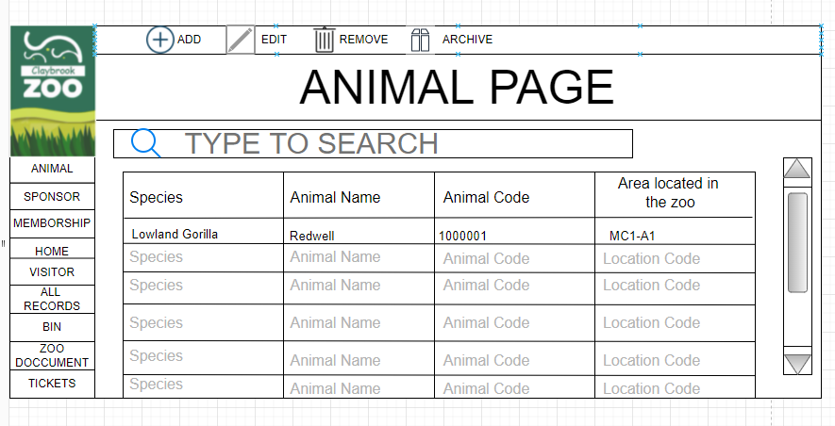

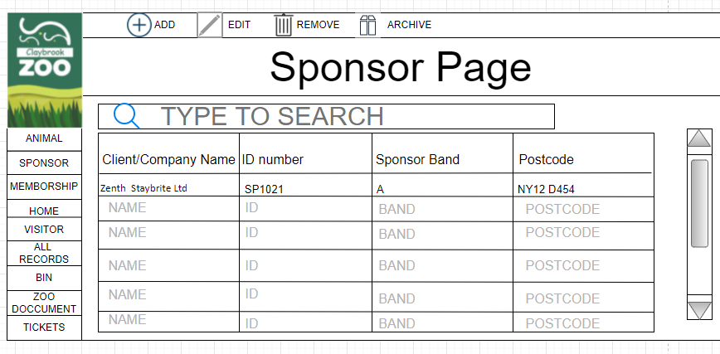

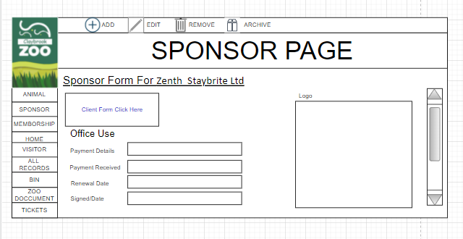

* **Website**

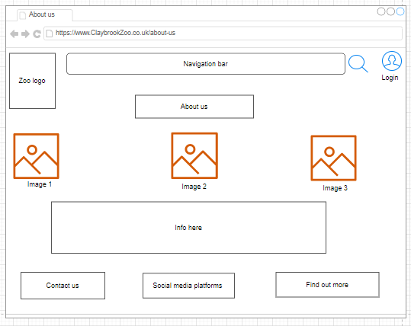

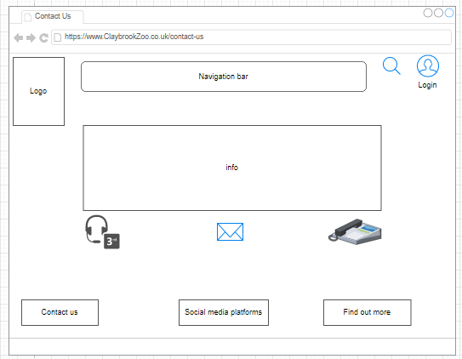

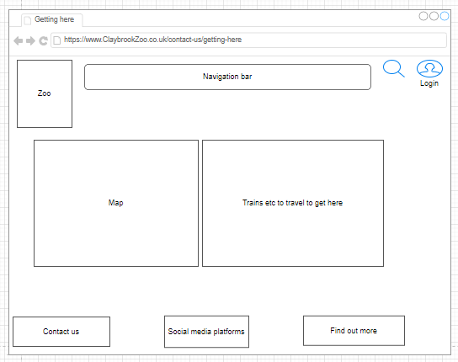

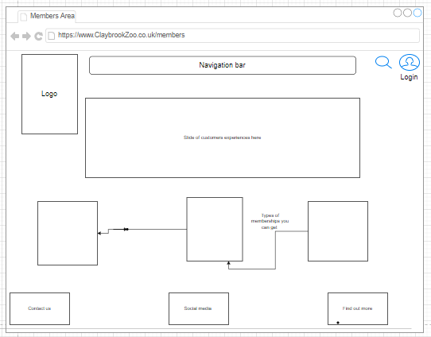

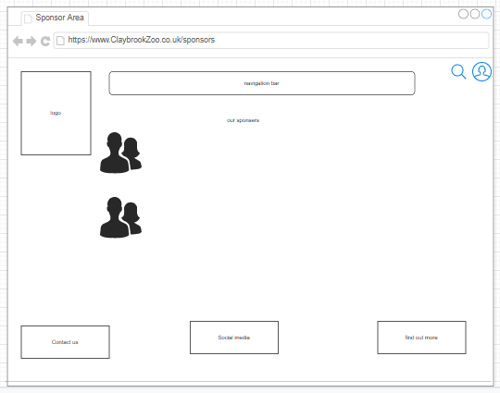

**These are the improved website wireframes that were developed after feedback from clients. The following wireframes were used to build the final website mock-up.**

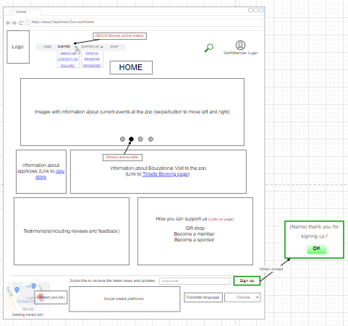

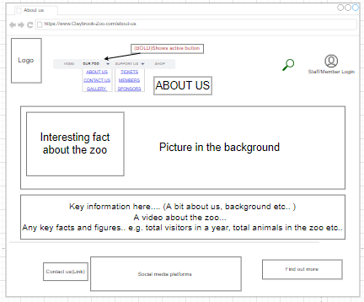

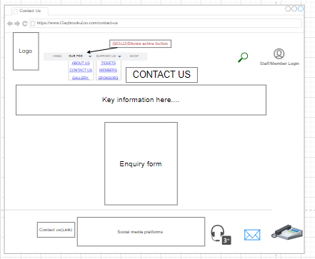

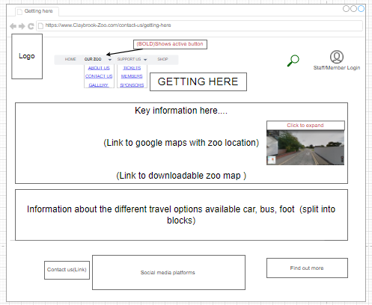

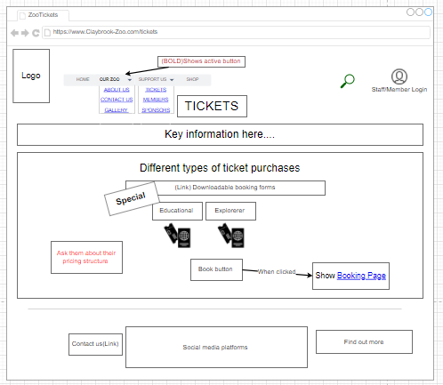

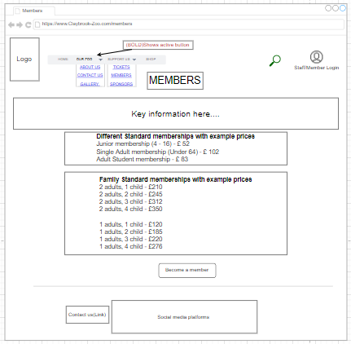

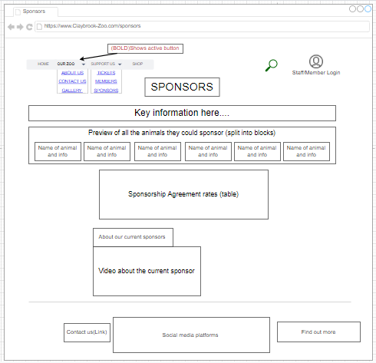

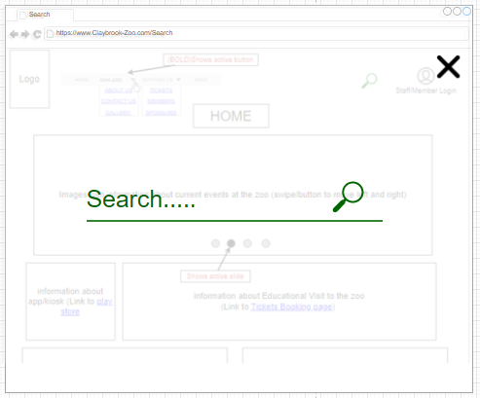

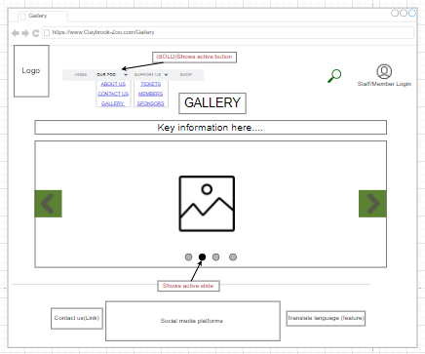

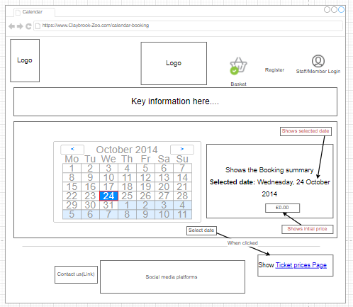

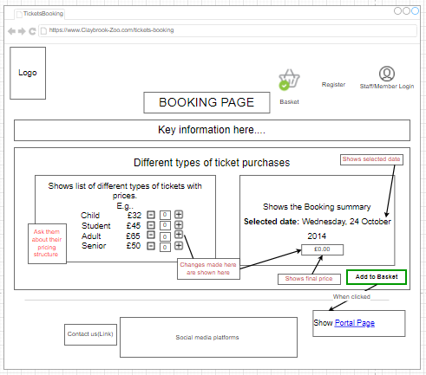

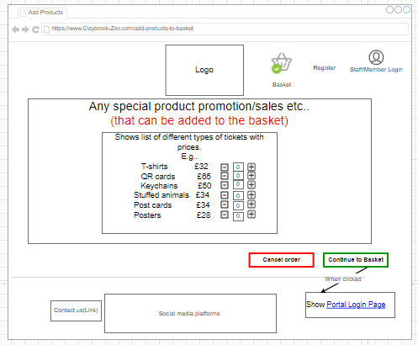

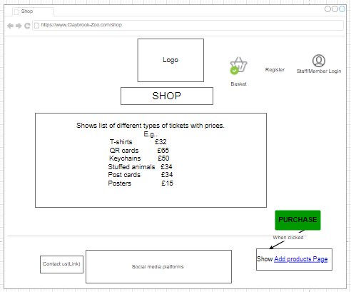

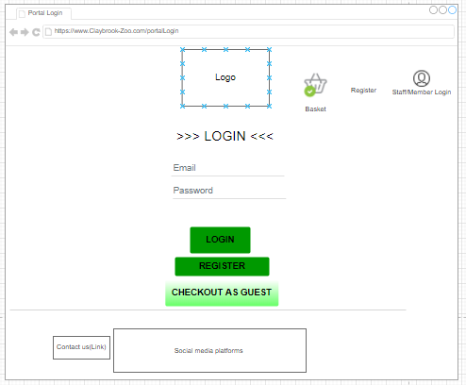

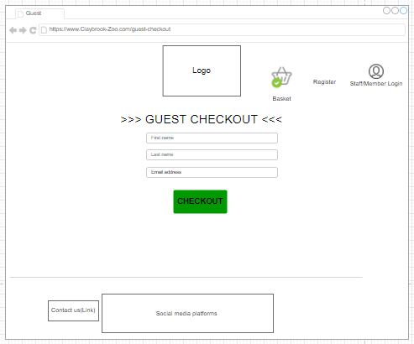

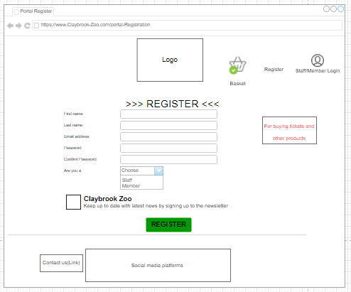

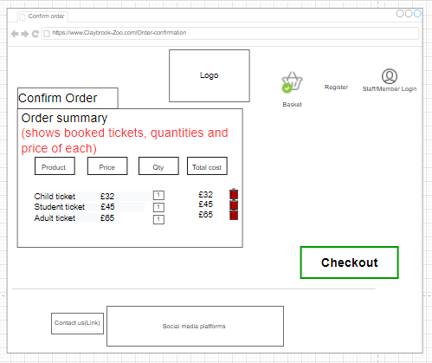

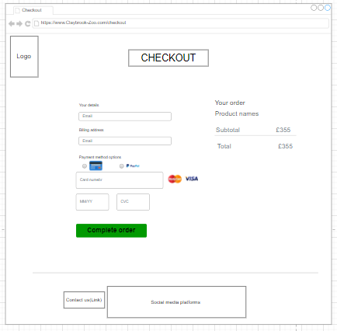

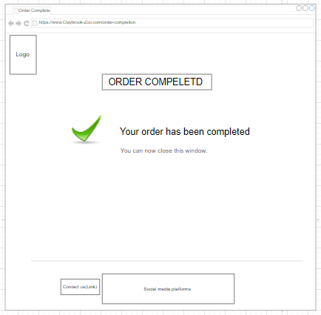

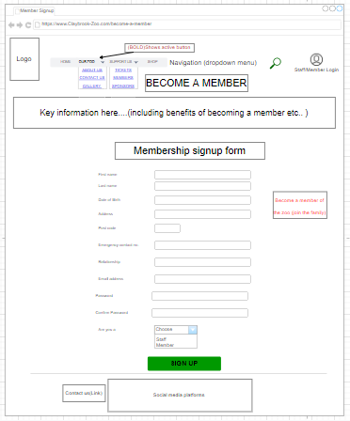

* **Kiosk**

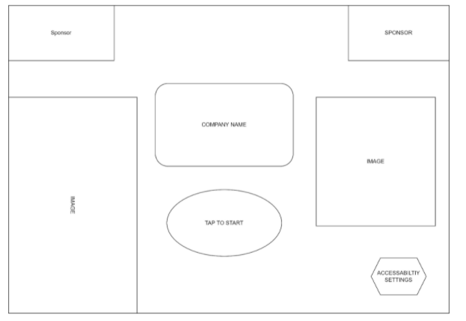

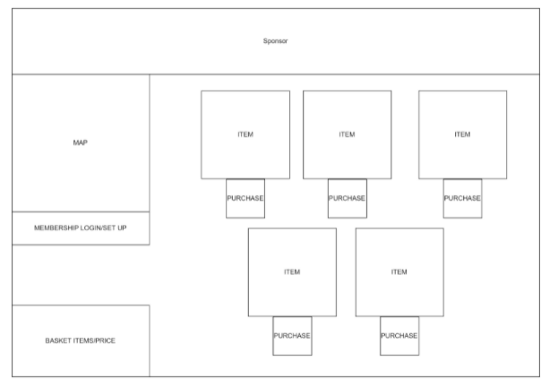

* 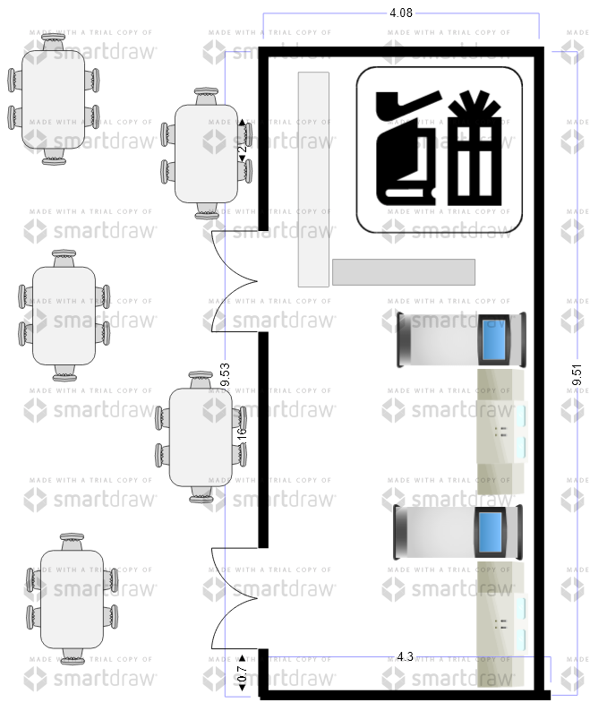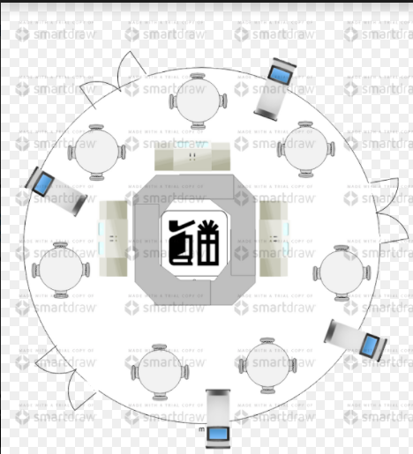

**Work Log**